Obligim/Zotim
i
Kuponi I
Blloku kodues
Drejtorati
Data e KSH
Përfituesi/Klienti/Emri I bankës
Përshkrim
Debi
shpenzimit
10 - BUXHETI
1
1
1
1
1
1
1
1
1
1
1
1
1
1
1 - PAGA DHE SHTESA
16020
16320
16920
17520
18020
48020
66405
73029
74200
75596
92100
93571
94771
19600
102,178.64
108,031.12
147,017.14
77,396.44
75,905.52
61,202.22
67,873.04
23,444.94
324,659.28
14,699.91
44,559.25
440,090.04
158,256.21
9,136.31
1 - PAGA DHE SHTESA
1 - PAGA DHE SHTESA
1 - PAGA DHE SHTESA
1 - PAGA DHE SHTESA
1 - PAGA DHE SHTESA
1 - PAGA DHE SHTESA
1 - PAGA DHE SHTESA
1 - PAGA DHE SHTESA
1 - PAGA DHE SHTESA
1 - PAGA DHE SHTESA
1 - PAGA DHE SHTESA
1 - PAGA DHE SHTESA
1 - PAGA DHE SHTESA
Gjithsejtë Paga dhe Meditje
1,654,450.06
Zyra e Kryetarit
12,499.47
1
0/636/16020/14310/00000/0111
0/636/16020/13620/00000/0111
16020
21/1/2025
21/1/2025
MORONICA E JUNIKUT SHPK
2025-369
2025-372
2025-326
2025-328
DREKE ZYRTARE
685.00
USHQIM DHE PIJE JO DREKE
ZYRTARE
1
16020
ARDI J SHPK
36.00
10/636/16020/13320/00000/0111
10/636/16020/13480/00000/0111
10/636/16020/13320/00000/0111
10/636/16020/14310/00000/0111
16020
16020
16020
16020
21/1/2025
24/2/2025
24/2/2025
24/2/2025
TELEKOMI I KOSOVES SHA
2025-354
2025-355
TELEFONIA MOBILE
SHPENZIME PER ANTARESI
TELEFONIA MOBILE
DREKE ZYRTARE
100.29
912.60
105.22
41.50
ASOCIACIONI I KOMUNAVE TE KOSOVES
TELEKOMI I KOSOVES SHA
2025-8824
2025-18658
2025-18680
2025-36288
2025-36481
2025-36502
MORONICA E JUNIKUT SHPK
USHQIM DHE PIJE JO DREKA
ZYRTARE
USHQIM DHE PIJE JO DREKA
ZYRTARE
1
0/636/16020/13620/00000/0111
0/636/16020/13620/00000/0111
16020
16020
24/2/2025
27/2/2025
ARDI J SHPK
ARDI J SHPK
2025-8833
2025-36515
2025-41493
36.00
85.20
1
2025-31280
1
0/636/16020/13780/00000/0111
0/636/16020/13780/00000/0111
16020
16020
5/3/2025
5/3/2025
PETROL COMPANY SHPK
PETROL COMPANY SHPK
2025-33577
2025-33500
2025-50130
2025-50137
DERIVATE PER VETURA
DERIVATE PER VETURA
166.64
332.58
1
USHQIM DHE PIJE JO DREKA
ZYRTARE
USHQIM DHE PIJE JO DREKA
ZYRTARE
1
0/636/16020/13620/00000/0111
0/636/16020/13620/00000/0111
16020
16020
7/3/2025
ARDI J SHPK
ARDI J SHPK
2025-42651
2025-42216
2025-54080
2025-56934
36.00
72.60
1
12/3/2025
10/636/16020/14310/00000/0111
10/636/16020/13320/00000/0111
10/636/16020/13610/00000/0111
10/636/16020/13780/00000/0111
16020
16020
16020
16020
12/3/2025
12/3/2025
4/4/2025
MORONICA E JUNIKUT SHPK
TELEKOMI I KOSOVES SHA
LETRA COM SHPK
2025-46493
2025-42913
2025-32038
2025-50281
2025-57279
2025-57462
2025-96249
DREKE ZYRTARE
425.00
130.77
388.50
223.99
TELEFONIA MOBILE
FURNIZIM PER ZYRE
14/4/2025
PETROL COMPANY SHPK
2025-116840 DERIVATE PER VETURA
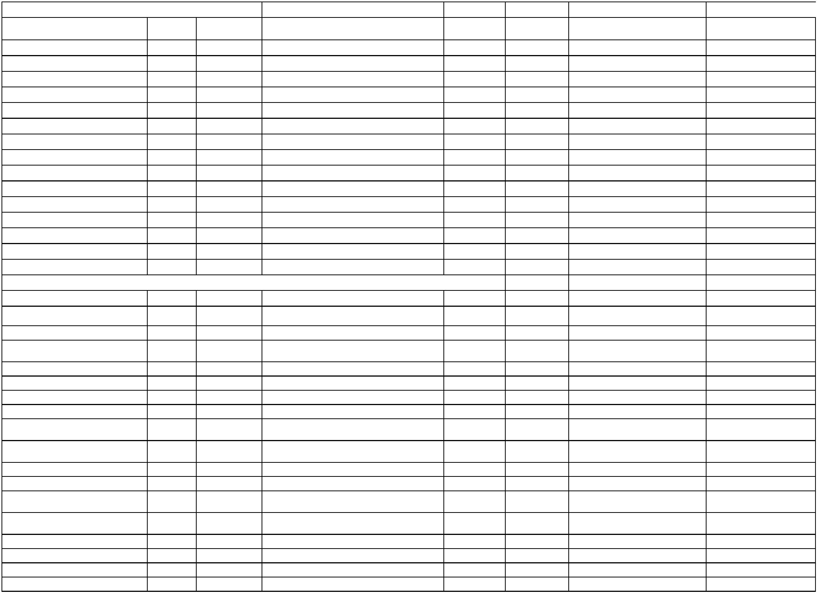

1
0/636/16020/13320/00000/0111
0/636/16020/13620/00000/0111
16020
16020
18/4/2025
28/4/2025
TELEKOMI I KOSOVES SHA
ARDI J SHPK
2025-72078
2025-73591
2025-127865 TELEFONIA MOBILE
USHQIM DHE PIJE JO DREKA
ZYRTARE
119.44
37.10
1
2025-140310
1
1
1
0/636/16020/13450/00000/0111
0/636/16020/13320/00000/0111
0/636/16020/14310/00000/0111
16020
16020
16020
21/5/2025
26/5/2025
26/5/2025
BURIM HAXHA BI
2025-78162
2025-90293
2025-92351
2025-173860 SHERBIME SHTYPJE/PRINTIMI
2025-178825 TELEFONIA MOBILE
2025-178903 DREKA ZYRTARE
USHQIM DHE PIJE JO DREKA
220.67
120.03
187.00
TELEKOMI I KOSOVES SHA
MORONICA E JUNIKUT SHPK
10/636/16020/13620/00000/0111
16020
26/5/2025
ARDI J SHPK
2025-94277
2025-178908
49.00
ZYRTARE
1
1
1
1
0/636/16020/14310/00000/0111
0/636/16020/13951/00000/0111
0/636/16020/13780/00000/0111
0/636/16020/13320/00000/0111
16020
16020
16020
16020
29/5/2025
10/6/2025
9/7/2025
9/7/2025
MORONICA E JUNIKUT SHPK
KOMPANIA E SIGURIMEVE PRISIG SHA
PETROL COMPANY SHPK
2025-101786 2025-185806 DREKE ZYRTARE
280.00
346.46
186.34
112.17
2025-109485 2025-201193 SIGURIMI I AUTOMJETEVE
2025-125986 2025-234697 DERIVATE PER VETURA
TELEKOMI I KOSOVES SHA
2025-116591 2025-234739 TELEFONIA MOBILE
USHQIM DHE PIJE JO DREKA
ZYRTARE
10/636/16020/13620/00000/0111
10/636/16020/13780/00000/0111
10/636/16020/13620/00000/0111
16020
16020
16020
9/7/2025
9/7/2025
10/7/2025
ARDI J SHPK
2025-116601 2025-234836
39.60
139.71
64.80
PETROL COMPANY SHPK
ARDI J SHPK
2025-119360 2025-235405 DERIVATE PER VETURA
USHQIM DHE PIJE JO DREKA
ZYRTARE
2025-125461 2025-244693
1
1
1
1
0/636/16020/13780/00000/0111
0/636/16020/13320/00000/0111
0/636/16020/13509/00000/0111
0/636/16020/13780/00000/0111
16020
16020
16020
16020
21/7/2025
23/7/2025
23/7/2025
30/7/2025
PETROL COMPANY SHPK
TELEKOMI I KOSOVES SHA
HASAN IS.KRASNIQI B.I.
PETROL COMPANY SHPK
2025-134349 2025-260377 DERIVATE PER VETURA
2025-139605 2025-262406 TELEFONI MOBILE
2025-141284 2025-262514 PAJISJE TJERA
299.14
84.28
366.00
369.31
2025-134332 2025-269765 DERIVATE PER VETURA
USHQIM DHE PIJE JO DREKA
ZYRTARE
1
0/636/16020/13620/00000/0111
0/636/16020/13445/00000/0111
16020
16020
30/7/2025
3/9/2025
ARDI J SHPK
2025-147488 2025-269810
50.40
SHERBIMET E VEQANTA-
KONTRAKTORE
1
BINAK QESTAJ
2025-168267 2025-334103
391.10
10/636/16020/13320/00000/0111
10/636/16020/13620/00000/0111
10/636/16020/14310/00000/0111
16020
16020
16020
26/9/2025
26/9/2025
30/9/2025
TELEKOMI I KOSOVES SHA
ARDI J SHPK
2025-179909 2025-363022 VALA
77.48
45.30
2025-182649 2025-363070 63625233 USHQIM DHE PIJE
2025-182643 2025-372634 63625234 USHQIM DHE PIJE
MORONICA E JUNIKUT SHPK
147.50
6
36256767 SHPENZIMET E
VEQANTA KONTRAKTORE
3625227 SHERBIMET E
SHTYPJE/PRINTIMIT
1
1
1
1
1
1
1
1
1
0/636/16020/13445/00000/0111
0/636/16020/13450/00000/0111
0/636/16020/13320/00000/0111
0/636/16020/13610/00000/0111
0/636/16020/13780/00000/0111
0/636/16020/13780/00000/0111
0/636/16020/13445/00000/0111
0/636/16020/13445/00000/0111
0/636/16020/13445/00000/0111
16020
16020
16020
16020
16020
16020
16020
16020
16020
3/10/2025
SAFETE POZHARI
2025-189049 2025-380803
2025-187770 2025-394865
508.66
213.26
93.33
6
15/10/2025 BURIM HAXHA BI
27/10/2025 TELEKOMI I KOSOVES SHA
28/10/2025 HASAN IS.KRASNIQI B.I.
30/10/2025 PETROL COMPANY SHPK
30/10/2025 PETROL COMPANY SHPK
2025-199749 2025-409157 63625696 TELEFONIJA MOBILE
2025-204490 2025-416389 63625264 FURNIZIM PER ZYRE
105.00
182.92
328.81
508.66
508.66
508.66
6
3625237 DERIVATE PER
VETURA
3625263 DERIVATE PER
VETURA
3625787 SHERBIMET E
VEQANTA- KONTRAKTORE
3625789 SHERBIMET E
VEQANTA- KONTRAKTORE
3625790 SHERBIMET E
VEQANTA- KONTRAKTORE
36257898 SHERBIMET E
VEQANTA- KONTRAKTORE
2025-212451 2025-459468 63625765 ARDI-J SHPK
2025-184788 2025-421844
2025-204472 2025-422656
2025-213595 2025-442692
2025-213580 2025-442696
2025-213576 2025-442700
2025-213587 2025-446649
6
6
6/11/2025
6/11/2025
6/11/2025
SADIJE LOKAJ
6
SAFETE POZHARI
ELDION KRASNIQI
6
6
1
0/636/16020/13445/00000/0111
0/636/16020/13620/00000/0111
16020
16020
10/11/2025 BINAK QESTAJ
17/11/2025 ARDI J SHPK
391.10
43.20
1
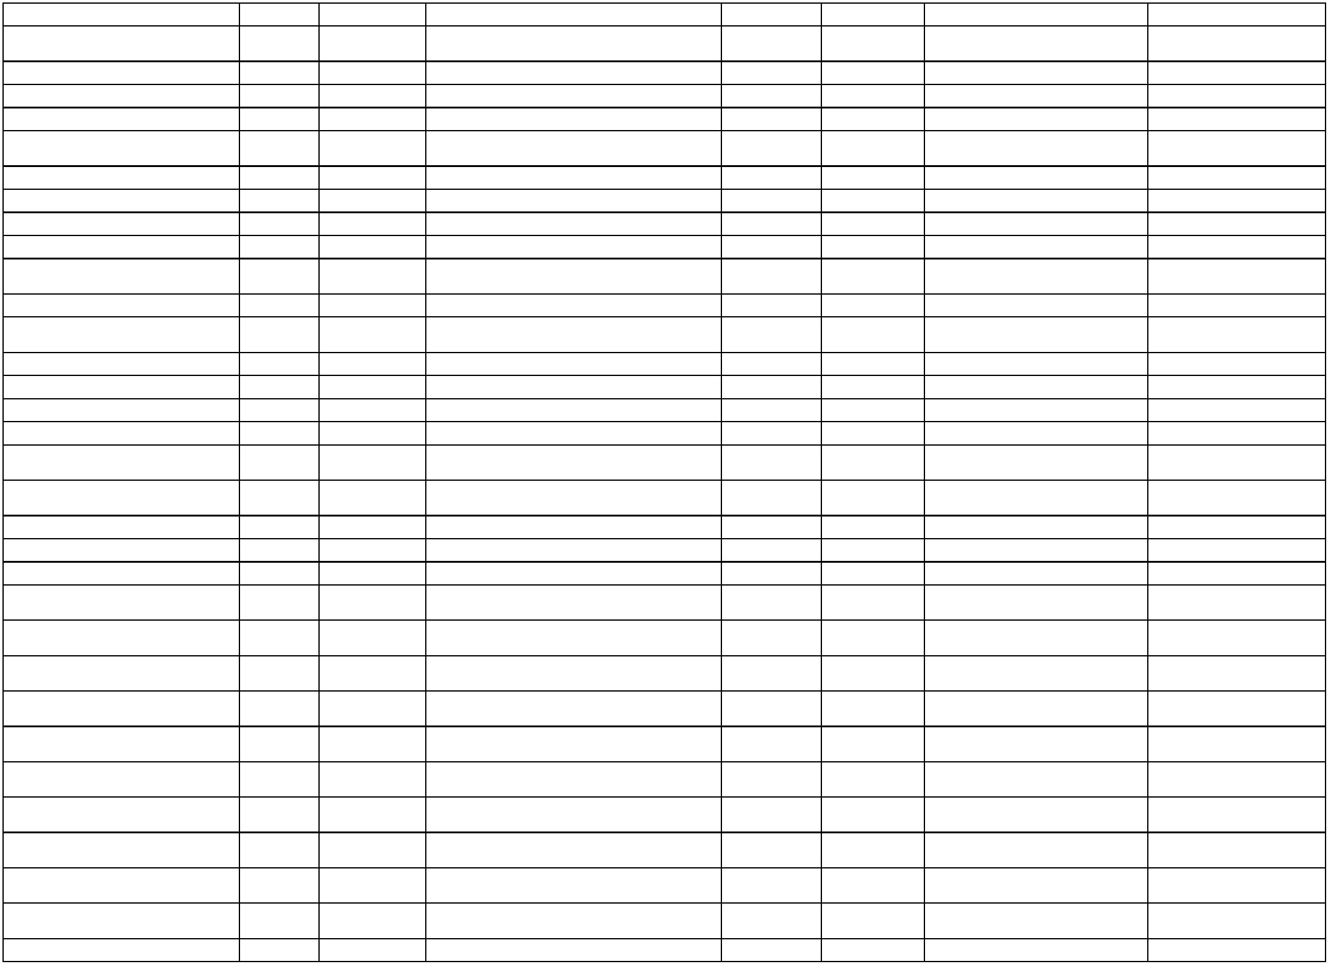

1
0/636/16020/13620/00000/0111
0/636/16020/13780/00000/0111
16020
16020
17/11/2025 ARDI J SHPK
2025-212446 2025-459474 63625767 ARDI-J SHPK
3625259 DERIVATE PER
VETURA
2025-223123 2025-481223 63625849 TELEFONIJA MOBILE
3625294 DERIVATE PER
VETURA
3625301 DERIVATE PER
VETURA
3625289 REGJISTRIMI DHE
SIGURIMI I AUTOMJETEVE
3625312 SHERBIMET E
36.00
6
1
24/11/2025 PETROL COMPANY SHPK
2025-210222 2025-475288
311.88
10/636/16020/13320/00000/0111
10/636/16020/13780/00000/0111
10/636/16020/13780/00000/0111
10/636/16020/13951/00000/0111
10/636/16020/13450/00000/0111
16020
16020
16020
16020
16020
26/11/2025 TELEKOMI I KOSOVES SHA
10/12/2025 PETROL COMPANY SHPK
10/12/2025 PETROL COMPANY SHPK
10/12/2025 KOMPANIA E SIGURIMEVE PRISIG SHA
11/12/2025 BURIM HAXHA BI
78.90
35.44
6
2025-229246 2025-517875
2025-229228 2025-517887
2025-224933 2025-518562
2025-235287 2025-521498
2025-119501 2025-547876
6
33.62
6
340.60
411.05
6
PRINTIMIT
KONTROLLIMI TEKNIK I
AUTOMJETEVE
1
0/636/16020/13954/00000/0111
0/636/16020/14310/00000/0111
16020
16020
19/12/2025 NEZIR M.SHALA BI
30.00
1
23/12/2025 MORONICA E JUNIKUT SHPK
2025-233424 2025-555639 63625873 DREKA ZYRTARE
319.00
Administrata
31,829.13
62.99
10/636/16320/13320/00000/0133
10/636/16320/13330/00000/0133
10/636/16320/13330/00000/0133
10/636/16320/13320/00000/0133
10/636/16320/13780/00000/0133
10/636/16320/13810/00000/0133
10/636/16320/14130/00000/0133
16320
16320
16320
16320
16320
16320
16320
21/1/2025
21/1/2025
30/1/2025
24/2/2025
24/2/2025
26/2/2025
26/2/2025
TELEKOMI I KOSOVES SHA
POSTA E KOSOVES SH.A
POSTA E KOSOVES SH.A
TELEKOMI I KOSOVES SHA
PETROL COMPANY SHPK
PETTY CASH - JUNIK
2025-340
2025-330
TELEFONIA MOBILE
SHPENZIME POSTARE
SHPENZIME POSTARE
TELEFONIA MOBILE
DERIVATE PER VETURA
PETYY CASH
2025-367
2025-351
6.60
2025-5649
2025-18685
2025-17493
2025-26429
2025-24323
2025-4385
2025-37457
2025-37468
2025-40068
2025-40577
11.60
80.10
64.98
500.00
930.00
NEXHMIJE X.VESELI B.I
QIRAJA PER PAJISJE
SHPENZIMET E PERFAQESIMIT
DHE AVOKATURES
10/636/16320/13420/00000/0133
16320
26/2/2025
AVOKAT NAIM SPAHIU SHPK
2025-17004
2025-40776
699.00
1
0/636/16320/13780/00000/0133
0/636/16320/13330/00000/0133
16320
16320
28/2/2025
7/3/2025
PETROL COMPANY SHPK
POSTA E KOSOVES SH.A
2025-33553
2025-37617
2025-44366
2025-52909
DERIVATE PER VETURA
SHPENZIME POSTARE
85.70
3.40
1
MIREMBAJTJA E NDERTESAVE
ADMINISTRATIVE DHE AFARISTE
10/636/16320/14022/00000/0133
16320
10/3/2025
HIDRO BAU SH.P.K
2025-42237
2025-54583
242.00
10/636/16320/13320/00000/0133
10/636/16320/13610/00000/0133
10/636/16320/13610/00000/0133
10/636/16320/13330/00000/0133
16320
16320
16320
16320
12/3/2025
12/3/2025
12/3/2025
18/3/2025
TELEKOMI I KOSOVES SHA
LETRA COM SHPK
2025-43052
2025-32081
2025-34000
2025-52403
2025-57507
2025-58196
2025-58235
2025-69892
TELEFONIA MOBILE
FURNIZIM PER ZYRE
FURNIZIM PER ZYRE
SHPENZIME POSTARE
52.01
259.00
103.60
2.30
LETRA COM SHPK
POSTA E KOSOVES SH.A
SHPENZIMET E PERFAQESIMIT
DHE AVOKATURES
10/636/16320/13420/00000/0133
16320
19/3/2025
AVOKAT NAIM SPAHIU SHPK
2025-21287
2025-71515
699.00
1
0/636/16320/13610/00000/0133
0/636/16320/13720/00000/0133
16320
16320
3/4/2025
8/4/2025
JETA EVENT SH.P.K.
2025-54133
2025-31614
2025-94574
FURNIZIME PER ZYRE
65.00
NAFTE PER NGROHJE
QENDRORE
1
PETROL COMPANY SHPK
2025-102142
4,761.20
1
0/636/16320/13780/00000/0133
0/636/16320/13320/00000/0133
16320
16320
14/4/2025
18/4/2025
PETROL COMPANY SHPK
TELEKOMI I KOSOVES SHA
2025-50374
2025-72118
2025-116826 DERIVATE PER VETURA
2025-127861 TELEFONIA MOBILE
135.57
56.50
1
SHPENZIMET E PERFAQESIMIT
DHE AVOKATURES
1
0/636/16320/13420/00000/0133
0/636/16320/13450/00000/0133
16320
16320
25/4/2025
23/5/2025
AVOKAT NAIM SPAHIU SHPK
BURIM HAXHA BI
2025-21259
2025-78300
2025-139256
699.00
330.01
1
2025-177658 SHERBIME SHTYPJE/PRINTIMI
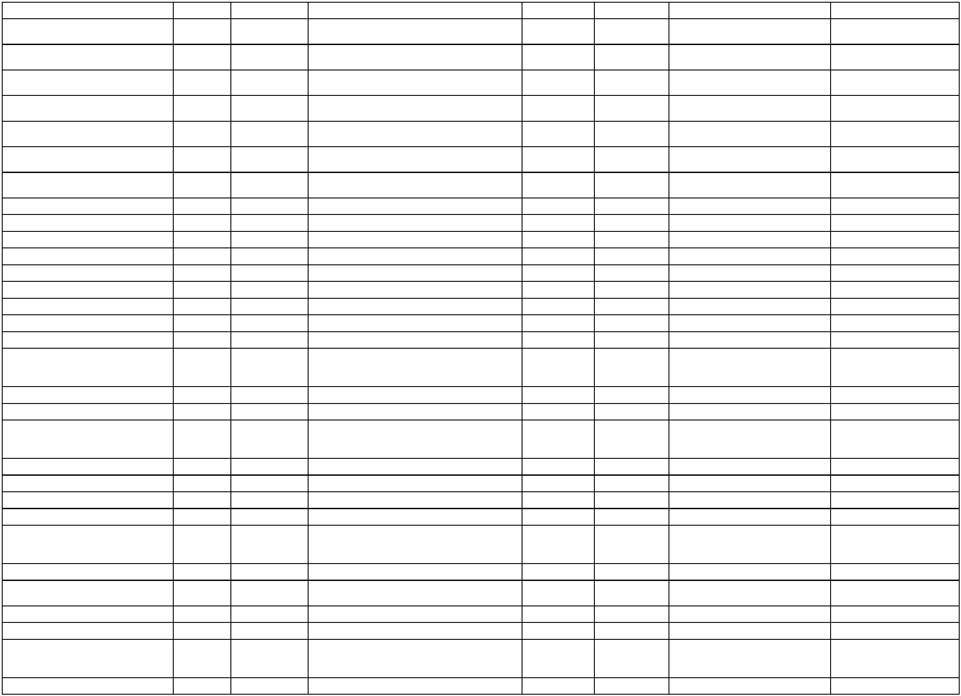

10/636/16320/13330/00000/0133
10/636/16320/13320/00000/0133
10/636/16320/13330/00000/0133
16320
16320
16320
26/5/2025
26/5/2025
29/5/2025
POSTA E KOSOVES SH.A
TELEKOMI I KOSOVES SHA
POSTA E KOSOVES SH.A
2025-81384
2025-90288
2025-86411
2025-178789 SHERBIME POSTARE
2025-178816 TELEFONIA MOBILE
2025-185796 SHERBIME POSTARE
11.30
56.03
116.20
SHPENZIMET E PERFAQESIMIT
DHE AVOKATURES
10/636/16320/13420/00000/0133
16320
10/6/2025
AVOKAT NAIM SPAHIU SHPK
2025-74228
2025-200088
699.00
MIREMBAJTJA E MOBILEVE DHE
PAJISJEVE
MEDITJE PER UDHETIME
JASHTE VENDIT
1
0/636/16320/14050/00000/0133
0/636/16320/13141/00000/0133
16320
16320
12/6/2025
18/6/2025
MURAT ABAZI BI
2025-110246 2025-203272
2025-119671 2025-211371
232.00
324.50
1
RRUSTEM PEPSHI
1
1
1
1
0/636/16320/13780/00000/0133
0/636/16320/13780/00000/0133
0/636/16320/13320/00000/0133
0/636/16320/13330/00000/0133
16320
16320
16320
16320
9/7/2025
9/7/2025
9/7/2025
9/7/2025
PETROL COMPANY SHPK
PETROL COMPANY SHPK
TELEKOMI I KOSOVES SHA
POSTA E KOSOVES SH.A
2025-81569
2025-234679 DERIVATE PER VETURA
75.37
43.97
56.00
13.30
2025-126000 2025-234685 DERIVATE PER VETURA
2025-116722 2025-234811 TELEFONIA MOBILE
2025-110119 2025-234874 Shpenzime Postare
Shërbime juridike për nevojat e
Komunes se Juniku
10/636/16320/13420/00000/0133
16320
9/7/2025
AVOKAT NAIM SPAHIU SHPK
2025-110421 2025-235172
699.00
REGJISTRIM DHE SIGURTIM I
AUTOMJETEVE
1
1
1
0/636/16320/13951/00000/0133
0/636/16320/13780/00000/0133
0/636/16320/13460/00000/0133
16320
16320
16320
9/7/2025
9/7/2025
10/7/2025
KOMPANIA E SIGURIMEVE PRISIG SHA
PETROL COMPANY SHPK
2025-98229
2025-235263
214.97
129.19
837.84
2025-119385 2025-235412 DERIVATE PER VETURA
SHERBIME KONTRAKTUESE
TJERA
SHERBIME KONTRAKTUESE
TJERA
SHER.E VEQANTA -
KONTRAKTOR INDIVIDUAL
SHER.E VEQANTA -
KONTRAKTOR INDIVIDUAL
TRUSTI PENSIONAL I KURSIMEVE
2025-136150 2025-245133
2025-136127 2025-245166
2025-135845 2025-245216
2025-135810 2025-245232
10/636/16320/13460/00000/0133
10/636/16320/13445/00000/0133
10/636/16320/13445/00000/0133
16320
16320
16320
10/7/2025
10/7/2025
10/7/2025
ADMINISTRATA TATIMORE E KOSOVES
ELDION KRASNIQI
308.03
462.97
355.76
BINAK QESTAJ
10/636/16320/13470/00000/0133
10/636/16320/13470/00000/0133
10/636/16320/13610/00000/0133
16320
16320
16320
15/7/2025
15/7/2025
21/7/2025
RIAL GROUP RKS LLC
RIAL GROUP RKS LLC
JETA EVENT SH.P.K.
2025-85874
2025-251361 SHERBIME TEKNIKE
220.00
330.00
325.00
2025-122913 2025-251380 SHERBIME TEKNIKE
2025-104474 2025-260348 FURNIZIM PER ZYRE
1
0/636/16320/13780/00000/0133
0/636/16320/13780/00000/0133
16320
16320
21/7/2025
21/7/2025
PETROL COMPANY SHPK
PETROL COMPANY SHPK
2025-134402 2025-260473 DERIVATE PER VETURA(DIESEL)
2025-134402 2025-260473 DERIVATE PER VETURA(BENZIN)
122.10
25.88
1
10/636/16320/13320/00000/0133
10/636/16320/13330/00000/0133
10/636/16320/13780/00000/0133
16320
16320
16320
23/7/2025
24/7/2025
31/7/2025
TELEKOMI I KOSOVES SHA
POSTA E KOSOVES SH.A
PETROL COMPANY SHPK
2025-138911 2025-262448 TELEFONIA MOBILE
2025-129547 2025-262730 SHPENZIME POSTARE
2025-137973 2025-270550 DERIVATE PER VETURA
56.00
25.90
97.63
SHPENZIMET E PERFAQESIMIT
DHE AVOKATURES
10/636/16320/13420/00000/0133
16320
31/7/2025
AVOKAT NAIM SPAHIU SHPK
2025-124472 2025-270570
699.00
SHER. TE VEQANTA
KONTRAKTORE
SHER. TE VEQANTA
KONTRAKTORE
SHER. TE VEQANTA
KONTRAKTORE
SHER. TE VEQANTA
KONTRAKTORE
10/636/16320/13445/00000/0133
10/636/16320/13445/00000/0133
10/636/16320/13445/00000/0133
10/636/16320/13445/00000/0133
10/636/16320/13460/00000/0133
16320
16320
16320
16320
16320
6/8/2025
6/8/2025
6/8/2025
7/8/2025
7/8/2025
SHQIPE QALLAKU
2025-153192 2025-275968
2025-153177 2025-275972
2025-153170 2025-275976
2025-153165 2025-276322
2025-153066 2025-276371
508.66
508.66
508.66
391.10
919.38
FORTESA GACAFERI
ELDION KRASNIQI
BINAK QESTAJ
SHER. TE VEQANTA
KONTRAKTORE
TRUSTI PENSIONAL I KURSIMEVE


#63625539 SHER. TE VEQANTA
KONTRAKTORE
10/636/16320/13460/00000/0133
16320
7/8/2025
ADMINISTRATA TATIMORE E KOSOVES
2025-153163 2025-276380
383.28
1
1
1
0/636/16320/13503/00000/0133
0/636/16320/13460/00000/0133
0/636/16320/13460/00000/0133
16320
16320
16320
12/8/2025
3/9/2025
3/9/2025
ARITECH SHPK
2025-114750 2025-306714 KOMPJUTERET
2025-168249 2025-334090 TATIMI NE BURIM
2025-168261 2025-334101 TRUSTI PENSIONAL
SHERBIMET E VEQANTA-
732.00
383.28
919.38
ADMINISTRATA TATIMORE E KOSOVES
TRUSTI PENSIONAL I KURSIMEVE
10/636/16320/13445/00000/0133
10/636/16320/13445/00000/0133
10/636/16320/13445/00000/0133
16320
16320
16320
3/9/2025
3/9/2025
3/9/2025
ELDION KRASNIQI
FORTESA GACAFERI
SHQIPE QALLAKU
2025-168269 2025-334108
2025-168276 2025-334113
2025-168284 2025-334121
508.66
508.66
508.66
KONTRAKTORE
SHERBIMET E VEQANTA-
KONTRAKTORE
SHERBIMET E VEQANTA-
KONTRAKTORE
1
0/636/16320/13320/00000/0133
0/636/16320/13320/00000/0133
16320
16320
11/9/2025
11/9/2025
TELEKOMI I KOSOVES SHA
TELEKOMI I KOSOVES SHA
2025-163321 2025-343124 VALA MOBIL
2025-163279 2025-343174 VALA
62.56
1
113.78
USHQIM DHE PIJE -JO DREKA
ZYRTARE
2025-152122 2025-343230 SHERBIME POSTARE
1
1
1
0/636/16320/13620/00000/0133
0/636/16320/13330/00000/0133
0/636/16320/13460/00000/0133
16320
16320
16320
11/9/2025
11/9/2025
11/9/2025
ARDI J SHPK
2025-169028 2025-343219
133.20
42.50
60.00
POSTA E KOSOVES SH.A
JETA EVENT SH.P.K.
Frunizim me Buqeta Lulesh për
Manifestime
2025-148313 2025-343296
2025-174750 2025-362873
SHPENZIMET E PERFAQËIMIT
DHE AVOKATURËS
10/636/16320/13420/00000/0133
16320
26/9/2025
AVOKAT NAIM SPAHIU SHPK
699.00
10/636/16320/13780/00000/0133
10/636/16320/13620/00000/0133
10/636/16320/13620/00000/0133
16320
16320
16320
26/9/2025
26/9/2025
26/9/2025
PETROL COMPANY SHPK
ARDI J SHPK
2025-93136
2025-362883 DERIVATE PER VETURA
29.08
29.41
2025-179950 2025-363036 ushqim dhe pije
MORONICA E JUNIKUT SHPK
2025-182638 2025-363056 63625235 USHQIM DHE PIJE
124.00
1
1
1
0/636/16320/13330/00000/0133
0/636/16320/13320/00000/0133
0/636/16320/13460/00000/0133
16320
16320
16320
26/9/2025
26/9/2025
3/10/2025
POSTA E KOSOVES SH.A
2025-181808 2025-363103 63625617 SHERBIMET POSTARE
2025-181790 2025-363259 63625621 VALA
20.30
61.02
TELEKOMI I KOSOVES SHA
TRUSTI PENSIONAL I KURSIMEVE
6
3625666 SHPENZIMET E
VEQANTA KONTRAKTORE
3625665 SHPENZIMET E
VEQANTA KONTRAKTORE
3625227 SHERBIME
SHTYPJE/PRINTIMI
2025-189065 2025-380853
2025-189085 2025-380863
2025-183540 2025-394839
919.38
6
10/636/16320/13460/00000/0133
16320
3/10/2025
ADMINISTRATA TATIMORE E KOSOVES
383.28
6
10/636/16320/13450/00000/0133
10/636/16320/13610/00000/0133
10/636/16320/13420/00000/0133
16320
16320
16320
15/10/2025 BURIM HAXHA BI
310.68
100.00
699.00
17/10/2025 JETA EVENT SH.P.K.
17/10/2025 AVOKAT NAIM SPAHIU SHPK
2025-179931 2025-401770 FURNIZIM PER ZYRE
SHPENZIMET E PERFAQËIMIT
DHE AVOKATURËS
2025-174782 2025-401778
1
0/636/16320/13320/00000/0133
16320
27/10/2025 TELEKOMI I KOSOVES SHA
2025-199766 2025-409155 63625694 TELEFONIJA MOBILE
SHPENZIMET E PERFAQËIMIT
56.00
10/636/16320/13420/00000/0133
10/636/16320/13470/00000/0133
10/636/16320/13780/00000/0133
16320
16320
16320
30/10/2025 AVOKAT NAIM SPAHIU SHPK
31/10/2025 RIAL GROUP RKS LLC
31/10/2025 PETROL COMPANY SHPK
2025-174768 2025-421783
699.00
220.00
49.50
DHE AVOKATURËS
2025-208920 2025-422951 63625262 SHERBIME TEKNIKE
3625236 DERIVATE PER
VETURA
3625281 SHERBIMET E
6
2025-184773 2025-423140
6
10/636/16320/13420/00000/0133
16320
24/11/2025 AVOKAT NAIM SPAHIU SHPK
2025-216189 2025-474809 PERFAQESIMIT DHE
AVOKATURES
699.00
6
3625269 DERIVATE PER
VETURA -NAFTË
3625269 DERIVATE PER
VETURA -BENZIN
10/636/16320/13780/00000/0133
10/636/16320/13780/00000/0133
10/636/16320/13330/00000/0133
16320
16320
16320
24/11/2025 PETROL COMPANY SHPK
24/11/2025 PETROL COMPANY SHPK
24/11/2025 POSTA E KOSOVES SH.A
2025-211041 2025-474867
2025-211041 2025-474867
96.77
21.34
5.50
6
2025-212454 2025-475410 63625766 SHERBIME POSTARE
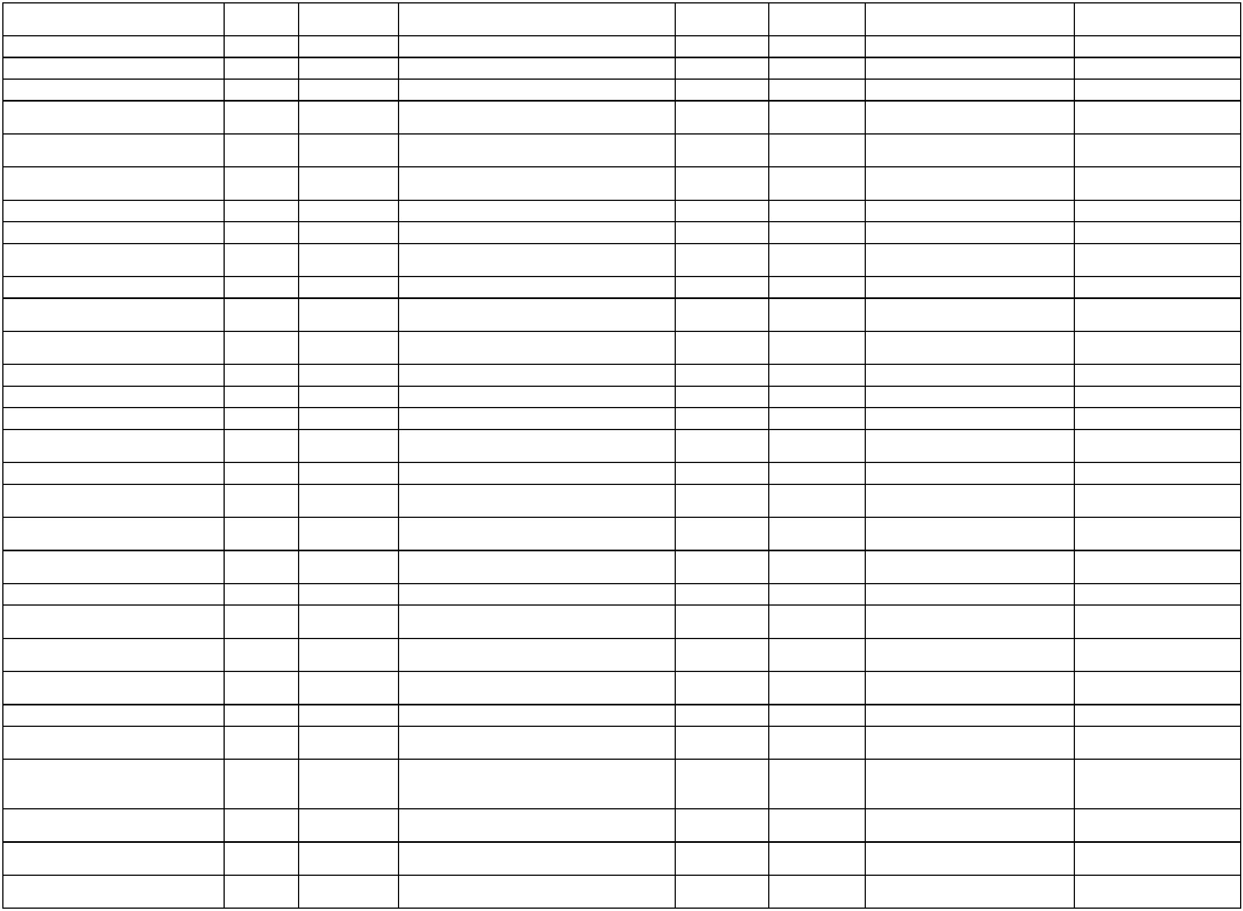

MIREMBAJTJA DHE RIPARIMI I
AUTOMJETEVE
1
0/636/16320/14010/00000/0133
0/636/16320/13320/00000/0133
16320
16320
24/11/2025 SEFERI MONT SHPK
2025-222332 2025-475850
407.50
56.50
1
26/11/2025 TELEKOMI I KOSOVES SHA
2025-223131 2025-481232 63625846 TELEFONIJA MOBILE
6
3625282 SHERBIMET E
10/636/16320/13420/00000/0133
16320
10/12/2025 AVOKAT NAIM SPAHIU SHPK
2025-216196 2025-517830 PERFAQESIMIT DHE
AVOKATURES
699.00
6
3625295 DERIVATE PER
VETURA (NAFTE)
3625291 MIREMBAJTIJA DHE
RIPARIMI I AUTOMJETEVE
10/636/16320/13780/00000/0133
10/636/16320/14010/00000/0133
10/636/16320/13320/00000/0133
10/636/16320/13320/00000/0133
10/636/16320/13610/00000/0133
10/636/16320/13330/00000/0133
10/636/16320/13954/00000/0133
10/636/16320/13954/00000/0133
10/636/16320/13954/00000/0133
16320
16320
16320
16320
16320
16320
16320
16320
16320
10/12/2025 PETROL COMPANY SHPK
10/12/2025 SEFERI MONT SHPK
11/12/2025 TELEKOMI I KOSOVES SHA
11/12/2025 TELEKOMI I KOSOVES SHA
18/12/2025 LETRA COM SHPK
2025-229264 2025-517934
2025-229321 2025-517967
32.22
184.00
64.97
90.81
453.25
6.70
6
2025-245341 2025-521428 63625893 TELEFONIJA MOBILE
2025-245327 2025-521453 63625894 TELEFONIJA MOBILE
2025-237253 2025-544697 63625324 FURNIZIM PER ZYRE
19/12/2025 POSTA E KOSOVES SH.A
19/12/2025 NEZIR M.SHALA BI
2025-187636 2025-545714 63625655 SHERBIME POSTARE
KONTROLLIMI TEKNIK I
AUTOMJETEVE
2025-119706 2025-547833
2025-119698 2025-547862
2025-119689 2025-547888
50.00
50.00
30.00
KONTROLLIMI TEKNIK I
AUTOMJETEVE
KONTROLLIMI TEKNIK I
AUTOMJETEVE
19/12/2025 NEZIR M.SHALA BI
19/12/2025 NEZIR M.SHALA BI
6
3625283 SHERBIMET E
10/636/16320/13420/00000/0133
16320
19/12/2025 AVOKAT NAIM SPAHIU SHPK
2025-216208 2025-547927 PERFAQESIMIT DHE
AVOKATURES
699.00
1
0/636/16320/13470/00000/0133
0/636/16320/13509/00000/0133
16320
16320
23/12/2025 PETTY CASH - JUNIK
23/12/2025 PETTY CASH - JUNIK
2025-552008 SHERBIME TEKNIKE
2025-552008 PAJISJE TJERA
102.50
397.50
1
MBYLLJE E PETTY CASHI-IT
ADMINISTRATE
3625319 MIREMBAJTIJA DHE
1
0/636/16320/13810/00000/0133
0/636/16320/14010/00000/0133
16320
16320
23/12/2025 PETTY CASH - JUNIK
23/12/2025 SEFERI MONT SHPK
2025-552008
-500.00
204.00
6
1
2025-237158 2025-553670
RIPARIMI IAUTOMJETEVE
Kuvendi Komunal
3,999.85
10/636/16920/13610/00000/0111
10/636/16920/14310/00000/0111
10/636/16920/13951/00000/0111
10/636/16920/13951/00000/0111
10/636/16920/13445/00000/0111
10/636/16920/13445/00000/0111
10/636/16920/13445/00000/0111
10/636/16920/13445/00000/0111
10/636/16920/13620/00000/0111
16920
16920
16920
16920
16920
16920
16920
16920
16920
14/3/2025
11/9/2025
26/9/2025
LETRA COM SHPK
2025-32071
2025-63288
FURNIZIM PER ZYRE
155.40
ODA E JUNIKUT SH.P.K.
2025-153266 2025-343208 DREKA ZYRTARE
REGJISTRIMI DHE SIGURIMI I
249.99
421.29
582.90
508.66
508.66
508.66
508.66
31.30
KOMPANIA E SIGURIMEVE PRISIG SHA
2025-175867 2025-363000
2025-201533 2025-423132
2025-213684 2025-442598
2025-213679 2025-442634
2025-213672 2025-442642
2025-213665 2025-446726
AUTOMJETEVE
3625252 REGJISTRIMI DHE
SIGURIMI I AUTOMJETEVE
3625776 SHERBIMET E
VEQANTA- KONTRAKTORE
3625777 SHERBIMET E
VEQANTA- KONTRAKTORE
3625778 SHERBIMET E
VEQANTA- KONTRAKTORE
3625779 SHERBIMET E
VEQANTA- KONTRAKTORE
6
31/10/2025 KOMPANIA E SIGURIMEVE PRISIG SHA
6
6/11/2025
6/11/2025
6/11/2025
EDOLINDA KRASNIQI
FORTESA GACAFERI
DORUNTINA FETAJ
6
6
6
10/11/2025 SHQIPE QALLAKU
23/12/2025 ARDI J SHPK
2025-233934 2025-555452 63625874 USHQIM DHE PIJE


10/636/16920/13620/00000/0111
10/636/16920/13620/00000/0111
10/636/16920/13620/00000/0111
10/636/16920/13620/00000/0111
16920
16920
16920
16920
23/12/2025 ARDI J SHPK
23/12/2025 ARDI J SHPK
23/12/2025 ARDI J SHPK
23/12/2025 ARDI J SHPK
2025-233934 2025-555503 63625874 USHQIM DHE PIJE
2025-233934 2025-555545 63625874 USHQIM DHE PIJE
2025-233934 2025-555590 63625874 USHQIM DHE PIJE
2025-233934 2025-555618 63625874 USHQIM DHE PIJE
214.25
115.74
104.34
90.00
Buxhet dhe Financa
8,979.65
40.96
10/636/17520/13320/00000/0112
10/636/17520/13310/00000/0112
10/636/17520/13320/00000/0112
10/636/17520/13310/00000/0112
10/636/17520/13509/00000/0112
10/636/17520/13320/00000/0112
17520
17520
17520
17520
17520
17520
21/1/2025
27/1/2025
24/2/2025
26/2/2025
4/3/2025
TELEKOMI I KOSOVES SHA
2025-348
2025-335
TELEFONIA MOBILE
INTERNETI GPRS
TELEKOMI I KOSOVES SHA
TELEKOMI I KOSOVES SHA
TELEKOMI I KOSOVES SHA
HASAN IS.KRASNIQI B.I.
2025-2196
2025-18667
2025-29927
2025-26111
2025-42927
2025-1698
2025-36280
2025-40049
2025-48702
2025-57518
5.05
TELEFONIA MOBILE
SHPENZIMET E INTERNETIT
PAJISJE TJERA
40.00
5.20
150.00
40.04
12/3/2025
TELEKOMI I KOSOVES SHA
TELEFONIA MOBILE
SHPENZIMET PER INTERNET
GPRS
1
0/636/17520/13310/00000/0112
17520
12/3/2025
TELEKOMI I KOSOVES SHA
2025-42999
2025-57529
2025-96237
5.00
1
0/636/17520/13610/00000/0112
0/636/17520/13320/00000/0112
17520
17520
4/4/2025
LETRA COM SHPK
2025-32061
2025-72088
FURNIZIM PER ZYRE
388.50
43.91
1
18/4/2025
TELEKOMI I KOSOVES SHA
2025-127845 TELEFONIA MOBILE
SHPENZIMET E INTERNETIT
GPRS
10/636/17520/13310/00000/0112
17520
19/5/2025
TELEKOMI I KOSOVES SHA
2025-90297
2025-170364
5.00
10/636/17520/13320/00000/0112
10/636/17520/14310/00000/0112
10/636/17520/13450/00000/0112
10/636/17520/13320/00000/0112
10/636/17520/13330/00000/0112
17520
17520
17520
17520
17520
26/5/2025
26/5/2025
11/6/2025
9/7/2025
9/7/2025
TELEKOMI I KOSOVES SHA
MORONICA E JUNIKUT SHPK
BURIM HAXHA BI
2025-90303
2025-92353
2025-78188
2025-178818 TELEFONIA MOBILE
2025-178875 DREKA ZYRTARE
40.58
46.50
2025-202727 SHERBIME SHTYPJE/PRINTIMI
906.96
40.56
TELEKOMI I KOSOVES SHA
POSTA E KOSOVES SH.A
2025-116587 2025-234828 TELEFONIA MOBILE
2025-116608 2025-234844 SHERBIME POSTARE
1,190.20
SHPENZIMET PER INTERNET
GPRS
SHER.E VEQANTA -
KONTRAKTOR INDIVIDUAL
1
0/636/17520/13310/00000/0112
0/636/17520/13445/00000/0112
17520
17520
9/7/2025
TELEKOMI I KOSOVES SHA
SAFETE POZHARI
2025-118465 2025-234862
2025-136074 2025-245101
5.09
1
10/7/2025
462.92
1
0/636/17520/13780/00000/0112
0/636/17520/13320/00000/0112
17520
17520
21/7/2025
23/7/2025
PETROL COMPANY SHPK
TELEKOMI I KOSOVES SHA
2025-93176
2025-260386 DERIVATE PER VETURA
31.40
42.02
1
2025-139542 2025-262351 TELEFONI MOBILE
10/636/17520/13310/00000/0112
10/636/17520/13445/00000/0112
10/636/17520/13445/00000/0112
17520
17520
17520
24/7/2025
7/8/2025
7/8/2025
TELEKOMI I KOSOVES SHA
SAFETE POZHARI
2025-138917 2025-262741 SHPENZIMET E INTENETIT GPRS
SHER. TE VEQANTA
5.11
508.66
508.66
2025-153038 2025-276290
KONTRAKTORE
SHER. TE VEQANTA
KONTRAKTORE
SADIJE LOKAJ
2025-153042 2025-276349
1
0/636/17520/13503/00000/0112
0/636/17520/13320/00000/0112
17520
17520
12/8/2025
29/8/2025
ARITECH SHPK
2025-114762 2025-306870 KOMPJUTERET
2025-158232 2025-325361 TELEFONIJA MOBILE
SHERBIME TJERA
195.00
44.99
1
TELEKOMI I KOSOVES SHA
10/636/17520/13460/00000/0112
17520
9/9/2025
SAMIR ZAJMI B.I
2025-137934 2025-341254
990.00
KONTRAKTUESE
10/636/17520/13310/00000/0112
10/636/17520/13310/00000/0112
10/636/17520/13320/00000/0112
17520
17520
17520
17/9/2025
26/9/2025
26/9/2025
TELEKOMI I KOSOVES SHA
TELEKOMI I KOSOVES SHA
TELEKOMI I KOSOVES SHA
2025-173170 2025-352212 GPRS VALA
2025-181570 2025-362929 63625611 GPRS
2025-181913 2025-363243 63625616 VALA
5.00
5.06
46.32
63625673 SHPENZIMET E
VEQANTA KONTRAKTORE
10/636/17520/13445/00000/0112
17520
3/10/2025
SADIJE LOKAJ
2025-188985 2025-380249
508.66


6
3625225 SHERBIME
SHTYPJE/PRINTIMI
3625692 SHPENZIMET E
TELEFONISE MOBILE
1
0/636/17520/13450/00000/0112
17520
15/10/2025 BURIM HAXHA BI
2025-183551 2025-394826
2025-198146 2025-409162
435.20
6
10/636/17520/13320/00000/0112
10/636/17520/13310/00000/0112
10/636/17520/13445/00000/0112
17520
17520
17520
27/10/2025 TELEKOMI I KOSOVES SHA
28/10/2025 TELEKOMI I KOSOVES SHA
51.30
5.36
2025-200565 2025-413187 63625709 GPRS VALA
6
3625774 SHERBIMET E
VEQANTA- KONTRAKTORE
3625775 SHERBIMET E
VEQANTA- KONTRAKTORE
6/11/2025
6/11/2025
AJETE KUCI
2025-213696 2025-442619
2025-213693 2025-442629
508.66
6
10/636/17520/13445/00000/0112
17520
LUARTA GJOTA
508.66
10/636/17520/13320/00000/0112
10/636/17520/13310/00000/0112
10/636/17520/14310/00000/0112
17520
17520
17520
17/11/2025 TELEKOMI I KOSOVES SHA
26/11/2025 TELEKOMI I KOSOVES SHA
10/12/2025 MORONICA E JUNIKUT SHPK
2025-221005 2025-459458 63625835 TELEFONJA MOBILE
2025-223155 2025-481274 63625842 GPRS-VALA
2025-233525 2025-518153 63625872 USHQIM DHE PIJE
44.04
4.99
73.00
10/636/17520/13320/00000/0112
10/636/17520/13330/00000/0112
10/636/17520/13610/00000/0112
17520
17520
17520
11/12/2025 TELEKOMI I KOSOVES SHA
19/12/2025 POSTA E KOSOVES SH.A
24/12/2025 SAMIR ZAJMI B.I
2025-245370 2025-521251 63625891 TELEFONIJA MOBILE
2025-248310 2025-547811 63625929 SHERBIMRT POSTARE
2025-256264 2025-556405 63625318 FURNIZIM PER ZYRE
40.19
10.90
990.00
Sherbimet Publike
30,746.05
37.97
1
0/636/18020/13320/00000/0451
0/636/18020/14220/00000/0451
18020
18020
27/1/2025
6/2/2025
TELEKOMI I KOSOVES SHA
MERITON BELEGU BI
2025-1407
2025-1695
TELEFONIA MOBILE
1
2025-12049
2025-17287
BOTIMET E PUBLIKUARA
2,600.00
MIREMBAJTJA E RRUGEVE
LOKALE
MIREMBAJTJA E RRUGEVE
LOKALE
1
0/636/18020/14032/00000/0451
0/636/18020/14032/00000/0451
18020
18020
21/2/2025
5/3/2025
EURO STEEL SHPK
EURO STEEL SHPK
2025-24084
2025-17460
2025-35587
2025-50057
400.00
400.00
1
10/636/18020/13320/00000/0451
10/636/18020/14310/00000/0451
10/636/18020/13780/00000/0451
10/636/18020/13320/00000/0451
10/636/18020/13610/00000/0451
18020
18020
18020
18020
18020
5/3/2025
5/3/2025
5/3/2025
12/3/2025
12/3/2025
TELEKOMI I KOSOVES SHA
MORONICA E JUNIKUT SHPK
PETROL COMPANY SHPK
TELEKOMI I KOSOVES SHA
LETRA COM SHPK
2025-22376
2025-13938
2025-17477
2025-42977
2025-33984
2025-50075
2025-50087
2025-50100
2025-57490
2025-58099
TELEFONIA MOBILE
DREKE ZYRTARE
40.61
72.00
493.62
40.40
51.80
DERIVATE PER VETURA
TELEFONIA MOBILE
FURNIZIM PER ZYRE
MIREMBAJTJA E RRUGEVE
LOKALE
1
0/636/18020/14032/00000/0451
18020
19/3/2025
EURO STEEL SHPK
2025-51686
2025-71321
2025-72373
400.00
1
0/636/18020/13780/00000/0451
0/636/18020/13320/00000/0451
18020
18020
20/3/2025
18/4/2025
PETROL COMPANY SHPK
TELEKOMI I KOSOVES SHA
2025-54027
2025-72070
DERIVATE PER VETURA
249.96
53.14
1
2025-127882 TELEFONIA MOBILE
MIDITJE PER UDHETIM JASHT
VENDIT
10/636/18020/13141/00000/0451
18020
5/5/2025
DEMOKRAT GANIJAJ
2025-78866
2025-149810
78.00
1
0/636/18020/13780/00000/0451
0/636/18020/14310/00000/0451
18020
18020
13/5/2025
13/5/2025
PETROL COMPANY SHPK
2025-83044
2025-89392
2025-162796 DERIVATE PER VETURA
94.31
85.00
1
MORONICA E JUNIKUT SHPK
2025-162838 DREKE ZYRTARE
SHERBIMET E
1
0/636/18020/13450/00000/0451
0/636/18020/14032/00000/0451
18020
18020
21/5/2025
23/5/2025
BURIM HAXHA BI
2025-82879
2025-74250
2025-173846
2025-177701
2025-178552
49.06
PRINTIMIT/SHTYPJES
MIREMBAJTJA E RRUGEVE
LOKALE
MIREMBAJTJA E RRUGEVE
LOKALE
1
EURO STEEL SHPK
400.00
10/636/18020/14032/00000/0451
10/636/18020/13320/00000/0451
10/636/18020/14032/00000/0451
18020
18020
18020
23/5/2025
26/5/2025
30/5/2025
ARFA GROUP SH P K
TELEKOMI I KOSOVES SHA
EURO STEEL SHPK
2025-81536
2025-94676
800.00
53.48
2025-178857 TELEFONIA MOBILE
MIREMBAJTJA E RRUGEVE
LOKALE
Mirëmbajtja e hapsirave publike
edhe menaxhimi me mbeturina
2025-104304 2025-186911
2025-110398 2025-235141
400.00
10/636/18020/14032/00000/0451
18020
9/7/2025
EURO STEEL SHPK
400.00


1
0/636/18020/13780/00000/0451
0/636/18020/13445/00000/0451
18020
18020
9/7/2025
PETROL COMPANY SHPK
FORTESA GACAFERI
2025-113772 2025-235418 DERIVATE PER VETURA
SHER.E VEQANTA -
KONTRAKTOR INDIVIDUAL
304.11
462.97
1
10/7/2025
2025-135855 2025-245331
2025-135862 2025-245337
2025-135872 2025-245340
2025-140875 2025-261311
SHER.E VEQANTA -
KONTRAKTOR INDIVIDUAL
SHER.E VEQANTA -
KONTRAKTOR INDIVIDUAL
USHQIM DHE PIJE-JO DREKA
ZYRTARE
1
0/636/18020/13445/00000/0451
0/636/18020/13445/00000/0451
18020
18020
10/7/2025
10/7/2025
SHQIPE QALLAKU
DORUNTINA FETAJ
462.97
462.97
1
10/636/18020/13620/00000/0451
10/636/18020/13320/00000/0451
10/636/18020/14032/00000/0451
18020
18020
18020
22/7/2025
23/7/2025
25/7/2025
ARDI J SHPK
28.80
59.71
TELEKOMI I KOSOVES SHA
EURO STEEL SHPK
2025-139505 2025-262359 TELEFONI MOBILE
MIREMBAJTJA E RRUGEVE
LOKALE
DERIVATE PER VETURA
(DIESEL)
DERIVATE PER VETURA
(BENZIN)
2025-134423 2025-264679
2025-139016 2025-269646
2025-139016 2025-269646
400.00
1
0/636/18020/13780/00000/0451
0/636/18020/13780/00000/0451
18020
18020
30/7/2025
30/7/2025
PETROL COMPANY SHPK
PETROL COMPANY SHPK
181.10
20.77
1
1
1
1
0/636/18020/13780/00000/0451
0/636/18020/13320/00000/0451
0/636/18020/13780/00000/0451
18020
18020
18020
30/7/2025
30/7/2025
31/7/2025
PETROL COMPANY SHPK
TELEKOMI I KOSOVES SHA
PETROL COMPANY SHPK
2025-138005 2025-269704 DERIVATE PER VETURA
2025-129526 2025-269853 TELEFONIA MOBILE
2025-147497 2025-270513 DERIVATE PER VETURA
SHERBIME TJERA
242.14
56.45
174.30
10/636/18020/13460/00000/0451
10/636/18020/14032/00000/0451
10/636/18020/13445/00000/0451
18020
18020
18020
12/8/2025
27/8/2025
3/9/2025
XAJE MALOKU BI
EURO STEEL SHPK
SAFETE POZHARI
2025-153351 2025-306865
2025-153331 2025-323266
2025-168291 2025-334132
4,000.00
400.00
508.66
KONTRAKTUESE
MIREMBAJTIJA E RRUGVE
LOKALE
SHERBIMET E VEQANTA-
KONTRAKTORE
10/636/18020/13820/00000/0451
10/636/18020/13320/00000/0451
10/636/18020/14032/00000/0451
18020
18020
18020
10/9/2025
11/9/2025
26/9/2025
DEMOKRAT GANIJAJ
TELEKOMI I KOSOVES SHA
EURO STEEL SHPK
2025-170259 2025-342245 AVANC PER UDHTIME ZYRTARE
170.00
64.25
2025-163287 2025-343107 VALA
MIREMBAJTIJA E RRUGEVE
LOKALE
2025-174675 2025-362897
400.00
PARA XHEMI-MEDITJE E
10/636/18020/13141/00000/0451
18020
26/9/2025
DEMOKRAT GANIJAJ
2025-363601 UDHETIMIT ZYRTAR JASHT
VENDIT
AVANC PER UDHETIME
170.00
10/636/18020/13820/00000/0451
10/636/18020/13445/00000/0451
10/636/18020/13445/00000/0451
10/636/18020/13445/00000/0451
10/636/18020/13460/00000/0451
18020
18020
18020
18020
18020
26/9/2025
3/10/2025
3/10/2025
3/10/2025
9/10/2025
DEMOKRAT GANIJAJ
SHQIPE QALLAKU
DORUNTINA FETAJ
FORTESA GACAFERI
XAJE MALOKU BI
2025-363601
2025-189156 2025-380191
2025-189123 2025-380839
2025-189150 2025-380844
2025-184806 2025-384715
-170.00
508.66
ZYRTARE
3625657 SHPENZIMET E
VEQANTA KONTRAKTORE
3625659 SHPENZIMET E
VEQANTA KONTRAKTORE
3625658 SHPENZIMET E
VEQANTA KONTRAKTORE
3625240 SHERBIME TJERA
6
6
508.66
6
508.66
6
3,000.00
KONTRAKTUESE
Korigjim/bartje e shpenzimeve të
vendimeve gjyqësore sipas
kërkesës së OB-re për shpenzimet
10/636/18020/14410/00000/0451
18020
17/10/2025
0.00
2025-71944 dhe 2025-78880
6
3625245 MIREMBAJTIJA E
1
0/636/18020/14032/00000/0451
0/636/18020/14032/00000/0451
18020
18020
17/10/2025 EURO STEEL SHPK
17/10/2025 EURO STEEL SHPK
2025-190863 2025-401758
2025-196689 2025-401762
400.00
185.00
RRUGEVE LOKALE
Mirmbajtja e hapsirave Publike dhe
Mbeturina
1
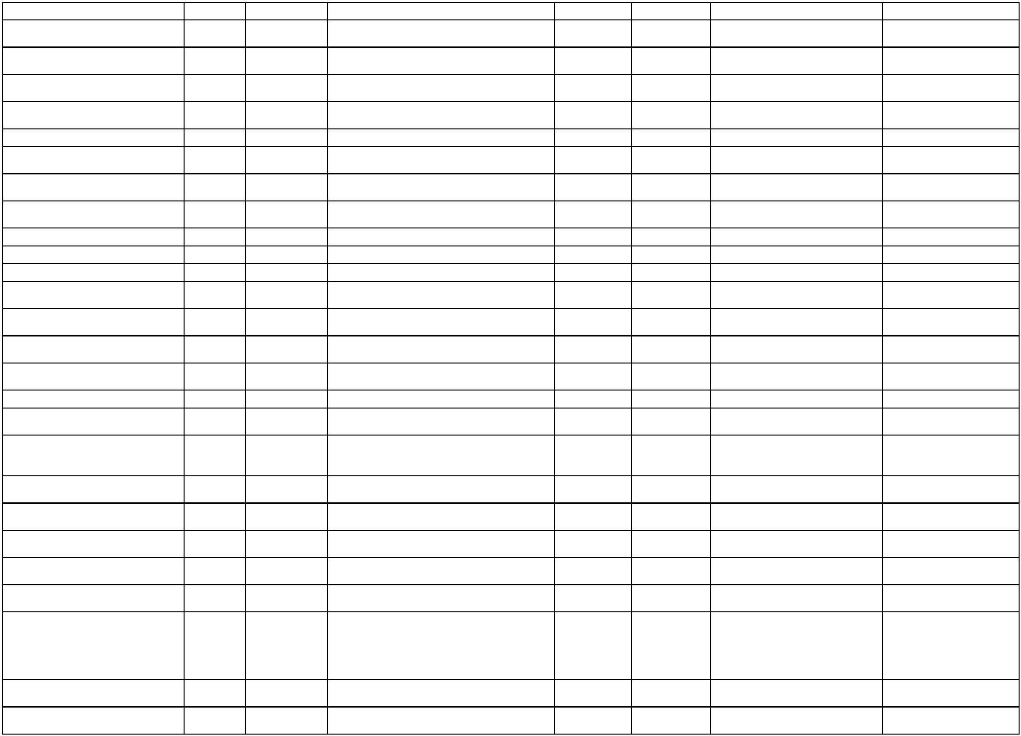

1
0/636/18020/13320/00000/0451
0/636/18020/13320/00000/0451
18020
18020
31/10/2025 TELEKOMI I KOSOVES SHA
31/10/2025 TELEKOMI I KOSOVES SHA
2025-206360 2025-423320 63625744 TELEFONIJA MOBILE
2025-206365 2025-423327 63625743 TELEFONIJA MOBILE
102.24
79.58
1
10/636/18020/14310/00000/0451
10/636/18020/13620/00000/0451
10/636/18020/14310/00000/0451
18020
18020
18020
31/10/2025 MORONICA E JUNIKUT SHPK
31/10/2025 ARDI J SHPK
2025-206382 2025-423340 63625740 DREKA ZYRTARE
2025-206369 2025-423349 63625742 ARDI-J SH.P.K
2025-206377 2025-423356 63625741 DREKA ZYRTARE
56.00
43.80
32.00
31/10/2025 MORONICA E JUNIKUT SHPK
6
3625268 SHERBIMET E
SHTYPJES/PRINTIMIT
3625286 KARBURANE PER
VETURA (DIESEL)
3625284 KARBURANE PER
VETURA (DIESEL)
3625266 KARBURANTE PER
VETURA (DIESEL)
3625266 KARBURANTE PER
VETURA (BENZIN0
3625251 MIREMBAJTIJA E
10/636/18020/13450/00000/0451
10/636/18020/13780/00000/0451
10/636/18020/13780/00000/0451
10/636/18020/13780/00000/0451
10/636/18020/13780/00000/0451
10/636/18020/14050/00000/0451
10/636/18020/13460/00000/0451
10/636/18020/13320/00000/0451
10/636/18020/14010/00000/0451
10/636/18020/14010/00000/0451
10/636/18020/13508/00000/0451
10/636/18020/14032/00000/0451
10/636/18020/13460/00000/0451
18020
18020
18020
18020
18020
18020
18020
18020
18020
18020
18020
18020
18020
17/11/2025 BURIM HAXHA BI
2025-208960 2025-459481
2025-217422 2025-459496
2025-217409 2025-459509
2025-208951 2025-475282
2025-208951 2025-475282
2025-212434 2025-475348
2025-145169 2025-475394
17.13
197.66
338.94
284.07
21.09
6
17/11/2025 PETROL COMPANY SHPK
17/11/2025 PETROL COMPANY SHPK
24/11/2025 PETROL COMPANY SHPK
24/11/2025 PETROL COMPANY SHPK
24/11/2025 ADEA FIBER SHPK
6
6
6
6
500.00
500.00
115.31
395.00
540.00
939.70
390.00
5,484.00
MOBILJEVE DHE PAJISJEVE
SHERBIME TJERA
KONTRAKTUESE
24/11/2025 XAJE MALOKU BI
24/11/2025 TELEKOMI I KOSOVES SHA
24/11/2025 SEFERI MONT SHPK
24/11/2025 SEFERI MONT SHPK
18/12/2025 TOREX GROUP LLC
18/12/2025 EURO GROUP RECYCLING SHPK
19/12/2025 ADHURIM HARAQIA B.I
2025-221466 2025-475405 63625836 TELEFONIJA MOBILE
6
3625292 MIREMBAJTIJA DHE
RIPARIMI I AUTOMJETEVE
3625293 MIREMBAJTIJA DHE
RIPARIMI I AUTOMJETEVE
2025-225724 2025-475430
2025-225760 2025-475442
6
2025-230001 2025-544848 63625302 PAJISJET E TRAFIKUT
6
3625287 MIREMBAJTIJA E
RRUGEVE LOKALE
3625279 SHERBIMET TJERA
2025-245108 2025-544915
2025-245275 2025-547949
6
KONTRAKTUESE
Zhivllim ekonomik
9,479.36
24.00
10/636/48020/13320/00000/0411
10/636/48020/13320/00000/0411
10/636/48020/13320/00000/0411
10/636/48020/14310/00000/0411
10/636/48020/14310/00000/0411
10/636/48020/13780/00000/0411
10/636/48020/13320/00000/0411
10/636/48020/13320/00000/0411
10/636/48020/14310/00000/0411
10/636/48020/13780/00000/0411
48020
48020
48020
48020
48020
48020
48020
48020
48020
48020
30/1/2025
24/2/2025
12/3/2025
12/3/2025
26/3/2025
14/4/2025
18/4/2025
26/5/2025
26/5/2025
12/6/2025
TELEKOMI I KOSOVES SHA
TELEKOMI I KOSOVES SHA
TELEKOMI I KOSOVES SHA
MORONICA E JUNIKUT SHPK
MORONICA E JUNIKUT SHPK
PETROL COMPANY SHPK
TELEKOMI I KOSOVES SHA
TELEKOMI I KOSOVES SHA
MORONICA E JUNIKUT SHPK
PETROL COMPANY SHPK
2025-4716
2025-4263
2025-36691
2025-57484
2025-60508
2025-79231
TELEFONIA MOBILE
TELEFONIA MOBILE
TELEFONIA MOBILE
DREKE ZYRTARE
DREKA ZYRTARE
2025-18646
2025-42905
2025-42994
2025-57583
2025-50330
2025-72102
2025-92550
2025-92541
2025-81586
24.00
24.00
49.00
360.00
110.82
34.00
2025-116849 DERIVATE PER VETURA
2025-127855 TELEFONIA MOBILE
2025-178842 TELEFONIA MOBILE
2025-178871 DREKA ZYRTARE
2025-203243 DERIVATE PER VETURA
ORGANIZIMI I FESTIVALIT DITET
32.00
26.50
61.04
10/636/48020/13460/00000/0411
10/636/48020/13320/00000/0411
10/636/48020/13445/00000/0411
48020
48020
48020
17/6/2025
9/7/2025
10/7/2025
SAMIR ZAJMI B.I
2025-114661 2025-210057
985.00
34.05
E GJERAVICES
TELEKOMI I KOSOVES SHA
LUARTA GJOTA
2025-116597 2025-234823 TELEFONIA MOBILE
SHER.E VEQANTA -
2025-135885 2025-245357
462.97
KONTRAKTOR INDIVIDUAL
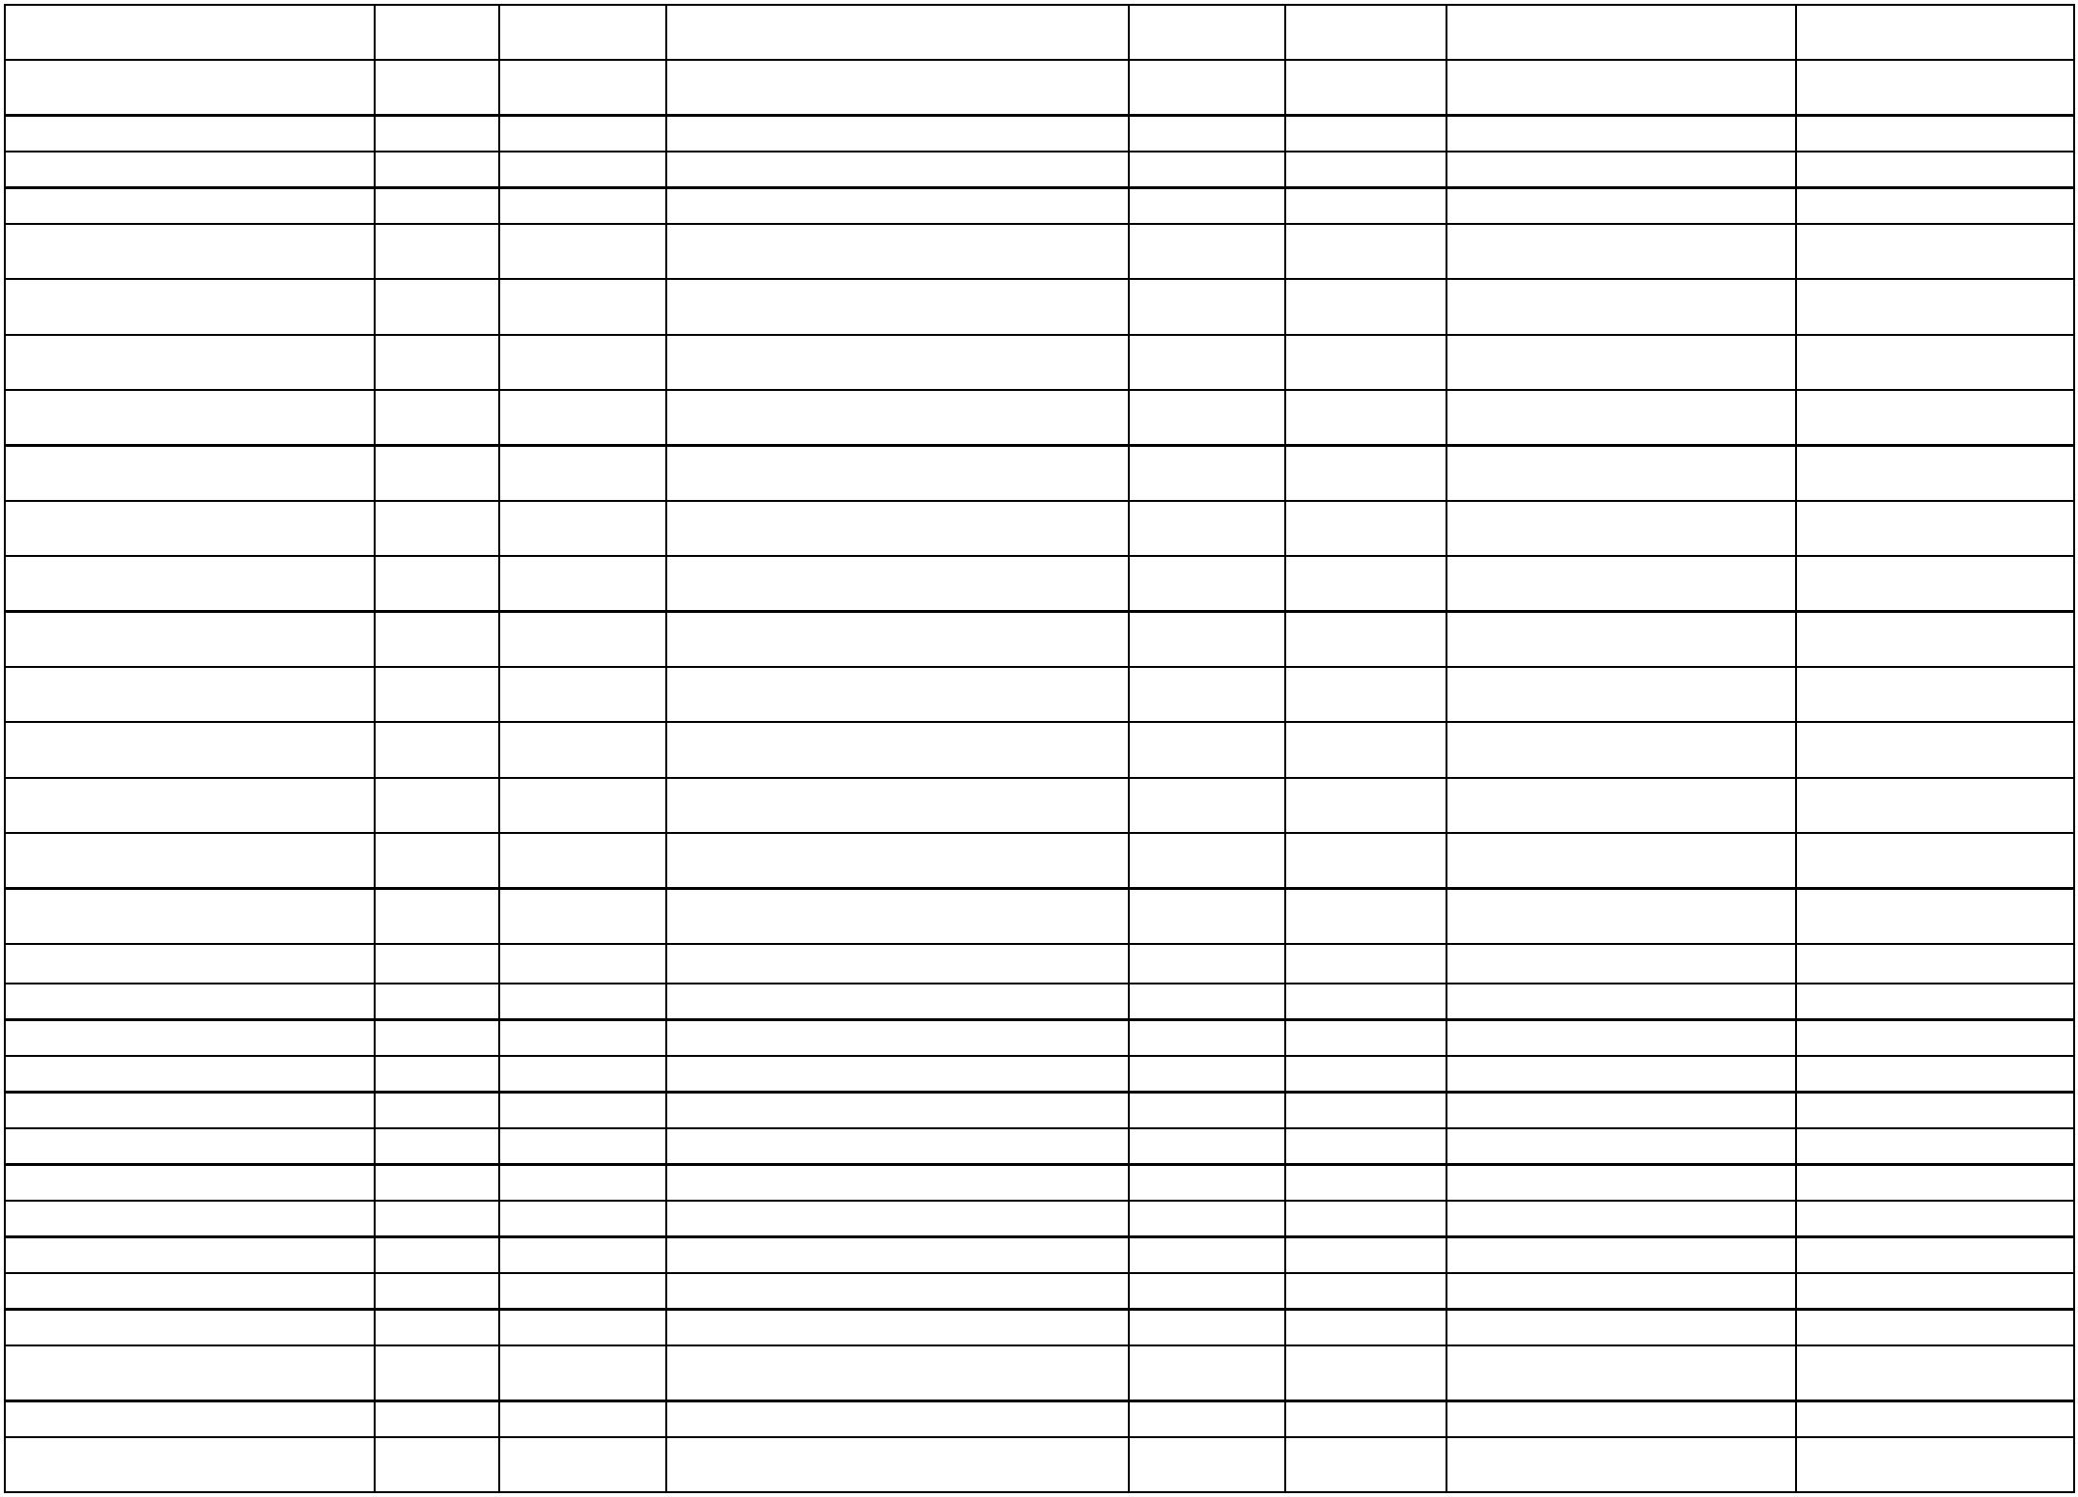

1
1
1
0/636/48020/13780/00000/0411
0/636/48020/13320/00000/0411
0/636/48020/13780/00000/0411
48020
48020
48020
21/7/2025
23/7/2025
30/7/2025
PETROL COMPANY SHPK
TELEKOMI I KOSOVES SHA
PETROL COMPANY SHPK
2025-138395 2025-260396 DERIVATE PER VETURA
2025-139589 2025-262390 TELEFONI MOBILE
78.64
32.00
52.34
2025-93148
2025-269754 DERIVATE PER VETURA
SHERBIMET E VEQANTA-
KONTRAKTORE
1
0/636/48020/13445/00000/0411
0/636/48020/13445/00000/0411
48020
48020
3/9/2025
3/9/2025
EDOLINDA KRASNIQI
LUARTA GJOTA
2025-168312 2025-334149
2025-168325 2025-334180
508.66
508.66
SHERBIMET E VEQANTA-
KONTRAKTORE
1
10/636/48020/13320/00000/0411
10/636/48020/13780/00000/0411
10/636/48020/13320/00000/0411
48020
48020
48020
11/9/2025
26/9/2025
26/9/2025
TELEKOMI I KOSOVES SHA
PETROL COMPANY SHPK
TELEKOMI I KOSOVES SHA
2025-163307 2025-343189 TELEFONIJA FIKSE
2025-128448 2025-362909 DERIVATE PER VETURA
2025-181794 2025-363222 63625620 VALA
36.00
38.03
42.49
6
3625674 SHPENZIMET E
VEQANTA KONTRAKTORE
3625663 SHPENZIMET E
VEQANTA KONTRAKTORE
3625661 SHPENZIMET E
VEQANTA KONTRAKTORE
3625660 SHPENZIMET E
VEQANTA KONTRAKTORE
1
1
1
0/636/48020/13445/00000/0411
0/636/48020/13445/00000/0411
0/636/48020/13445/00000/0411
48020
48020
48020
3/10/2025
3/10/2025
3/10/2025
3/10/2025
EDOLINDA KRASNIQI
LUARTA GJOTA
2025-188978 2025-380204
2025-189110 2025-380821
2025-189116 2025-380827
2025-189119 2025-380834
508.66
508.66
508.66
6
6
AJETE KUCI
6
10/636/48020/13445/00000/0411
10/636/48020/13503/00000/0411
10/636/48020/13450/00000/0411
48020
48020
48020
BLENDONA KRASNIQI
508.66
1,459.00
62.77
15/10/2025 ARITECH SHPK
15/10/2025 BURIM HAXHA BI
2025-146118 2025-394784 KOMPJUTERET
63625239 SHERBIMET E
SHTYPJE/PRINTIMIT
2025-187779 2025-394859
10/636/48020/13320/00000/0411
10/636/48020/13141/00000/0411
10/636/48020/13445/00000/0411
10/636/48020/13445/00000/0411
10/636/48020/13445/00000/0411
10/636/48020/13320/00000/0411
10/636/48020/13780/00000/0411
48020
48020
48020
48020
48020
48020
48020
27/10/2025 TELEKOMI I KOSOVES SHA
31/10/2025 FLORENTINA QESTAJ
2025-202656 2025-409141 63625719 TELEFONIJA MOBILE
36.00
178.00
508.66
508.66
508.66
41.29
6
3625746 MEDITJE PER
UDHETIME JASHTE VENDIT
3625782 SHERBIMET E
VEQANTA- KONTRAKTORE
3625783 SHERBIMET E
VEQANTA- KONTRAKTORE
3625784 SHERBIMET E
VEQANTA- KONTRAKTORE
2025-206454 2025-423021
2025-213647 2025-442659
2025-213638 2025-442666
2025-213634 2025-442673
6
6/11/2025
6/11/2025
6/11/2025
ENDRIT GJOTA
6
LIRIGEZON GOCAJ
FITESA BERISHA GACAFERI
6
26/11/2025 TELEKOMI I KOSOVES SHA
10/12/2025 PETROL COMPANY SHPK
2025-225578 2025-481246 63625866 TELEFONIJA MOBILE
2025-237278 2025-517924 63625310 DRIVATE PER VETURA
96.38
63625309 SHERBIMET/SHTYPJE
PRINTIM
10/636/48020/13450/00000/0411
48020
11/12/2025 BURIM HAXHA BI
2025-235109 2025-521579
59.80
1
0/636/48020/13320/00000/0411
0/636/48020/13951/00000/0411
48020
48020
18/12/2025 TELEKOMI I KOSOVES SHA
2025-245266 2025-544609 63625898 TELEFONIJA MOBILE
3625247 REGJISTRIMI DHE
40.01
6
SIGURIMI I AUTOMJETEVE
1
18/12/2025 KOMPANIA E SIGURIMEVE PRISIG SHA
2025-193973 2025-544821
421.29
Urbanizem
38,709.95
35.53
10/636/66405/13320/00000/0620
10/636/66405/13320/00000/0620
10/636/66405/13320/00000/0620
10/636/66405/13610/00000/0620
10/636/66405/13320/00000/0620
10/636/66405/13450/00000/0620
10/636/66405/13780/00000/0620
66405
66405
66405
66405
66405
66405
66405
27/1/2025
27/2/2025
12/3/2025
12/3/2025
25/4/2025
21/5/2025
23/5/2025
TELEKOMI I KOSOVES SHA
TELEKOMI I KOSOVES SHA
TELEKOMI I KOSOVES SHA
LETRA COM SHPK
2025-1828
2025-28892
2025-43020
2025-33966
2025-72091
2025-78305
2025-67206
2025-2040
2025-41462
2025-57497
2025-58042
TELEFONIA MOBILE
TELEFONIA MOBILE
TELEFONIA MOBILE
FURNIZIM PER ZYRE
32.04
34.88
207.20
32.18
TELEKOMI I KOSOVES SHA
BURIM HAXHA BI
2025-138930 TELEFONIA MOBILE
2025-173928 SHERBIME SHTYPJE/PRINTIMI
2025-177584 DERIVATE PER VETURA
109.61
63.21
PETROL COMPANY SHPK


1
0/636/66405/13320/00000/0620
0/636/66405/13440/00000/0620
66405
66405
26/5/2025
29/5/2025
TELEKOMI I KOSOVES SHA
VIZIONI B-SH.P.K
2025-91425
2025-178852 TELEFONIA MOBILE
HARTIMI I PROJEKTEVE IDEORE
32.00
1
2025-107151 2025-186297 DHE KRYESORE PER KOMUNEN
E JUNIKUT
13,100.00
1
1
1
1
0/636/66405/13320/00000/0620
0/636/66405/13445/00000/0620
0/636/66405/13320/00000/0620
0/636/66405/13440/00000/0620
66405
66405
66405
66405
10/7/2025
10/7/2025
24/7/2025
30/7/2025
TELEKOMI I KOSOVES SHA
SADIJE LOKAJ
2025-120717 2025-244661 TELEFONIA MOBILE
SHER.E VEQANTA -
32.25
462.97
32.00
2025-135830 2025-245227
KONTRAKTOR INDIVIDUAL
TELEKOMI I KOSOVES SHA
VIZIONI B-SH.P.K
2025-140241 2025-262725 TELEFONIA MOBILE
SHERBIME KESHILLDHENESE
2025-145245 2025-269015
2025-153207 2025-276294
2025-168301 2025-334140
5,443.39
DHE PROFESIONALE
SHER. TE VEQANTA
KONTRAKTORE
SHERBIMET E VEQANTA-
KONTRAKTORE
1
0/636/66405/13445/00000/0620
0/636/66405/13445/00000/0620
66405
66405
7/8/2025
3/9/2025
FITESA BERISHA GACAFERI
SADIJE LOKAJ
508.66
508.66
1
1
0/636/66405/13320/00000/0620
0/636/66405/13320/00000/0620
66405
66405
11/9/2025
26/9/2025
TELEKOMI I KOSOVES SHA
TELEKOMI I KOSOVES SHA
2025-163297 2025-343182 VALA
36.00
36.49
1
2025-181924 2025-362948 63625615 VALA
63625238 SHPENZIME
SHTYPJE/PRINTIMI
10/636/66405/13450/00000/0620
66405
15/10/2025 BURIM HAXHA BI
2025-184839 2025-394852
71.29
1
1
1
0/636/66405/13320/00000/0620
0/636/66405/14310/00000/0620
0/636/66405/13445/00000/0620
66405
66405
66405
27/10/2025 TELEKOMI I KOSOVES SHA
30/10/2025 MORONICA E JUNIKUT SHPK
2025-203896 2025-409137 63625732 TELEFONIJA MOBILE
36.00
71.00
2025-183564 2025-422768 63625644 DREKA ZYRTARE
6
3625780 SHERBIMET E
VEQANTA- KONTRAKTORE
3625781 SHERBIMET E
VEQANTA- KONTRAKTORE
6/11/2025
6/11/2025
FISNIK KUQI
2025-213659 2025-442649
2025-213655 2025-442653
391.10
6
10/636/66405/13445/00000/0620
66405
MUSA PEPSHI
391.10
1
0/636/66405/13460/00000/0620
0/636/66405/13460/00000/0620
66405
66405
6/11/2025
6/11/2025
TRUSTI PENSIONAL I KURSIMEVE
2025-212442 2025-442705 63625772 TRUSTI PENSIONAL
2025-212426 2025-442711 63625768 TATIMI NE BURIM
919.38
383.28
1
ADMINISTRATA TATIMORE E KOSOVES
10/636/66405/13320/00000/0620
10/636/66405/13445/00000/0620
10/636/66405/13445/00000/0620
10/636/66405/13445/00000/0620
10/636/66405/13445/00000/0620
10/636/66405/13445/00000/0620
66405
66405
66405
66405
66405
66405
26/11/2025 TELEKOMI I KOSOVES SHA
2025-223108 2025-481240 63625849 TELEFONIJA MOBILE
36.41
391.10
508.66
391.10
391.10
508.66
6
3625822 SHERBIMET E
VEQANTA -KONTRAKTOR
3625823 SHERBIMET E
VEQANTA -KONTRAKTOR
3625837 SHERBIMET E
VEQANTA -KONTRAKTOR
3625820 SHERBIMET E
VEQANTA -KONTRAKTOR
3625821 SHERBIMET E
VEQANTA -KONTRAKTOR
3/12/2025
3/12/2025
3/12/2025
3/12/2025
3/12/2025
FISNIK KUQI
2025-219688 2025-501628
2025-219680 2025-501748
2025-221509 2025-501802
2025-219724 2025-501820
2025-219717 2025-501838
6
FITESA BERISHA GACAFERI
BINAK QESTAJ
6
6
MUSA PEPSHI
6
LIRIGEZON GOCAJ
1
0/636/66405/13460/00000/0620
0/636/66405/13460/00000/0620
66405
66405
3/12/2025
3/12/2025
TRUSTI PENSIONAL I KURSIMEVE
2025-212436 2025-501865 63625771 TRUSTI PENSIONAL
2025-212407 2025-501877 63625770 TATIMI NE BURIM
919.38
383.28
1
ADMINISTRATA TATIMORE E KOSOVES
6
3625304 DERIVATE PER
VETURA
3625303 DERIVATE PER
VETURA
10/636/66405/13780/00000/0620
10/636/66405/13780/00000/0620
10/636/66405/13320/00000/0620
66405
66405
66405
10/12/2025 PETROL COMPANY SHPK
10/12/2025 PETROL COMPANY SHPK
11/12/2025 TELEKOMI I KOSOVES SHA
2025-230106 2025-517912
2025-230090 2025-517945
29.70
48.33
28.04
6
2025-245313 2025-521359 63625895 TELEFONIJA MOBILE
63625308 SHERBIMET/SHTYPJE
PRINTIM
10/636/66405/13450/00000/0620
66405
11/12/2025 BURIM HAXHA BI
2025-236092 2025-521523
131.35
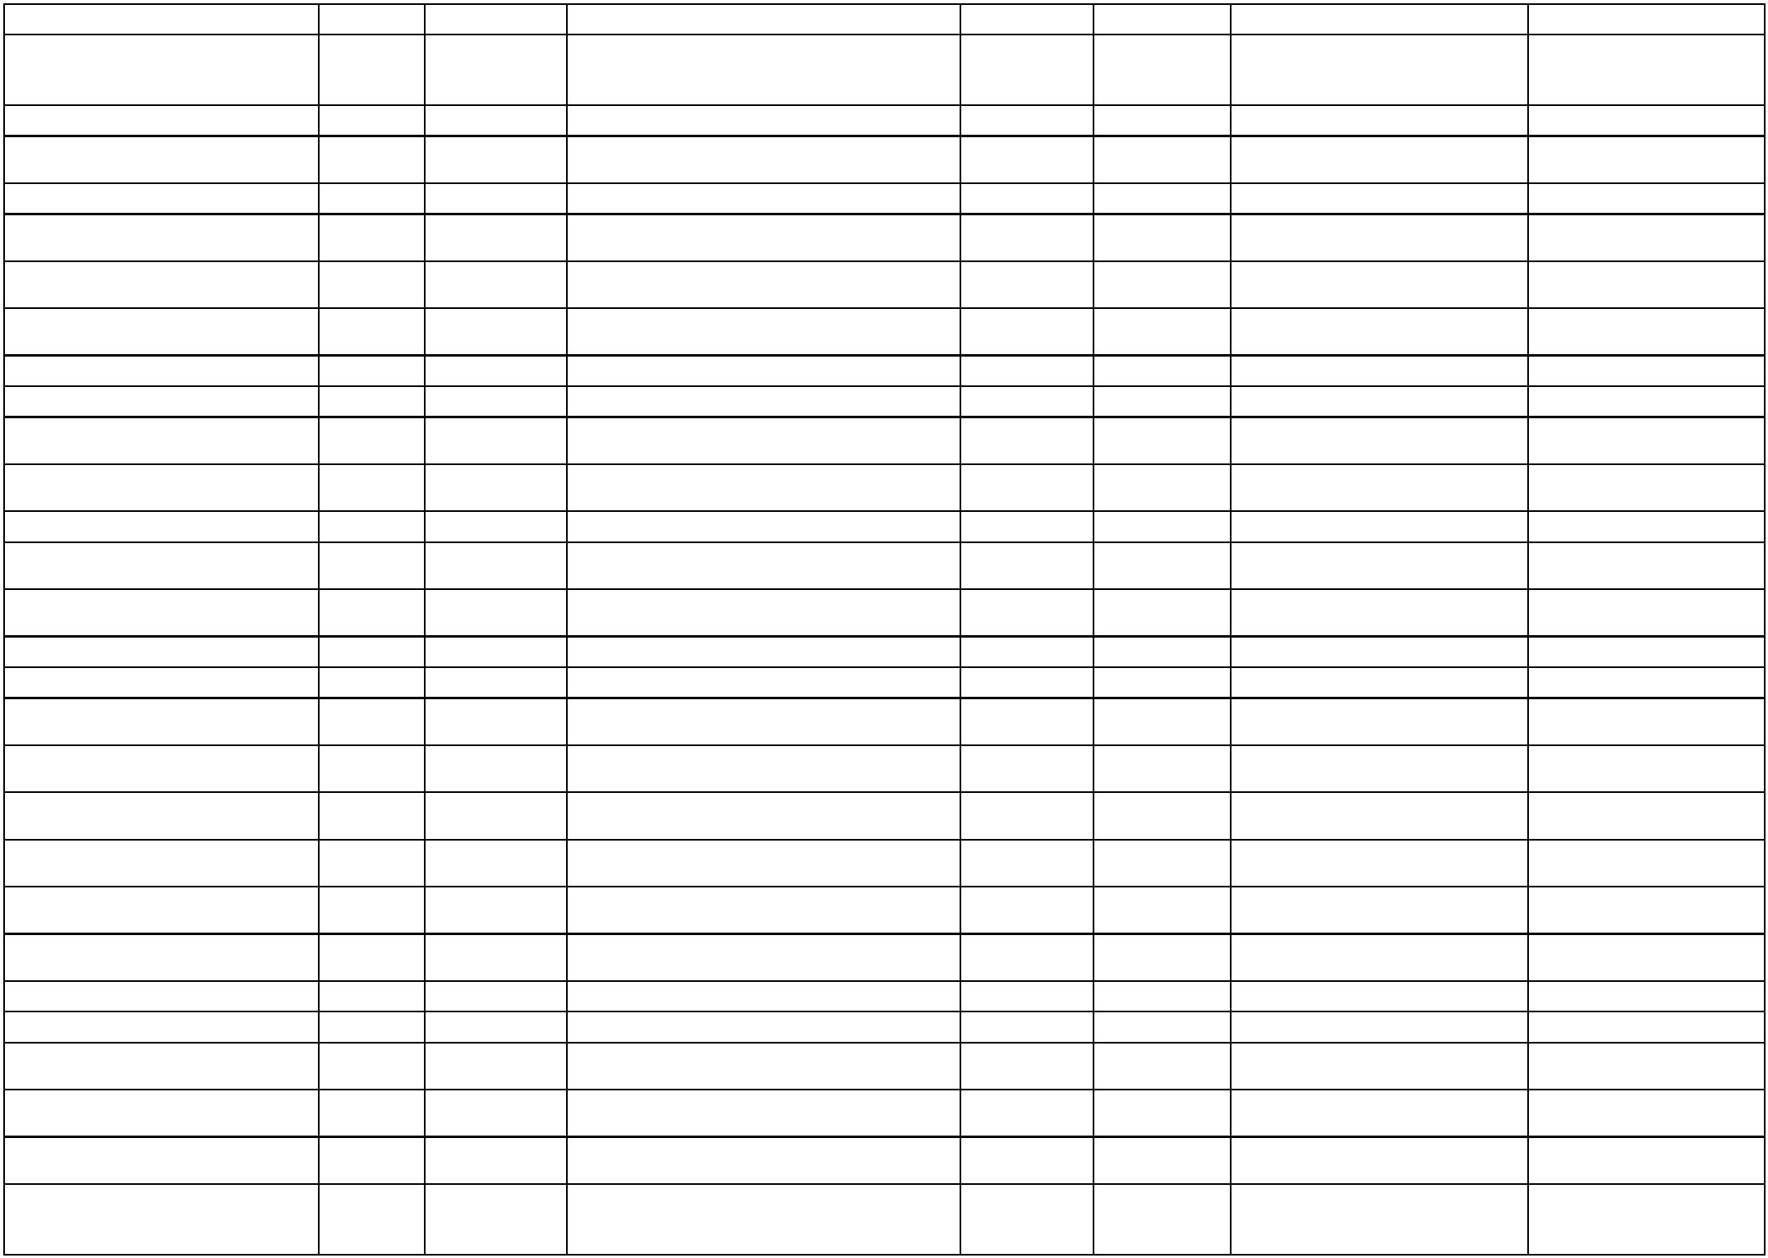

63625320 MIREMBAJTIJA DHE
RIPARIMI I AUTOMJETEVE
10/636/66405/14010/00000/0620
66405
18/12/2025 SEFERI MONT SHPK
2025-237188 2025-544646
280.00
1
0/636/66405/13460/00000/0620
0/636/66405/13460/00000/0620
66405
66405
23/12/2025 ADMINISTRATA TATIMORE E KOSOVES
23/12/2025 TRUSTI PENSIONAL I KURSIMEVE
2025-212416 2025-551716 63625769 TATIMI NE BURIM
2025-212429 2025-551748 63625773 TRUSTI PENSIONAL
383.28
919.38
1
HARTIMI I PROJEKTEVE IDEORE
2025-107151 2025-186297 DHE KRYESORE PER KOMUNEN
E JUNIKUT
2
2/636/66405/13440/00000/0620
66405
29/5/2025
29/7/2025
VIZIONI B-SH.P.K
10,219.88
2
2/636/66405/13780/00000/0620
2/636/66405/13320/00000/0620
66405
66405
PETROL COMPANY SHPK
2025-134361 2025-267945 DERIVATE PER VETURA
31.04
59.67
2
11/12/2025 TELEKOMI I KOSOVES SHA
15/12/2025 ARDI J SHPK
2025-245313 2025-521359 63625895 TELEFONIJA MOBILE
6
3625328 FURNIZIMET E
PASTRIMIT
3625329 SHPENZIMET E
2
2/636/66405/13640/00000/0620
2/636/66405/13450/00000/0620
66405
66405
2025-248740 2025-529137
2025-248770 2025-544673
45.00
34.37
6
2
18/12/2025 BURIM HAXHA BI
PRINTIMIT
Admin. Shendetsi
3,171.85
10/636/73029/13320/00000/0760
10/636/73029/13320/00000/0760
10/636/73029/13630/00000/0760
10/636/73029/14050/00000/0760
10/636/73029/13445/00000/0760
10/636/73029/13780/00000/0760
10/636/73029/13780/00000/0760
10/636/73029/14010/00000/0760
10/636/73029/13320/00000/0760
73029
73029
73029
73029
73029
73029
73029
73029
73029
12/3/2025
26/5/2025
9/7/2025
TELEKOMI I KOSOVES SHA
TELEKOMI I KOSOVES SHA
BRT PHARM SH.P.K.
2025-43110
2025-90285
2025-57480
TELEFONIA MOBILE
41.78
2025-178831 TELEFONIA MOBILE
34.76
1,405.00
450.00
508.66
261.35
154.94
280.00
35.36
2025-111761 2025-234543 Frunizime Mjeksore QKMF Junik
MIREMBAJTJA E MOBILEVE DHE
30/7/2025
3/10/2025
PRO MEDICAL SHPK
2025-128645 2025-269589
2025-189027 2025-380797
2025-211072 2025-459491
2025-211068 2025-474915
2025-231604 2025-517972
PAJISJEVE
36256769 SHPENZIMET E
VEQANTA KONTRAKTORE
3625277 DERIVATE PER
VETURA
3625276 DERIVATE PER
VETURA
3625303 MIREMBAJTA DHE
RIPARIMI I AUTOMJETEVE
6
ELDION KRASNIQI
6
17/11/2025 PETROL COMPANY SHPK
24/11/2025 PETROL COMPANY SHPK
10/12/2025 SEFERI MONT SHPK
6
6
11/12/2025 TELEKOMI I KOSOVES SHA
2025-245541 2025-521287 63625892 TELEFONIJA MOBILE
QKMF
77,080.86
SHERB. VEQ. KONS. DHE KONT.
INDV.
10/636/74200/13445/00000/0721
74200
22/1/2025
KOSOVAMED HEALTHCARE SHPK
2025-1107
2025-571
4,500.00
SHERB. VEQ. KONS. DHE KONT.
INDV.
10/636/74200/13445/00000/0721
10/636/74200/13320/00000/0721
10/636/74200/13445/00000/0721
74200
74200
74200
22/1/2025
30/1/2025
11/2/2025
KOSOVAMED HEALTHCARE SHPK
TELEKOMI I KOSOVES SHA
2025-1067
2025-5948
2025-12725
2025-572
4,140.00
32.10
2025-4390
2025-26328
TELEFONIA MOBILE
SHERB. VEQ. KONS. KONT.
INDV.
KOSOVAMED HEALTHCARE SHPK
3,730.00
SHERB. VEQ. KONS. KONT.
INDV.
10/636/74200/13445/00000/0721
10/636/74200/13780/00000/0721
10/636/74200/13320/00000/0721
10/636/74200/13630/00000/0721
10/636/74200/13640/00000/0721
10/636/74200/13780/00000/0721
10/636/74200/13720/00000/0721
74200
74200
74200
74200
74200
74200
74200
12/2/2025
24/2/2025
24/2/2025
26/2/2025
26/2/2025
28/2/2025
5/3/2025
KOSOVAMED HEALTHCARE SHPK
PETROL COMPANY SHPK
TELEKOMI I KOSOVES SHA
BRT PHARM SH.P.K.
2025-12710
2025-17443
2025-18723
2025-21212
2025-31204
2025-33607
2025-31631
2025-27783
2025-37262
2025-37271
2025-40083
2025-40489
2025-44353
2025-50121
4,500.00
198.36
32.00
DERIVATE PER VETURA
TELEFONIA MOBILE
FURNIZIME MJEKESORE
FURNIZIME PASTRIMI
849.50
295.50
160.69
4,166.05
SHAIP MUSTAFA BI
PETROL COMPANY SHPK
PETROL COMPANY SHPK
10/636/93571/13230/00000/0912
NAFTE PER NGROHJE
QENDRORE
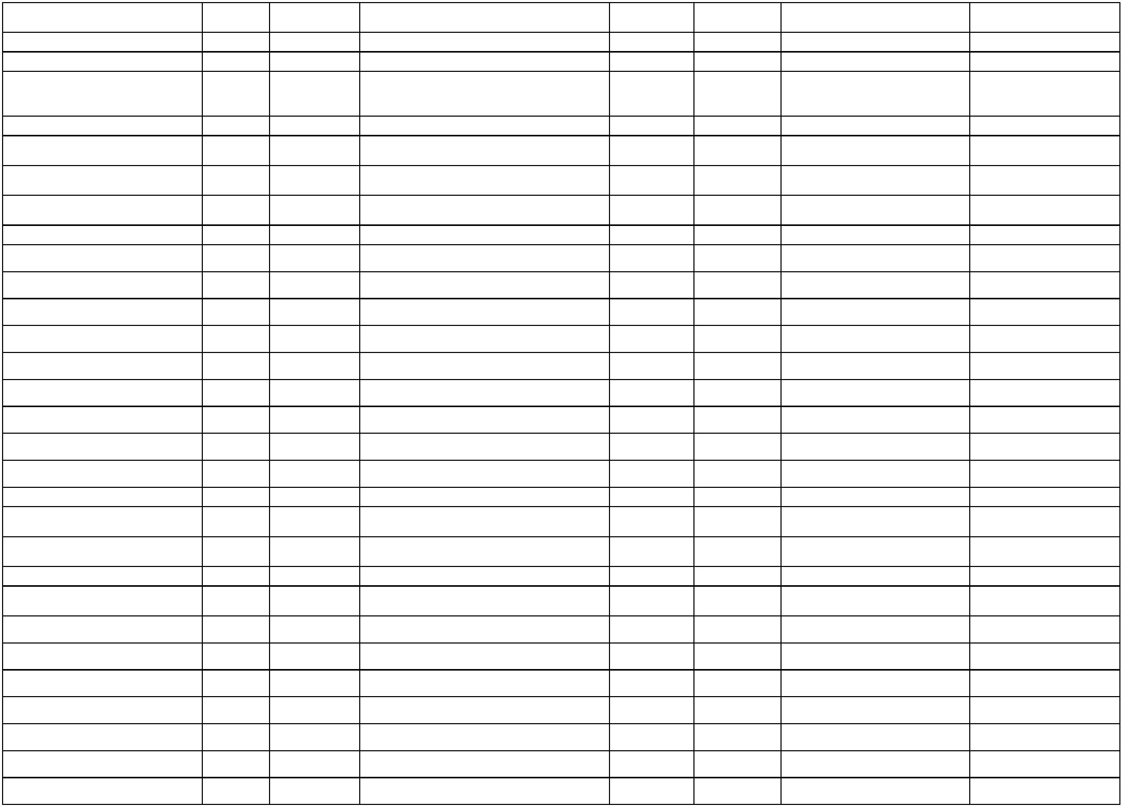

10/636/74200/13640/00000/0721
10/636/74200/13445/00000/0721
10/636/74200/13445/00000/0721
10/636/74200/13445/00000/0721
10/636/74200/13780/00000/0721
10/636/74200/13320/00000/0721
10/636/74200/13445/00000/0721
10/636/74200/13450/00000/0721
10/636/74200/13445/00000/0721
10/636/74200/13610/00000/0721
10/636/74200/13780/00000/0721
10/636/74200/13630/00000/0721
10/636/74200/13320/00000/0721
10/636/74200/13445/00000/0721
10/636/74200/13445/00000/0721
10/636/74200/13445/00000/0721
10/636/74200/13445/00000/0721
10/636/74200/13445/00000/0721
10/636/74200/13445/00000/0721
10/636/74200/13445/00000/0721
10/636/74200/13445/00000/0721
10/636/74200/13320/00000/0721
10/636/74200/13780/00000/0721
10/636/74200/14050/00000/0721
10/636/74200/13780/00000/0721
10/636/74200/13445/00000/0721
10/636/74200/13445/00000/0721
10/636/74200/13445/00000/0721
10/636/74200/13445/00000/0721
10/636/74200/13445/00000/0721
74200
74200
74200
74200
74200
74200
74200
74200
74200
74200
74200
74200
74200
74200
74200
74200
74200
74200
74200
74200
74200
74200
74200
74200
74200
74200
74200
74200
74200
74200
7/3/2025
21/3/2025
3/4/2025
SHAIP MUSTAFA BI
2025-34107
2025-54000
2025-53987
2025-64927
2025-50317
2025-72125
2025-87240
2025-78211
2025-52917
2025-75197
2025-94682
2025-110175
FURNIZIME PASTRIMI
675.80
2,371.60
4,850.00
7,438.80
70.73
SHERB. TE VEQ. KON. DHE
KONT. INDV.
SHERB. TE VEQ. KON. DHE
KONT. INDV.
SHERB. E VEQ. KON. DHE KONT.
INDIV.
KOSOVAMED HEALTHCARE SHPK
KOSOVAMED HEALTHCARE SHPK
KOSOVAMED HEALTHCARE SHPK
PETROL COMPANY SHPK
TELEKOMI I KOSOVES SHA
KOSOVAMED HEALTHCARE SHPK
BURIM HAXHA BI
11/4/2025
14/4/2025
18/4/2025
7/5/2025
2025-116833 DERIVATE PER VETURA
2025-127849 TELEFONIA MOBILE
SHERBIME TE VEQ. KONS. DHE
KONT. INDV.
40.93
2025-157029
7,370.00
365.26
7,617.50
950.00
170.92
1,316.00
38.13
21/5/2025
5/6/2025
2025-173829 SHERBIME SHTYPJE/PRINTIMI
sherbime te veqanta konst dhe
kontraktor indi.
KOSOVAMED HEALTHCARE SHPK
AGIMI DE SHPK
2025-109450 2025-197748
10/6/2025
12/6/2025
9/7/2025
2025-47162
2025-81556
2025-200163 FURNIZIME PER ZYRE
PETROL COMPANY SHPK
BRT PHARM SH.P.K.
2025-203255 DERIVATE PER VETURA
2025-111790 2025-234581 Frunizime Mjeksore QKMF Junik
10/7/2025
10/7/2025
10/7/2025
10/7/2025
10/7/2025
10/7/2025
10/7/2025
10/7/2025
10/7/2025
21/7/2025
21/7/2025
30/7/2025
30/7/2025
6/8/2025
TELEKOMI I KOSOVES SHA
LIRIGEZON GOCAJ
2025-116595 2025-244659 TELEFONIA MOBILE
SHERBIME TE VEQANTA -
2025-136138 2025-245196
2025-135789 2025-245242
2025-136023 2025-245247
2025-135890 2025-245254
2025-135897 2025-245259
2025-135903 2025-245328
2025-136082 2025-245346
2025-135882 2025-245350
462.97
462.97
462.97
462.97
355.76
355.76
462.97
462.97
38.13
KONTRAKTOR INDIVIDUAL
SHER.E VEQANTA -
KONTRAKTOR INDIVIDUAL
SHER.E VEQANTA -
KONTRAKTOR INDIVIDUAL
SHER.E VEQANTA -
KONTRAKTOR INDIVIDUAL
SHER.E VEQANTA -
KONTRAKTOR INDIVIDUAL
SHER.E VEQANTA -
KONTRAKTOR INDIVIDUAL
SHER.E VEQANTA -
KONTRAKTOR INDIVIDUAL
SHER.E VEQANTA -
KONTRAKTOR INDIVIDUAL
FITESA BERISHA GACAFERI
BLENDONA KRASNIQI
AJETE KUCI
MUSA PEPSHI
FISNIK KUQI
ENDRIT GJOTA
EDOLINDA KRASNIQI
TELEKOMI I KOSOVES SHA
PETROL COMPANY SHPK
PRO MEDICAL SHPK
PETROL COMPANY SHPK
DORUNTINA FETAJ
2025-139520 2025-260370 TELEFONI MOBILE
2025-122894 2025-260482 DERIVATE PER VETURA
57.95
MIREMBJATJA E MOBILEVE DHE
PAJISJEVE
2025-146508 2025-269611
1,227.00
70.81
2025-149438 2025-269781 DERIVATE PER VETURA
SHER. TE VEQANTA
KONTRAKTORE
2025-152951 2025-275957
2025-153009 2025-276251
2025-153019 2025-276260
2025-153016 2025-276266
2025-153023 2025-276274
508.66
508.66
508.66
508.66
391.10
SHER. TE VEQANTA
KONTRAKTORE
7/8/2025
ENDRIT GJOTA
SHER. TE VEQANTA
KONTRAKTORE
SHER. TE VEQANTA
KONTRAKTORE
SHER. TE VEQANTA
KONTRAKTORE
7/8/2025
EDOLINDA KRASNIQI
LUARTA GJOTA
7/8/2025
7/8/2025
FISNIK KUQI
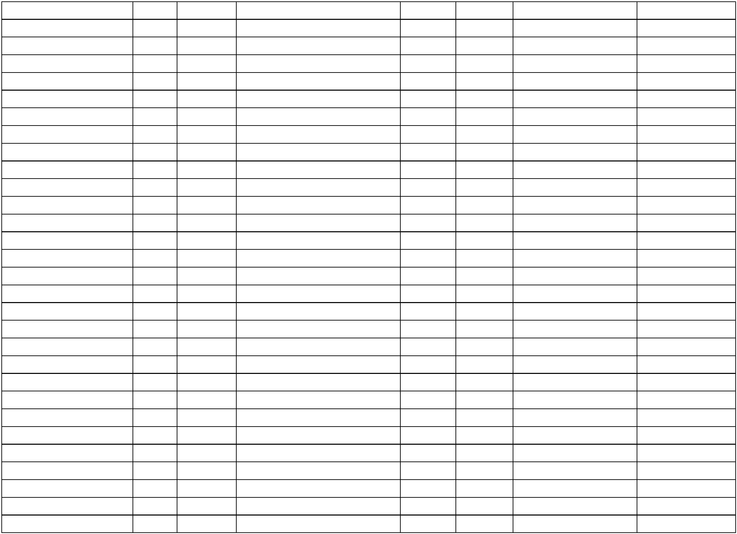

SHER. TE VEQANTA
KONTRAKTORE
SHER. TE VEQANTA
10/636/74200/13445/00000/0721
10/636/74200/13445/00000/0721
10/636/74200/13445/00000/0721
10/636/74200/13445/00000/0721
10/636/74200/13445/00000/0721
10/636/74200/13445/00000/0721
10/636/74200/13445/00000/0721
10/636/74200/13440/00000/0721
10/636/74200/13445/00000/0721
10/636/74200/13445/00000/0721
10/636/74200/13445/00000/0721
10/636/74200/13445/00000/0721
10/636/74200/13445/00000/0721
10/636/74200/13445/00000/0721
10/636/74200/13430/00000/0721
10/636/74200/13320/00000/0721
10/636/74200/13951/00000/0721
10/636/74200/13320/00000/0721
10/636/74200/13630/00000/0721
10/636/74200/14310/00000/0721
10/636/74200/13320/00000/0721
10/636/74200/13780/00000/0721
10/636/74200/14010/00000/0721
10/636/74200/13630/00000/0721
21/636/74200/13445/00000/0721
21/636/74200/13445/00000/0721
21/636/74200/13445/00000/0721
21/636/74200/13445/00000/0721
21/636/74200/13445/00000/0721
21/636/74200/13445/00000/0721
74200
74200
74200
74200
74200
74200
74200
74200
74200
74200
74200
74200
74200
74200
74200
74200
74200
74200
74200
74200
74200
74200
74200
74200
74200
74200
74200
74200
74200
74200
7/8/2025
7/8/2025
7/8/2025
3/9/2025
3/9/2025
3/9/2025
3/9/2025
3/9/2025
3/9/2025
3/9/2025
3/9/2025
3/10/2025
3/10/2025
3/10/2025
AJETE KUCI
2025-152985 2025-276307
2025-152996 2025-276314
2025-153201 2025-276339
2025-168239 2025-334067
2025-168226 2025-334631
2025-168219 2025-334638
2025-168210 2025-334718
2025-168190 2025-334727
2025-168198 2025-334733
2025-168205 2025-334740
2025-168181 2025-334814
2025-189091 2025-380210
2025-188998 2025-380668
2025-189002 2025-380736
2025-185790 2025-386429
508.66
508.66
508.66
508.66
508.66
508.66
391.10
508.66
391.10
508.66
508.66
508.66
508.66
508.66
245.00
39.46
BLENDONA KRASNIQI
LIRIGEZON GOCAJ
BLENDONA KRASNIQI
ENDRIT GJOTA
KONTRAKTORE
SHER. TE VEQANTA
KONTRAKTORE
SHERBIMET E VEQANTA-
KONTRAKTORE
SHERBIMET E VEQANTA-
KONTRAKTORE
SHERBIMET E VEQANTA-
AJETE KUCI
KONTRAKTORE
SHERBIMET E VEQANTA-
KONTRAKTORE
SHERBIMET E VEQANTA-
MUSA PEPSHI
LIRIGEZON GOCAJ
FISNIK KUQI
KONTRAKTORE
SHERBIMET E VEQANTA-
KONTRAKTORE
SHERBIMET E VEQANTA-
KONTRAKTORE
SHERBIMET E VEQANTA-
KONTRAKTORE
DORUNTINA FETAJ
FITESA BERISHA GACAFERI
ENDRIT GJOTA
6
3625664 SHPENZIMET E
VEQANTA KONTRAKTORE
3625672 SHPENZIMET E
VEQANTA KONTRAKTORE
3625671 SHPENZIMET E
VEQANTA KONTRAKTORE
3625646 SHERBIME TE
NDRRYSHME SHENDETSORE
6
LIRIGEZON GOCAJ
FITESA BERISHA GACAFERI
6
6
10/10/2025 SHERBIMI SPITALOR KLINIK I KOSOVES
15/10/2025 TELEKOMI I KOSOVES SHA
15/10/2025 KOMPANIA E SIGURIMEVE PRISIG SHA
27/10/2025 TELEKOMI I KOSOVES SHA
27/10/2025 BRT PHARM SH.P.K.
2025-187482 2025-394746 636325651 TELEFONIJA MOBILE
REXHISTRIMI DHE SIGURIMI I
AUTOMJETEVE
2025-163197 2025-394767
340.60
32.46
2025-203684 2025-409152 63625730 TELEFONIJA MOBILE
2025-203584 2025-410170 63625253 FURNIZIME MJEKSORE
2025-206468 2025-459362 63625747 DREKA ZYRTARE
2025-170008 2025-459385 VALA MOBIL
747.50
21.00
17/11/2025 SOKOL GAXHERRI BI
17/11/2025 TELEKOMI I KOSOVES SHA
10/12/2025 PETROL COMPANY SHPK
10/12/2025 SEFERI MONT SHPK
74.09
6
3625307 DERIVATE PER
VETURA
3625296 MIREMBAJTIJA DHE
RIPARIMI I AUTOMJETEVE
2025-231622 2025-517957
2025-229290 2025-517979
48.19
6
196.00
175.00
508.66
508.66
508.66
508.66
508.66
508.66
18/12/2025 BRT PHARM SH.P.K.
2025-234204 2025-544810 63625321 FURNIZIME MJEKSORE
3625826 SHERBIMET E
VEQANTA -KONTRAKTOR
6
3/12/2025
3/12/2025
3/12/2025
3/12/2025
3/12/2025
3/12/2025
DORUNTINA FETAJ
ELDION KRASNIQI
SAFETE POZHARI
FORTESA GACAFERI
EDOLINDA KRASNIQI
SADIJE LOKAJ
2025-219643 2025-501642
2025-219611 2025-501652
2025-219663 2025-501673
2025-219657 2025-501701
2025-219633 2025-501712
2025-219602 2025-501737
6
3625830 SHERBIMET E
VEQANTA -KONTRAKTOR
3625823 SHERBIMET E
VEQANTA -KONTRAKTOR
3625824 SHERBIMET E
VEQANTA -KONTRAKTOR
3625827 SHERBIMET E
VEQANTA -KONTRAKTOR
3625831 SHERBIMET E
VEQANTA -KONTRAKTOR
6
6
6
6

6
3625828 SHERBIMET E
VEQANTA -KONTRAKTOR
3625829 SHERBIMET E
VEQANTA -KONTRAKTOR
3625836 SHERBIMET E
VEQANTA -KONTRAKTOR
3625825 SHERBIMET E
21/636/74200/13445/00000/0721
21/636/74200/13445/00000/0721
21/636/74200/13445/00000/0721
21/636/74200/13445/00000/0721
74200
74200
74200
74200
3/12/2025
3/12/2025
3/12/2025
3/12/2025
LUARTA GJOTA
AJETE KUCI
2025-219626 2025-501758
2025-219621 2025-501796
2025-219731 2025-501813
2025-219648 2025-501827
508.66
508.66
508.66
508.66
6
6
ENDRIT GJOTA
SHQIPE QALLAKU
6
VEQANTA -KONTRAKTOR
Sociali
2,498.25
USHQIM DHE PIJE JO DREKA
ZYRTARE
SHERB. E VEQ. KON. DHE KONT.
INDIV.
1
1
1
1
1
1
0/636/75596/13620/00000/1040
0/636/75596/13445/00000/1040
0/636/75596/13445/00000/1040
0/636/75596/13445/00000/1040
0/636/75596/13445/00000/1040
0/636/75596/13780/00000/1040
75596
75596
75596
75596
75596
75596
7/3/2025
11/4/2025
3/10/2025
3/10/2025
3/10/2025
ARDI J SHPK
2025-36891
2025-64942
2025-52900
40.20
KOSOVAMED HEALTHCARE SHPK
MUSA PEPSHI
2025-110268
650.00
391.10
391.10
391.10
85.00
6
3625670 SHPENZIMET E
VEQANTA KONTRAKTORE
36256768 SHPENZIMET E
VEQANTA KONTRAKTORE
3625663 SHPENZIMET E
VEQANTA KONTRAKTORE
3625274 DERIVATE PER
VETURA
3625275 DERIVATE PER
VETURA
2025-189011 2025-380790
2025-189036 2025-380808
2025-189100 2025-380814
2025-211063 2025-474843
2025-211049 2025-474855
6
BINAK QESTAJ
6
FISNIK KUQI
6
24/11/2025 PETROL COMPANY SHPK
6
10/636/75596/13780/00000/1040
10/636/75596/13320/00000/1040
10/636/75596/13630/00000/1040
75596
75596
75596
24/11/2025 PETROL COMPANY SHPK
10/12/2025 TELEKOMI I KOSOVES SHA
18/12/2025 BRT PHARM SH.P.K.
149.87
43.88
2025-228287 2025-518170 63625840 VALA
2025-234233 2025-544771 63625322 FURNIZIME MJEKSORE
356.00
Admin. Arsim
4,795.84
188.10
55.67
10/636/92100/13780/00000/0980
10/636/92100/13320/00000/0980
10/636/92100/13320/00000/0980
92100
92100
92100
26/2/2025
27/2/2025
27/2/2025
PETROL COMPANY SHPK
TELEKOMI I KOSOVES SHA
TELEKOMI I KOSOVES SHA
2025-30528
2025-29409
2025-29405
2025-40851
2025-41474
2025-41477
DERIVATE PER VETURA
TELEFONIA MOBILE
TELEFONIA MOBILE
67.60
USHQIM DHE PIJE JO DREKA
ZYRTARE
USHQIM DHE PIJE JO DREKA
ZYRTARE
1
0/636/92100/13620/00000/0980
0/636/92100/13620/00000/0980
92100
92100
27/2/2025
27/2/2025
ARDI J SHPK
ARDI J SHPK
2025-29328
2025-29336
2025-41485
2025-41487
30.51
83.53
1
10/636/92100/13320/00000/0980
10/636/92100/13610/00000/0980
10/636/92100/13810/00000/0980
10/636/92100/13320/00000/0980
92100
92100
92100
92100
12/3/2025
12/3/2025
4/4/2025
TELEKOMI I KOSOVES SHA
LETRA COM SHPK
2025-43791
2025-31985
2025-51189
2025-72060
2025-57449
2025-58149
2025-96218
TELEFONIA MOBILE
FURNIZIME PER ZYRE
HAPJE E PETTY CASH
63.27
372.96
250.00
69.62
PETTY CASH - JUNIK
18/4/2025
TELEKOMI I KOSOVES SHA
2025-127872 TELEFONIA MOBILE
MBYLLJE E PETTY CASHIT-
KTHIM I MJETEVE NGA BANKA
SHERBIMET E
SHTYPJES/PRINTIMIT
1
0/636/92100/13810/00000/0980
0/636/92100/13450/00000/0980
92100
92100
7/5/2025
PETTY CASH - JUNIK
BURIM HAXHA BI
2025-157188
2025-173879
-250.00
112.35
1
21/5/2025
2025-78196
1
1
1
1
0/636/92100/13780/00000/0980
0/636/92100/13780/00000/0980
0/636/92100/13320/00000/0980
0/636/92100/13810/00000/0980
92100
92100
92100
92100
23/5/2025
23/5/2025
26/5/2025
27/5/2025
PETROL COMPANY SHPK
PETROL COMPANY SHPK
TELEKOMI I KOSOVES SHA
PETTY CASH - JUNIK
2025-67225
2025-67225
2025-90453
2025-177586 DERIVATE (DIESEL)
2025-177586 DERIVATE (BENZIN)
2025-178863 TELEFONIA MOBILE
58.95
34.11
53.42
2025-102814 2025-180402 PETTY CASH HAPJE
USHQIM DHE PIJE JO DREKA
ZYRTARE
250.00
10/636/92100/13620/00000/0980
92100
29/5/2025
ARDI J SHPK
2025-103382 2025-185758
25.20
1
0/636/92100/14310/00000/0980
0/636/92100/14310/00000/0980
92100
92100
29/5/2025
29/5/2025
SOKOL GAXHERRI BI
SOKOL GAXHERRI BI
2025-103253 2025-185763 DREKA ZYRTARE
2025-103262 2025-185776 DREKA ZYRTARE
29.60
66.00
1
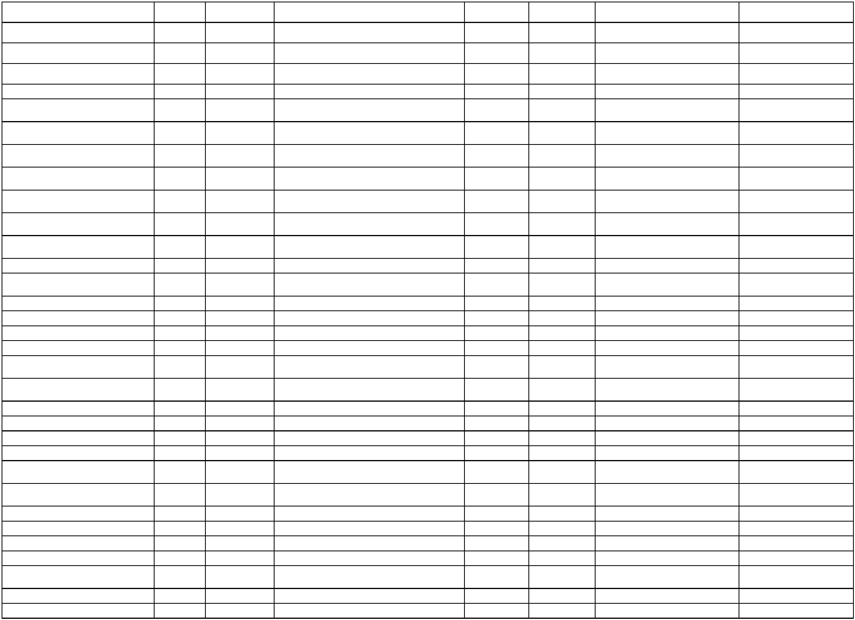

USHQIM DHE PIJE JO DREKA
ZYRTARE
10/636/92100/13620/00000/0980
10/636/92100/13509/00000/0980
10/636/92100/14050/00000/0980
10/636/92100/13780/00000/0980
10/636/92100/13810/00000/0980
92100
92100
92100
92100
92100
29/5/2025
4/6/2025
12/6/2025
9/7/2025
10/7/2025
ARDI J SHPK
2025-103278 2025-185814
59.28
642.00
311.00
41.07
AGIMI DE SHPK
2025-109511 2025-196955 PAISJE TJERA
kontrolli servisimi dhe mbushja e
aparateve kunder zjarrit
MURAT ABAZI BI
2025-110678 2025-203282
PETROL COMPANY SHPK
PETTY CASH - JUNIK
2025-125941 2025-234704 DERIVATE PER VETURA
MBYLLJE E PETTY CASHIT-
KTHIM I MJETEVE NGA BANKA
2025-244697
-250.00
1
1
1
0/636/92100/13320/00000/0980
0/636/92100/13810/00000/0980
0/636/92100/13320/00000/0980
92100
92100
92100
10/7/2025
18/7/2025
25/7/2025
TELEKOMI I KOSOVES SHA
PETTY CASH - JUNIK
2025-124924 2025-245700 TELEFONIA MOBILE
2025-255716 KTHIM I MJETEVE
59.19
0.00
TELEKOMI I KOSOVES SHA
2025-145149 2025-264666 TELEFONIA MOBILE
DERIVATE PER VETURA
(DIESEL)
60.66
10/636/92100/13780/00000/0980
10/636/92100/13780/00000/0980
10/636/92100/13780/00000/0980
92100
92100
92100
31/7/2025
31/7/2025
9/9/2025
PETROL COMPANY SHPK
PETROL COMPANY SHPK
PETROL COMPANY SHPK
2025-147494 2025-270533
2025-147494 2025-270533
2025-126024 2025-341231
2025-126024 2025-341231
130.73
32.05
DERIVATE PER VETURA
(BENZIN)
DERIVATE PER VETURA
(DIESEL)
DERIVATE PER VETURA
(BENZIN)
324.51
10/636/92100/13780/00000/0980
10/636/92100/13320/00000/0980
10/636/92100/13320/00000/0980
92100
92100
92100
9/9/2025
11/9/2025
26/9/2025
PETROL COMPANY SHPK
TELEKOMI I KOSOVES SHA
TELEKOMI I KOSOVES SHA
39.39
63.09
71.21
2025-169001 2025-343111 TELEFONIJA MOBILE
2025-182713 2025-362859 63625635 TELEFONIJA MOBILE
6
3625230 SHERBIMET E
PRINTIMIT
3625229 SHERBIMET E
PRINTIMIT
1
0/636/92100/13450/00000/0980
0/636/92100/13450/00000/0980
92100
92100
15/10/2025 BURIM HAXHA BI
15/10/2025 BURIM HAXHA BI
2025-183507 2025-394801
2025-183526 2025-394812
38.99
11.73
6
1
10/636/92100/13509/00000/0980
10/636/92100/13610/00000/0980
10/636/92100/13810/00000/0980
92100
92100
92100
15/10/2025 PETTY CASH - JUNIK
15/10/2025 PETTY CASH - JUNIK
15/10/2025 PETTY CASH - JUNIK
2025-394951 PAJISJE TJERA
230.00
20.00
0.00
2025-394951 FURNIZIM PER ZYRE
2025-394951 AVANC PER PETY CASH
10/636/92100/13320/00000/0980
10/636/92100/13810/00000/0980
10/636/92100/13780/00000/0980
10/636/92100/13780/00000/0980
10/636/92100/13320/00000/0980
10/636/92100/13780/00000/0980
10/636/92100/13320/00000/0980
10/636/92100/14032/00000/0980
92100
92100
92100
92100
92100
92100
92100
92100
27/10/2025 TELEKOMI I KOSOVES SHA
17/11/2025 PETTY CASH - JUNIK
2025-202645 2025-409145 63625714 TELEFONIJA MOBILE
2025-209005 2025-459318 63625748 HAPJE - PATTY CASH
81.50
250.00
54.91
39.81
80.17
22.41
41.25
780.00
6
3625271 DERIVATE PER
VETURA
3625272 DERIVATE PER
VETURA
24/11/2025 PETROL COMPANY SHPK
24/11/2025 PETROL COMPANY SHPK
26/11/2025 TELEKOMI I KOSOVES SHA
10/12/2025 PETROL COMPANY SHPK
11/12/2025 TELEKOMI I KOSOVES SHA
18/12/2025 EURO GROUP RECYCLING SHPK
2025-210185 2025-474880
2025-210207 2025-474894
6
2025-225635 2025-481258 63625862 TELEFONIJA MOBILE
3625306 DERIVATE PER
6
2025-230061 2025-517858
VETURA
2025-245290 2025-521394 63625896 TELEFONIJA MOBILE
3625325 MIREMBAJTIJA E
6
2025-238512 2025-544887
RRUGEVE LOKALE
1
0/636/92100/13509/00000/0980
0/636/92100/13610/00000/0980
92100
92100
23/12/2025 PETTY CASH - JUNIK
23/12/2025 PETTY CASH - JUNIK
2025-553555 PAJISJE TJERA
177.50
72.50
1
2025-553555 FURNIZIM PER ZYRE
MBYLLJE E PETTY CASHIT- AD
ARSIM
10/636/92100/13810/00000/0980
92100
23/12/2025 PETTY CASH - JUNIK
2025-553555
-250.00
Arsim fillore
42,197.40


1
0/636/93571/14310/00000/0912
0/636/93571/14310/00000/0912
93571
93571
26/2/2025
26/2/2025
SOKOL GAXHERRI BI
SOKOL GAXHERRI BI
2025-32502
2025-32490
2025-40477
2025-40481
DREKE ZYRTARE
DREKE ZYRTARE
1,086.80
660.00
1
SHERBIME TJERA
KONTAKTUESE
10/636/93571/13460/00000/0912
10/636/93571/14310/00000/0912
10/636/93571/13460/00000/0912
93571
93571
93571
26/2/2025
6/3/2025
6/3/2025
NT JUNIKU REISEN
SOKOL GAXHERRI BI
NT JUNIKU REISEN
2025-31909
2025-38667
2025-36899
2025-40753
2025-52674
2025-52692
280.00
448.00
DREKA ZYRTARE
SHERBIME KONTRAKTUESE
TJERA
1,260.00
1
1
1
0/636/93571/13640/00000/0912
0/636/93571/14310/00000/0912
0/636/93571/13509/00000/0912
93571
93571
93571
7/3/2025
19/3/2025
14/4/2025
SHAIP MUSTAFA BI
2025-34090
2025-52308
2025-64614
2025-52962
2025-71334
FURNIZIME PASTRIMI
DREKA ZYRTARE
211.50
999.00
850.00
TROFTA E JUNIKUT VFV SHPK
BLEON GAXHERRI BI
2025-116808 PAJISJE TJERA
SHERBIME TJERA
1
0/636/93571/13460/00000/0912
0/636/93571/13460/00000/0912
93571
93571
25/4/2025
16/5/2025
NT JUNIKU REISEN
NT JUNIKU REISEN
2025-67169
2025-83724
2025-139090
2025-169071
2025-173842
1,400.00
1,120.00
KONTRAKTUESE
SHERBIME KONTRAKTUESE
TJERA
SHERBIMET E
SHTYPJES/PRINTIMIT
1
10/636/93571/13450/00000/0912
10/636/93571/14310/00000/0912
10/636/93571/13460/00000/0912
93571
93571
93571
21/5/2025
26/5/2025
12/6/2025
BURIM HAXHA BI
2025-81491
2025-89421
164.88
59.50
MORONICA E JUNIKUT SHPK
NT JUNIKU REISEN
2025-178884 DREKE ZYRTARE
2025-108056 2025-203635 TRANSPORT I NXENESVE JUNIK
USHQIM DHE PIJE JO DREKA
ZYRTARE
1,400.00
10/636/93571/13620/00000/0912
10/636/93571/14310/00000/0912
10/636/93571/13620/00000/0912
93571
93571
93571
9/7/2025
10/7/2025
10/7/2025
ARDI J SHPK
2025-114876 2025-234853
52.56
64.50
21.60
TROFTA E JUNIKUT VFV SHPK
ARDI J SHPK
2025-114873 2025-244670 DREKA ZYRTARE
USHQIM DHE PIJE JO DREKA
ZYRTARE
USHQIM DHE PIJE JO DREKA
ZYRTARE
SHERBIME TE VEQANTA-
KONTRAKTOR INDIVIDUAL
2025-128516 2025-244678
2025-125102 2025-244685
2025-136176 2025-245110
1
0/636/93571/13620/00000/0912
0/636/93571/13445/00000/0912
93571
93571
10/7/2025
10/7/2025
ARDI J SHPK
21.60
1
ALBULENA METAJ
565.09
10/636/93571/14310/00000/0912
10/636/93571/14310/00000/0912
10/636/93571/14310/00000/0912
93571
93571
93571
10/7/2025
10/7/2025
25/7/2025
TROFTA E JUNIKUT VFV SHPK
SOKOL GAXHERRI BI
2025-125109 2025-245714 DREKA ZYRTARE
2025-128525 2025-245726 DREKA ZYRTARE
2025-145046 2025-264655 DREKA ZYRTARE
53.00
110.00
66.00
SOKOL GAXHERRI BI
SHERBIME KONTRAKTUESE
TJERA
1
1
1
0/636/93571/13460/00000/0912
0/636/93571/13445/00000/0912
0/636/93571/13445/00000/0912
93571
93571
93571
30/7/2025
6/8/2025
7/8/2025
NT JUNIKU REISEN
ALBULENA METAJ
MUSA PEPSHI
2025-146104 2025-269459
2025-153048 2025-275981
2025-153056 2025-276280
2025-141949 2025-289680
875.00
565.09
391.10
SHER. TE VEQANTA
KONTRAKTORE
SHER. TE VEQANTA
KONTRAKTORE
MIREMBAJTJA E NDERTESAVE
ARSIMORE
10/636/93571/14023/00000/0912
10/636/93571/13503/00000/0912
10/636/93571/13460/00000/0912
10/636/93571/13760/00000/0912
10/636/93571/13620/00000/0912
93571
93571
93571
93571
93571
8/8/2025
12/8/2025
27/8/2025
5/9/2025
MEGRANT ING SHPK
ARITECH SHPK
7,555.00
1,104.00
990.00
2025-152974 2025-306867 KOMPJUTERET
SHERBIMET TJERA
KONTRAKTUESE
2025-140450 2025-336622 FURNIZIM ME PELET
SHOQATA E GRUAS QERSHIZA JUNIK
AOME SHPK
2025-140375 2025-323144
9,760.00
99.87
63625710 USHQIM DHE PIJE JO
DREKA ZYRTARE
MIREMBAJTJA E NDERTESAVE
ARSIMORE
31/10/2025 ARDI J SHPK
2025-202723 2025-423374
2025-141949 2025-468180
10/636/93571/14023/00000/0912
10/636/93571/13511/00000/0912
10/636/93571/13620/00000/0912
93571
93571
93571
20/11/2025 MEGRANT ING SHPK
10/12/2025 VLERA SPORT LTD SHPK
10/12/2025 ARDI J SHPK
6,778.00
995.00
213.47
2025-230397 2025-517842 63625300 PAJISJE SPORTIVE
3625875 USHQIM DHE PIJE JO
DREKA ZYRTARE
6
2025-234048 2025-518144


10/636/93571/13320/00000/0912
10/636/93571/13440/00000/0912
10/636/93571/13450/00000/0912
93571
93571
93571
18/12/2025 TELEKOMI I KOSOVES SHA
18/12/2025 VIZIONI B-SH.P.K
2025-245278 2025-544583 63625897 TELEFONIJA MOBILE
SHERBIME KESHILLDHENESE
DHE PROFESIONALE
65.15
1,460.13
451.56
2025-151352 2025-545527
63625311 SHERBIME SHTYPJE/
PRINTIMIT
24/12/2025 BURIM HAXHA BI
2025-236066 2025-557264
Arsim I mesem
18,481.35
1,118.00
192.70
SHERBIME TJERA
KONTAKTUESE
10/636/94771/13460/00000/0922
10/636/94771/13640/00000/0922
10/636/94771/13460/00000/0922
10/636/94771/13450/00000/0922
94771
94771
94771
94771
26/2/2025
7/3/2025
NT JUNIKU REISEN
SHAIP MUSTAFA BI
NT JUNIKU REISEN
BURIM HAXHA BI
2025-31878
2025-34061
2025-51575
2025-78208
2025-40761
2025-52923
2025-71279
2025-173891
FURNIZIME PASTRIMI
SHERBIME TJERA
KONTRAKTUESE
19/3/2025
21/5/2025
1,330.00
109.15
SHERBIMET E
SHTYPJES/PRINTIMIT
10/636/94771/13760/00000/0922
10/636/94771/13445/00000/0922
10/636/94771/14310/00000/0922
10/636/94771/13445/00000/0922
10/636/94771/14310/00000/0922
10/636/94771/13460/00000/0922
10/636/94771/14023/00000/0922
10/636/94771/13445/00000/0922
10/636/94771/13445/00000/0922
10/636/94771/13460/00000/0922
10/636/94771/13445/00000/0922
10/636/94771/13445/00000/0922
10/636/94771/13780/00000/0922
10/636/94771/13460/00000/0922
10/636/94771/13450/00000/0922
10/636/94771/13450/00000/0922
10/636/94771/13450/00000/0922
10/636/94771/13640/00000/0922
10/636/94771/13610/00000/0922
10/636/94771/13440/00000/0922
94771
94771
94771
94771
94771
94771
94771
94771
94771
94771
94771
94771
94771
94771
94771
94771
94771
94771
94771
94771
12/8/2025
3/9/2025
AOME SHPK
2025-140426 2025-306871 FURNIZIM ME DRU
3,872.00
565.09
49.00
SHERBIMET E VEQANTA-
KONTRAKTORE
2025-182570 2025-372678 63625633 DREKA ZYRTARE
ALBULENA METAJ
SOKOL GAXHERRI BI
ALBULENA METAJ
MORONICA E JUNIKUT SHPK
2025-168387 2025-334619
30/9/2025
3/10/2025
9/10/2025
6
3625656 SHPENZIMET E
VEQANTA KONTRAKTORE
3625676 DREKA ZYRTARE
(KOMPESIM BRENDA VENDIT )
3625246 SHERBIME
KONTRAKTUESE TJERA
2025-189160 2025-380181
2025-190685 2025-384707
2025-192412 2025-401766
565.09
100.50
1,540.00
539.00
565.09
508.66
1,400.00
565.09
508.66
125.79
1,330.00
52.12
6
6
17/10/2025 NT JUNIKU REISEN
27/10/2025 BLEON GAXHERRI BI
2025-182371 2025-409130 NE KABINETE NE SH F M U
3625785 SHERBIMET E
6
6/11/2025
6/11/2025
ALBULENA METAJ
2025-213626 2025-442678
2025-213602 2025-442686
2025-216177 2025-475363
2025-219571 2025-501686
2025-219588 2025-501724
2025-230034 2025-517864
2025-224917 2025-518004
2025-234857 2025-521551
2025-236147 2025-521561
2025-235307 2025-521590
2025-217634 2025-529083
VEQANTA- KONTRAKTORE
3625786 SHERBIMET E
VEQANTA- KONTRAKTORE
3625280 SHERBIME
KONTRAKTUESE TJERA
3625833 SHERBIMET E
VEQANTA -KONTRAKTOR
3625832 SHERBIMET E
VEQANTA -KONTRAKTOR
3625305 DERIVATE PER
VETURA
3625290 SHERBIMET TJERA
KONTRAKTUESE
3625316 SHERBIMET E
PRINTIMIT
3625314 SHERBIMET E
PRINTIMIT
3625313 SHERBIMET E
PRINTIMIT
3625278 FURNIZIMET PER
HIGJEN
6
BLENDONA KRASNIQI
6
24/11/2025 NT JUNIKU REISEN
6
3/12/2025
3/12/2025
ALBULENA METAJ
6
BLENDONA KRASNIQI
6
10/12/2025 PETROL COMPANY SHPK
10/12/2025 NT JUNIKU REISEN
11/12/2025 BURIM HAXHA BI
11/12/2025 BURIM HAXHA BI
11/12/2025 BURIM HAXHA BI
15/12/2025 ARDI J SHPK
6
6
6
280.92
195.29
950.00
80.29
6
6
18/12/2025 LETRA COM SHPK
19/12/2025 VIZIONI B-SH.P.K
2025-237238 2025-544746 63625327 FURNIZIME ME LETER
2025-237332 2025-547902 KESHILLDHENESE DHE
875.00
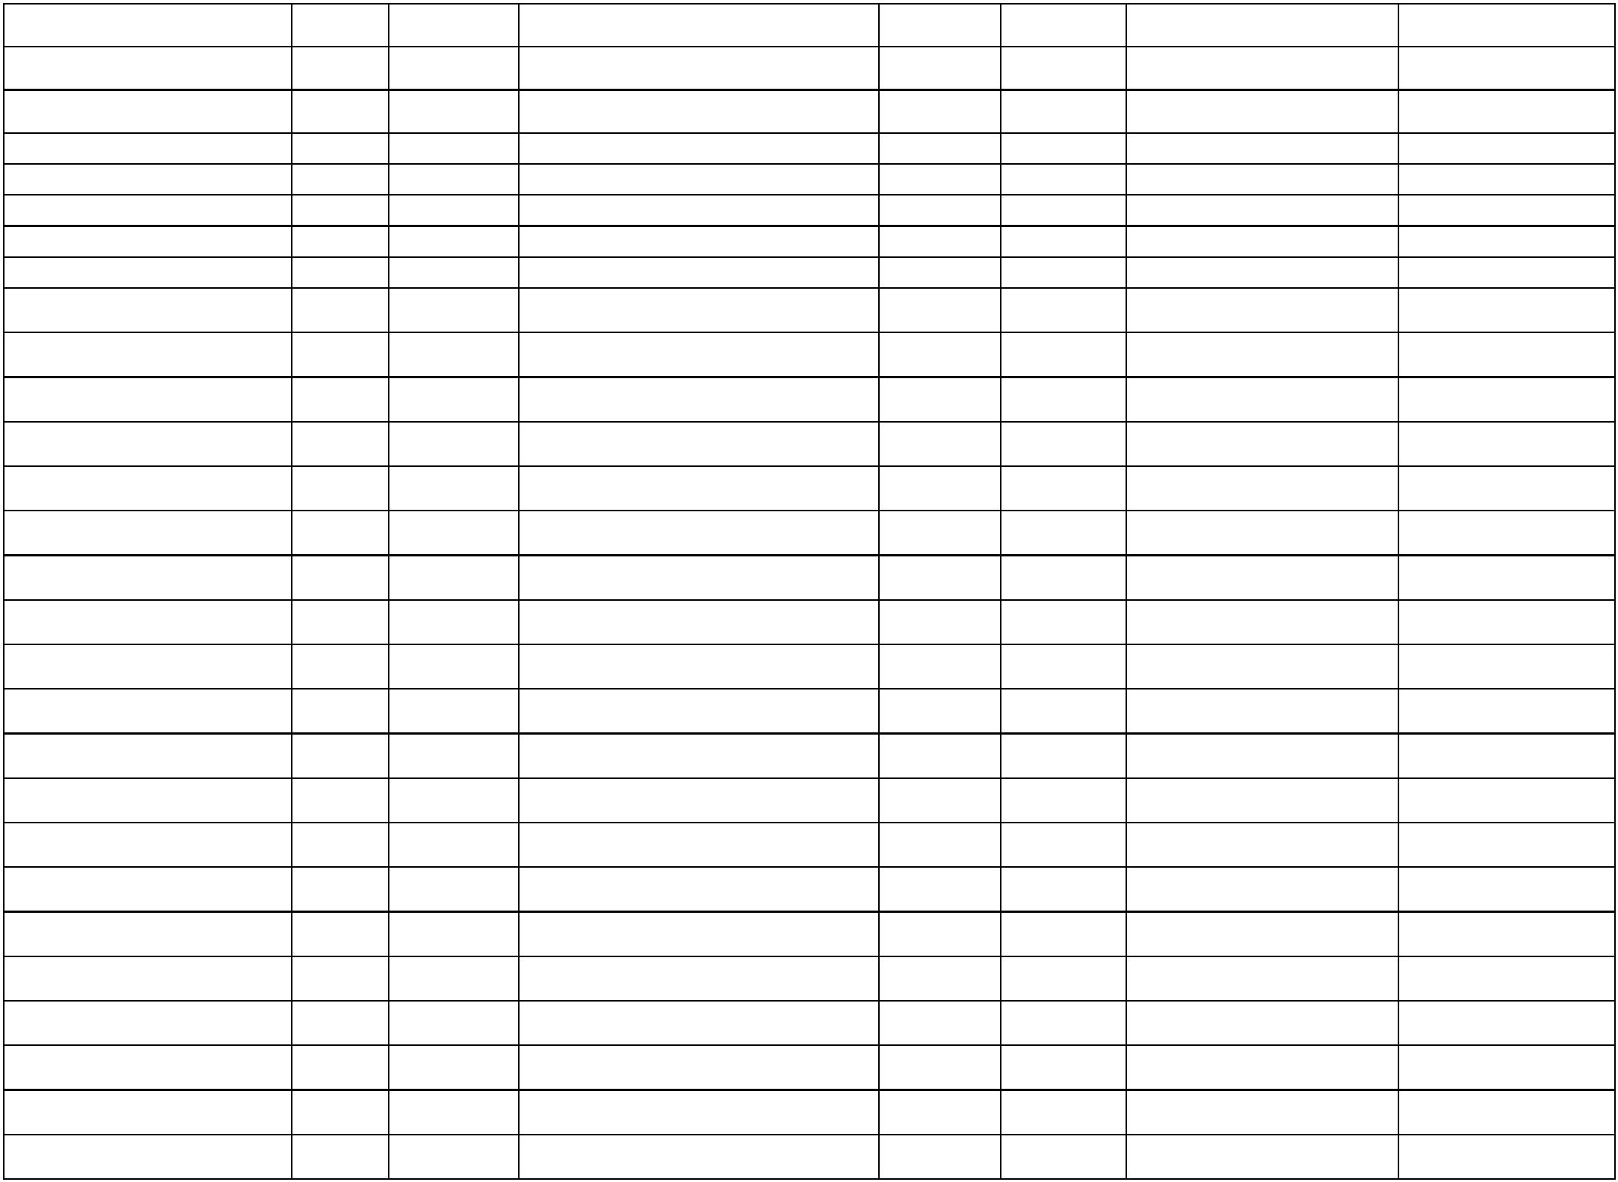

1
0/636/94771/13460/00000/0922
0/636/94771/13450/00000/0922
94771
94771
23/12/2025 NT JUNIKU REISEN
24/12/2025 BURIM HAXHA BI
2025-256550 2025-551771 KONTRAKUESE TE
3625315 SHERBIMET E
1,050.00
6
PRINTIMIT
1
2025-236118 2025-557289
13.91
Gjithsejte Mallra dhe Sherbime
284,469.01
Zyra e Kryetarit
149.26
4.50
10/636/16020/13250/00000/0111
10/636/16020/13250/00000/0111
10/636/16020/13250/00000/0111
10/636/16020/13250/00000/0111
10/636/16020/13250/00000/0111
10/636/16020/13250/00000/0111
16020
16020
16020
16020
16020
21/1/2025
21/1/2025
24/2/2025
24/2/2025
17/3/2025
17/3/2025
TELEKOMI I KOSOVES SHA
TELEKOMI I KOSOVES SHA
TELEKOMI I KOSOVES SHA
TELEKOMI I KOSOVES SHA
TELEKOMI I KOSOVES SHA
TELEKOMI I KOSOVES SHA
2025-357
2025-339
TELEFONIA FIKSE
TELEFONIA FIKSE
TELEFONIA FIKSE
TELEFONIA FIKSE
TELEFONIA FIKSE
TELEFONIA FIKSE
2025-360
2025-343
9.44
2025-17164
2025-17175
2025-50128
2025-50132
2025-36298
2025-36492
2025-67926
2025-67930
4.50
9.59
9.44
16020
16020
16020
16020
16020
16020
16020
16020
16020
16020
4.50
10/636/16020/13250/00000/0111
10/636/16020/13250/00000/0111
10/636/16020/13250/00000/0111
10/636/16020/13250/00000/0111
10/636/16020/13250/00000/0111
10/636/16020/13250/00000/0111
10/636/16020/13250/00000/0111
30/4/2025
30/4/2025
19/5/2025
19/5/2025
10/7/2025
10/7/2025
22/7/2025
24/7/2025
25/9/2025
TELEKOMI I KOSOVES SHA
TELEKOMI I KOSOVES SHA
TELEKOMI I KOSOVES SHA
TELEKOMI I KOSOVES SHA
TELEKOMI I KOSOVES SHA
TELEKOMI I KOSOVES SHA
TELEKOMI I KOSOVES SHA
TELEKOMI I KOSOVES SHA
TELEKOMI I KOSOVES SHA
2025-78477
2025-78469
2025-95822
2025-95832
2025-144814 TELEFONIA FIKSE
2025-144935 TELEFONIA FIKSE
2025-170298 TELEFONIA FIKSE
2025-170309 TELEFONIA FIKSE
9.99
4.50
9.69
4.50
4.50
9.44
4.50
2025-120696 2025-244944 TELEFONIA FIKSE
2025-120711 2025-244954 TELEFONIA FIKSE
2025-140889 2025-261348 TELEFONI FIKSE
10/636/16020/13250/00000/0111
10/636/16020/13250/00000/0111
10/636/16020/13250/00000/0111
10/636/16020/13250/00000/0111
10/636/16020/13250/00000/0111
10/636/16020/13210/00000/0111
10/636/16020/13210/00000/0111
10/636/16020/13210/00000/0111
10/636/16020/13250/00000/0111
10/636/16020/13220/00000/0111
2025-140140 2025-262737 TELEFONIA FIKSE
2025-179924 2025-362253 PTK TELEKOMI
2025-199728 2025-413293 63625698 PTK TELEKOMI
2025-199743 2025-413300 63625697 TELEFONIJA FIKSE
2025-179979 2025-422640 PTK TELEFONI
9.69
9.44
9.79
4.50
4.50
6.59
4.50
4.50
4.50
2.16
16020
16020
16020
16020
16020
16020
16020
16020
28/10/2025 TELEKOMI I KOSOVES SHA
28/10/2025 TELEKOMI I KOSOVES SHA
30/10/2025 TELEKOMI I KOSOVES SHA
18/12/2025 KESCO MAIN OPERATIONS ACCOUNT
18/12/2025 KESCO MAIN OPERATIONS ACCOUNT
18/12/2025 KESCO MAIN OPERATIONS ACCOUNT
19/12/2025 TELEKOMI I KOSOVES SHA
19/12/2025 KRU HIDRODRINI SH A
2025-247067 2025-544378 63625915 RRYMA
2025-247046 2025-544383 63625917 RRYMA
2025-247038 2025-544390 63625918 RRYMA
2025-247024 2025-545988 63625919 TELEFONIJA FIKSE
2025-247056 2025-546172 63625916 UJI
Administrata
5,399.27
10/636/16320/13250/00000/0133
10/636/16320/13210/00000/0133
10/636/16320/13220/00000/0133
10/636/16320/13220/00000/0133
10/636/16320/13250/00000/0133
10/636/16320/13210/00000/0133
16320
16320
16320
16320
16320
16320
21/1/2025
21/1/2025
21/1/2025
24/2/2025
24/2/2025
24/2/2025
TELEKOMI I KOSOVES SHA
KESCO MAIN OPERATIONS ACCOUNT
KRU HIDRODRINI SH A
2025-355
2025-337
TELEFONIA FIKSE
4.50
2025-364
2025-347
RRYMA
413.77
5.10
2025-365
2025-350
UJI
KRU HIDRODRINI SH A
2025-21283
2025-18696
2025-12321
2025-37428
2025-37436
2025-37447
UJI
18.48
TELEKOMI I KOSOVES SHA
KESCO MAIN OPERATIONS ACCOUNT
TELEFONIA FIKSE
RRYMA
4.50
445.49


10/636/16320/13210/00000/0133
10/636/16320/13220/00000/0133
10/636/16320/13250/00000/0133
10/636/16320/13210/00000/0133
10/636/16320/13210/00000/0133
10/636/16320/13210/00000/0133
10/636/16320/13210/00000/0133
10/636/16320/13210/00000/0133
10/636/16320/13210/00000/0133
10/636/16320/13250/00000/0133
10/636/16320/13220/00000/0133
10/636/16320/13210/00000/0133
10/636/16320/13210/00000/0133
10/636/16320/13250/00000/0133
10/636/16320/13220/00000/0133
10/636/16320/13210/00000/0133
10/636/16320/13220/00000/0133
10/636/16320/13220/00000/0133
10/636/16320/13210/00000/0133
10/636/16320/13220/00000/0133
10/636/16320/13210/00000/0133
10/636/16320/13210/00000/0133
10/636/16320/13210/00000/0133
10/636/16320/13220/00000/0133
10/636/16320/13220/00000/0133
10/636/16320/13210/00000/0133
10/636/16320/13210/00000/0133
10/636/16320/13250/00000/0133
16320
16320
16320
16320
16320
16320
16320
16320
16320
16320
16320
16320
16320
16320
16320
16320
16320
16320
16320
16320
16320
16320
16320
16320
16320
16320
16320
16320
7/3/2025
14/3/2025
14/3/2025
18/3/2025
18/3/2025
18/3/2025
18/3/2025
18/3/2025
18/3/2025
16/4/2025
16/4/2025
16/4/2025
19/5/2025
19/5/2025
19/5/2025
10/7/2025
10/7/2025
15/7/2025
15/7/2025
15/7/2025
15/7/2025
15/7/2025
15/7/2025
15/7/2025
15/7/2025
15/7/2025
15/7/2025
31/7/2025
KESCO MAIN OPERATIONS ACCOUNT
KRU HIDRODRINI SH A
2025-42648
2025-49871
2025-49837
2025-51564
2025-51566
2025-51576
2025-51579
2025-51580
2025-51585
2025-72178
2025-72264
2025-72218
2025-95283
2025-95286
2025-95288
2025-54052
2025-63404
2025-63437
2025-69465
2025-69483
2025-69487
2025-69494
2025-69498
2025-69508
RRYMA
UJI
383.02
14.60
4.50
TELEKOMI I KOSOVES SHA
TELEFONIA FIKSE
RRYMA
RRYMA
RRYMA
RRYMA
RRYMA
RRYMA
KESCO MAIN OPERATIONS ACCOUNT
KESCO MAIN OPERATIONS ACCOUNT
KESCO MAIN OPERATIONS ACCOUNT
KESCO MAIN OPERATIONS ACCOUNT
KESCO MAIN OPERATIONS ACCOUNT
KESCO MAIN OPERATIONS ACCOUNT
TELEKOMI I KOSOVES SHA
21.86
56.37
3.88
3.88
3.88
3.88
2025-118907 TELEFONIA FIKSE
2025-119129 UJI
4.50
KRU HIDRODRINI SH A
14.60
347.65
288.03
4.50
KESCO MAIN OPERATIONS ACCOUNT
KESCO MAIN OPERATIONS ACCOUNT
TELEKOMI I KOSOVES SHA
2025-119140 RRYMA
2025-170287 RRYMA
2025-170293 TELEFONIA FIKSE
2025-170333 UJI
KRU HIDRODRINI SH A
9.16
KESCO MAIN OPERATIONS ACCOUNT
KRU HIDRODRINI SH A
2025-119537 2025-244812 RRYMA
2025-119521 2025-244888 UJI
2025-137243 2025-250832 UJI
2025-137319 2025-250865 UJI
2025-137230 2025-250875 UJI
2025-137333 2025-250894 RRYMA
2025-137341 2025-250920 RRYMA
2025-137307 2025-250930 RRYMA
2025-137251 2025-251147 UJI
2025-137284 2025-251149 UJI
2025-137297 2025-251154 RRYMA
2025-137325 2025-251156 RRYMA
2025-150898 2025-270619 TELEFONIJA FIKSE
212.99
11.49
12.27
11.91
235.44
226.64
62.51
15.82
2.16
KRU HIDRODRINI SH A
KESCO MAIN OPERATIONS ACCOUNT
KRU HIDRODRINI SH A
KESCO MAIN OPERATIONS ACCOUNT
KESCO MAIN OPERATIONS ACCOUNT
KESCO MAIN OPERATIONS ACCOUNT
KRU HIDRODRINI SH A
KRU HIDRODRINI SH A
2.16
KESCO MAIN OPERATIONS ACCOUNT
KESCO MAIN OPERATIONS ACCOUNT
TELEKOMI I KOSOVES SHA
60.90
28.11
4.50


10/636/16320/13220/00000/0133
10/636/16320/13250/00000/0133
10/636/16320/13210/00000/0133
10/636/16320/13220/00000/0133
10/636/16320/13220/00000/0133
10/636/16320/13250/00000/0133
10/636/16320/13250/00000/0133
10/636/16320/13210/00000/0133
10/636/16320/13250/00000/0133
10/636/16320/13220/00000/0133
10/636/16320/13210/00000/0133
10/636/16320/13210/00000/0133
10/636/16320/13250/00000/0133
10/636/16320/13250/00000/0133
10/636/16320/13250/00000/0133
10/636/16320/13250/00000/0133
10/636/16320/13250/00000/0133
10/636/16320/13250/00000/0133
10/636/16320/13210/00000/0133
10/636/16320/13250/00000/0133
10/636/16320/13250/00000/0133
10/636/16320/13220/00000/0133
10/636/16320/13210/00000/0133
10/636/16320/13210/00000/0133
10/636/16320/13250/00000/0133
10/636/16320/13220/00000/0133
10/636/16320/13220/00000/0133
16320
16320
16320
16320
16320
16320
16320
16320
16320
16320
16320
16320
16320
16320
16320
16320
16320
16320
16320
16320
16320
16320
16320
16320
16320
16320
16320
31/7/2025
28/8/2025
9/9/2025
KRU HIDRODRINI SH A
2025-150886 2025-270636 UJI
13.05
20.99
273.21
16.16
16.16
20.99
4.50
TELEKOMI I KOSOVES SHA
KESCO MAIN OPERATIONS ACCOUNT
KRU HIDRODRINI SH A
2025-152135 2025-324447 TELEFONI FIKS
2025-140219 2025-341643 RRYMA
10/9/2025
24/9/2025
25/9/2025
25/9/2025
2025-163345 2025-342119 UJI
KRU HIDRODRINI SH A
2025-181556 2025-359109 63625612 UJI
TELEKOMI I KOSOVES SHA
TELEKOMI I KOSOVES SHA
2025-179890 2025-362237 PTK Telekomi
2025-180010 2025-362246 PTK TELEFONI
2025-199708 2025-413194 63625699 RRYMA
2025-199759 2025-413310 63625695 TELEFONIJA FIKSE
2025-199771 2025-416262 63625693 UJI
28/10/2025 KESCO MAIN OPERATIONS ACCOUNT
28/10/2025 TELEKOMI I KOSOVES SHA
28/10/2025 KRU HIDRODRINI SH A
242.16
4.50
22.38
320.89
348.89
32.98
4.50
30/10/2025 KESCO MAIN OPERATIONS ACCOUNT
30/10/2025 KESCO MAIN OPERATIONS ACCOUNT
11/11/2025 TELEKOMI I KOSOVES SHA
11/11/2025 TELEKOMI I KOSOVES SHA
11/11/2025 TELEKOMI I KOSOVES SHA
17/11/2025 TELEKOMI I KOSOVES SHA
17/11/2025 TELEKOMI I KOSOVES SHA
17/11/2025 TELEKOMI I KOSOVES SHA
26/11/2025 KESCO MAIN OPERATIONS ACCOUNT
26/11/2025 TELEKOMI I KOSOVES SHA
26/11/2025 TELEKOMI I KOSOVES SHA
26/11/2025 KRU HIDRODRINI SH A
2025-181784 2025-421563 63625622 RRYMA
2025-163361 2025-421775 KEDS
2025-210587 2025-448080 63625754 TELEFONIJA FIKSE
2025-210581 2025-448082 63625753 TELEFONIJA FIKSE
2025-210561 2025-448091 63625752 TELEFONIJA FIKSE
2025-210595 2025-459394 63625755 TELEFONIJA FIKSE
2025-210604 2025-459399 63625756 TELEFONIJA FIKSE
2025-210612 2025-459409 63625757 TELEFONIJA FIKSE
2025-224015 2025-480722 63625851 RRYMA
2025-223120 2025-486251 63625849 TELEFONIJA FIKSE
2025-224052 2025-486274 63625852 TELEFONIJA FIKSE
2025-224027 2025-486458 63625850 UJI
20.99
32.98
32.98
32.98
463.08
30.86
20.99
20.82
237.04
182.06
20.99
2.16
18/12/2025 KESCO MAIN OPERATIONS ACCOUNT
18/12/2025 KESCO MAIN OPERATIONS ACCOUNT
19/12/2025 TELEKOMI I KOSOVES SHA
19/12/2025 KRU HIDRODRINI SH A
2025-246958 2025-544339 63625924 RRYMA
2025-246990 2025-544350 63625922 RRYMA
2025-246980 2025-545848 63625923 TELEFONIJA MOBILE
2025-247003 2025-546129 63625920 UJI
19/12/2025 KRU HIDRODRINI SH A
2025-246997 2025-546225 63625921 UJI
16.93
Buxhet dhe Financa
99.27


10/636/17520/13250/00000/0112
10/636/17520/13250/00000/0112
10/636/17520/13250/00000/0112
10/636/17520/13250/00000/0112
10/636/17520/13250/00000/0112
10/636/17520/13250/00000/0112
10/636/17520/13250/00000/0112
10/636/17520/13250/00000/0112
10/636/17520/13250/00000/0112
10/636/17520/13250/00000/0112
10/636/17520/13250/00000/0112
10/636/17520/13250/00000/0112
17520
17520
17520
17520
17520
17520
17520
17520
17520
17520
17520
17520
21/1/2025
24/2/2025
17/3/2025
30/4/2025
9/7/2025
TELEKOMI I KOSOVES SHA
TELEKOMI I KOSOVES SHA
TELEKOMI I KOSOVES SHA
TELEKOMI I KOSOVES SHA
TELEKOMI I KOSOVES SHA
TELEKOMI I KOSOVES SHA
2025-362
2025-345
TELEFONIA FIKSE
TELEFONIA FIKSE
TELEFONIA FIKSE
6.99
6.99
6.99
6.99
13.29
4.50
20.99
4.50
9.54
9.49
4.50
4.50
2025-17182
2025-50079
2025-78471
2025-95840
2025-36276
2025-67935
2025-145363 TELEFONIA FIKSE
2025-235009 TELEFONIA FIKSE
10/7/2025
2025-120682 2025-244961 TELEFONIA FIKSE
63625251 SHPENZIMET E
TELEFONISE FIKSE
28/10/2025 TELEKOMI I KOSOVES SHA
11/11/2025 TELEKOMI I KOSOVES SHA
17/11/2025 TELEKOMI I KOSOVES SHA
26/11/2025 TELEKOMI I KOSOVES SHA
10/12/2025 TELEKOMI I KOSOVES SHA
10/12/2025 TELEKOMI I KOSOVES SHA
2025-198121 2025-413283
2025-210567 2025-448088 63625752 TELEFONIJA FIKSE
2025-210618 2025-459357 63625758 TELEFONIJA FIKSE
2025-223148 2025-486199 63625843 TELEFONIJA FIKSE
2025-223137 2025-519139 63625845 TELEFONIJA FIKSE
2025-223143 2025-519158 63625844 TELEFONIJA FIKSE
Sherbimet Publike
21,499.21
210.58
236.22
201.87
121.91
229.53
137.55
282.09
408.47
158.21
11.95
10/636/18020/13210/00000/0451
10/636/18020/13210/00000/0451
10/636/18020/13210/00000/0451
10/636/18020/13210/00000/0451
10/636/18020/13210/00000/0451
10/636/18020/13210/00000/0451
10/636/18020/13210/00000/0451
10/636/18020/13210/00000/0451
10/636/18020/13210/00000/0451
10/636/18020/13210/00000/0451
10/636/18020/13210/00000/0451
10/636/18020/13210/00000/0451
10/636/18020/13230/00000/0451
10/636/18020/13210/00000/0451
10/636/18020/13210/00000/0451
10/636/18020/13210/00000/0451
10/636/18020/13210/00000/0451
10/636/18020/13210/00000/0451
10/636/18020/13220/00000/0451
18020
18020
18020
18020
18020
18020
18020
18020
18020
18020
18020
18020
18020
18020
18020
18020
18020
18020
18020
27/1/2025
27/1/2025
27/1/2025
27/1/2025
27/1/2025
27/1/2025
27/1/2025
27/1/2025
27/1/2025
27/1/2025
21/2/2025
21/2/2025
21/2/2025
21/2/2025
21/2/2025
21/2/2025
21/2/2025
21/2/2025
21/2/2025
KESCO MAIN OPERATIONS ACCOUNT
2025-2465
2025-2463
2025-2461
2025-2436
2025-2433
2025-2430
2025-2413
2025-2403
2025-2456
2025-1461
2025-2407
2025-14305
2025-17254
2025-2491
2025-2408
2025-14330
2025-2459
2025-14277
2025-2326
2025-1701
2025-1704
2025-1707
2025-1713
2025-1714
2025-1716
2025-1722
2025-1730
2025-1736
2025-1738
2025-35605
2025-35611
2025-35619
2025-35638
2025-35652
2025-35663
2025-35672
2025-35680
2025-35687
RRYMA
RRYMA
RRYMA
RRYMA
RRYMA
RRYMA
RRYMA
RRYMA
RRYMA
RRYMA
RRYMA
RRYMA
MBETURINAT
RRYMA
RRYMA
RRYMA
RRYMA
RRYMA
UJI
KESCO MAIN OPERATIONS ACCOUNT
KESCO MAIN OPERATIONS ACCOUNT
KESCO MAIN OPERATIONS ACCOUNT
KESCO MAIN OPERATIONS ACCOUNT
KESCO MAIN OPERATIONS ACCOUNT
KESCO MAIN OPERATIONS ACCOUNT
KESCO MAIN OPERATIONS ACCOUNT
KESCO MAIN OPERATIONS ACCOUNT
KESCO MAIN OPERATIONS ACCOUNT
KESCO MAIN OPERATIONS ACCOUNT
KESCO MAIN OPERATIONS ACCOUNT
EURO STEEL SHPK
597.08
493.23
396.00
56.14
KESCO MAIN OPERATIONS ACCOUNT
KESCO MAIN OPERATIONS ACCOUNT
KESCO MAIN OPERATIONS ACCOUNT
KESCO MAIN OPERATIONS ACCOUNT
KESCO MAIN OPERATIONS ACCOUNT
KRU HIDRODRINI SH A
226.39
292.51
241.65
257.31
2.89


10/636/18020/13220/00000/0451
10/636/18020/13210/00000/0451
10/636/18020/13220/00000/0451
10/636/18020/13230/00000/0451
10/636/18020/13210/00000/0451
10/636/18020/13210/00000/0451
10/636/18020/13210/00000/0451
10/636/18020/13210/00000/0451
10/636/18020/13210/00000/0451
10/636/18020/13210/00000/0451
10/636/18020/13210/00000/0451
10/636/18020/13210/00000/0451
10/636/18020/13210/00000/0451
10/636/18020/13210/00000/0451
10/636/18020/13210/00000/0451
10/636/18020/13210/00000/0451
10/636/18020/13210/00000/0451
10/636/18020/13210/00000/0451
10/636/18020/13210/00000/0451
10/636/18020/13210/00000/0451
10/636/18020/13210/00000/0451
10/636/18020/13210/00000/0451
10/636/18020/13210/00000/0451
10/636/18020/13210/00000/0451
10/636/18020/13210/00000/0451
10/636/18020/13210/00000/0451
10/636/18020/13210/00000/0451
10/636/18020/13210/00000/0451
10/636/18020/13210/00000/0451
10/636/18020/13210/00000/0451
10/636/18020/13210/00000/0451
10/636/18020/13210/00000/0451
10/636/18020/13210/00000/0451
10/636/18020/13210/00000/0451
10/636/18020/13210/00000/0451
10/636/18020/13210/00000/0451
10/636/18020/13210/00000/0451
10/636/18020/13210/00000/0451
18020
18020
18020
18020
18020
18020
18020
18020
18020
18020
18020
18020
18020
18020
18020
18020
18020
18020
18020
18020
18020
18020
18020
18020
18020
18020
18020
18020
18020
18020
18020
18020
18020
18020
18020
18020
18020
18020
21/2/2025
21/2/2025
21/2/2025
26/2/2025
5/3/2025
5/3/2025
5/3/2025
5/3/2025
5/3/2025
5/3/2025
5/3/2025
5/3/2025
5/3/2025
5/3/2025
5/3/2025
5/3/2025
5/3/2025
5/3/2025
5/3/2025
5/3/2025
5/3/2025
5/3/2025
8/4/2025
8/4/2025
8/4/2025
8/4/2025
8/4/2025
8/4/2025
8/4/2025
8/4/2025
10/4/2025
10/4/2025
10/4/2025
10/4/2025
10/4/2025
10/4/2025
10/4/2025
10/4/2025
KRU HIDRODRINI SH A
2025-2331
2025-14316
2025-1442
2025-3480
2025-2356
2025-14299
2025-14227
2025-1475
2025-2472
2025-2442
2025-2438
2025-2462
2025-2409
2025-2426
2025-2422
2025-2401
2025-2421
2025-14248
2025-14272
2025-2452
2025-2478
2025-14197
2025-2443
2025-2416
2025-2419
2025-2427
2025-14294
2025-2450
2025-2453
2025-2466
2025-2481
2025-2487
2025-14157
2025-14203
2025-14172
2025-14215
2025-1471
2025-1457
2025-35694
2025-35951
2025-35997
2025-40118
2025-50208
2025-50220
2025-50236
2025-50259
2025-50331
2025-50400
2025-50438
2025-50444
2025-50448
2025-50453
2025-50523
2025-50535
2025-50548
2025-50560
2025-50566
2025-50573
2025-50579
2025-50585
UJI
182.09
70.99
2.16
KESCO MAIN OPERATIONS ACCOUNT
KRU HIDRODRINI SH A
RRYMA
UJI
EURO STEEL SHPK
MBETURINAT
RRYMA
RRYMA
RRYMA
RRYMA
RRYMA
RRYMA
RRYMA
RRYMA
RRYMA
RRYMA
RRYMA
RRYMA
RRYMA
RRYMA
RRYMA
RRYMA
RRYMA
RRYMA
441.00
180.77
127.28
122.81
179.77
182.89
103.49
136.58
106.06
105.74
123.93
84.45
83.72
96.45
77.10
90.31
90.08
3.88
KESCO MAIN OPERATIONS ACCOUNT
KESCO MAIN OPERATIONS ACCOUNT
KESCO MAIN OPERATIONS ACCOUNT
KESCO MAIN OPERATIONS ACCOUNT
KESCO MAIN OPERATIONS ACCOUNT
KESCO MAIN OPERATIONS ACCOUNT
KESCO MAIN OPERATIONS ACCOUNT
KESCO MAIN OPERATIONS ACCOUNT
KESCO MAIN OPERATIONS ACCOUNT
KESCO MAIN OPERATIONS ACCOUNT
KESCO MAIN OPERATIONS ACCOUNT
KESCO MAIN OPERATIONS ACCOUNT
KESCO MAIN OPERATIONS ACCOUNT
KESCO MAIN OPERATIONS ACCOUNT
KESCO MAIN OPERATIONS ACCOUNT
KESCO MAIN OPERATIONS ACCOUNT
KESCO MAIN OPERATIONS ACCOUNT
KESCO MAIN OPERATIONS ACCOUNT
KESCO MAIN OPERATIONS ACCOUNT
KESCO MAIN OPERATIONS ACCOUNT
KESCO MAIN OPERATIONS ACCOUNT
KESCO MAIN OPERATIONS ACCOUNT
KESCO MAIN OPERATIONS ACCOUNT
KESCO MAIN OPERATIONS ACCOUNT
KESCO MAIN OPERATIONS ACCOUNT
KESCO MAIN OPERATIONS ACCOUNT
KESCO MAIN OPERATIONS ACCOUNT
KESCO MAIN OPERATIONS ACCOUNT
KESCO MAIN OPERATIONS ACCOUNT
KESCO MAIN OPERATIONS ACCOUNT
KESCO MAIN OPERATIONS ACCOUNT
KESCO MAIN OPERATIONS ACCOUNT
KESCO MAIN OPERATIONS ACCOUNT
KESCO MAIN OPERATIONS ACCOUNT
3.88
2025-102185 RRYMA
2025-102191 RRYMA
2025-102196 RRYMA
2025-102200 RRYMA
2025-102203 RRYMA
2025-102205 RRYMA
2025-102210 RRYMA
2025-102213 RRYMA
2025-105262 RRYMA
2025-105265 RRYMA
2025-105269 RRYMA
2025-105308 RRYMA
2025-105358 RRYMA
2025-105445 RRYMA
2025-105471 RRYMA
2025-105475 RRYMA
68.04
50.33
52.90
78.47
69.54
60.19
62.06
59.61
49.01
55.13
53.23
51.12
50.55
22.08
32.68
29.86


10/636/18020/13210/00000/0451
10/636/18020/13210/00000/0451
10/636/18020/13210/00000/0451
10/636/18020/13250/00000/0451
10/636/18020/13210/00000/0451
10/636/18020/13210/00000/0451
10/636/18020/13210/00000/0451
10/636/18020/13210/00000/0451
10/636/18020/13210/00000/0451
10/636/18020/13210/00000/0451
10/636/18020/13210/00000/0451
10/636/18020/13210/00000/0451
10/636/18020/13210/00000/0451
10/636/18020/13220/00000/0451
10/636/18020/13220/00000/0451
10/636/18020/13220/00000/0451
10/636/18020/13220/00000/0451
10/636/18020/13220/00000/0451
10/636/18020/13210/00000/0451
10/636/18020/13220/00000/0451
10/636/18020/13230/00000/0451
10/636/18020/13230/00000/0451
10/636/18020/13210/00000/0451
10/636/18020/13220/00000/0451
10/636/18020/13220/00000/0451
10/636/18020/13220/00000/0451
10/636/18020/13220/00000/0451
10/636/18020/13220/00000/0451
10/636/18020/13220/00000/0451
10/636/18020/13220/00000/0451
10/636/18020/13220/00000/0451
10/636/18020/13220/00000/0451
10/636/18020/13220/00000/0451
10/636/18020/13250/00000/0451
10/636/18020/13210/00000/0451
10/636/18020/13250/00000/0451
10/636/18020/13210/00000/0451
10/636/18020/13210/00000/0451
18020
18020
18020
18020
18020
18020
18020
18020
18020
18020
18020
18020
18020
18020
18020
18020
18020
18020
18020
18020
18020
18020
18020
18020
18020
18020
18020
18020
18020
18020
18020
18020
18020
18020
18020
18020
18020
18020
10/4/2025
10/4/2025
10/4/2025
10/4/2025
10/4/2025
10/4/2025
10/4/2025
10/4/2025
10/4/2025
10/4/2025
10/4/2025
10/4/2025
10/4/2025
10/4/2025
10/4/2025
10/4/2025
10/4/2025
10/4/2025
12/5/2025
12/5/2025
12/5/2025
12/5/2025
13/5/2025
15/5/2025
15/5/2025
15/5/2025
15/5/2025
15/5/2025
15/5/2025
15/5/2025
15/5/2025
15/5/2025
15/5/2025
15/5/2025
15/5/2025
11/6/2025
11/6/2025
11/6/2025
KESCO MAIN OPERATIONS ACCOUNT
KESCO MAIN OPERATIONS ACCOUNT
KESCO MAIN OPERATIONS ACCOUNT
TELEKOMI I KOSOVES SHA
2025-2483
2025-2482
2025-14184
2025-2345
2025-1465
2025-14252
2025-14233
2025-14260
2025-2473
2025-2493
2025-2495
2025-14321
2025-14145
2025-2338
2025-1437
2025-1449
2025-1453
2025-1444
2025-88630
2025-88729
2025-89394
2025-89408
2025-88640
2025-88765
2025-88755
2025-88751
2025-88745
2025-88721
2025-88712
2025-88704
2025-88678
2025-88671
2025-88665
2025-88658
2025-88645
2025-105478 RRYMA
2025-105481 RRYMA
2025-105483 RRYMA
2025-105485 TELEFONIA FIKSE
2025-105490 RRYMA
2025-105494 RRYMA
2025-105499 RRYMA
2025-105504 RRYMA
2025-105508 RRYMA
2025-105509 RRYMA
2025-105514 RRYMA
2025-105518 RRYMA
2025-105521 RRYMA
2025-105526 UJI
40.18
40.62
28.88
32.98
19.06
3.88
KESCO MAIN OPERATIONS ACCOUNT
KESCO MAIN OPERATIONS ACCOUNT
KESCO MAIN OPERATIONS ACCOUNT
KESCO MAIN OPERATIONS ACCOUNT
KESCO MAIN OPERATIONS ACCOUNT
KESCO MAIN OPERATIONS ACCOUNT
KESCO MAIN OPERATIONS ACCOUNT
KESCO MAIN OPERATIONS ACCOUNT
KESCO MAIN OPERATIONS ACCOUNT
KRU HIDRODRINI SH A
3.88
18.62
3.88
3.88
3.88
3.88
3.88
21.25
15.38
2.16
KRU HIDRODRINI SH A
2025-105530 UJI
KRU HIDRODRINI SH A
2025-105534 UJI
KRU HIDRODRINI SH A
2025-105540 UJI
2.16
KRU HIDRODRINI SH A
2025-105542 UJI
2.16
KESCO MAIN OPERATIONS ACCOUNT
KRU HIDRODRINI SH A
2025-160125 RRYMA
2025-160131 UJI
112.54
2.16
EURO STEEL SHPK
2025-160136 MBETURINAT
2025-160141 MBETURINAT
2025-162894 RRYMA
2025-167497 UJI
396.00
396.00
66.79
2.16
EURO STEEL SHPK
KESCO MAIN OPERATIONS ACCOUNT
KRU HIDRODRINI SH A
KRU HIDRODRINI SH A
2025-167503 UJI
2.16
KRU HIDRODRINI SH A
2025-167506 UJI
2.16
KRU HIDRODRINI SH A
2025-167512 UJI
2.16
KRU HIDRODRINI SH A
2025-167518 UJI
30.15
2.16
KRU HIDRODRINI SH A
2025-167525 UJI
KRU HIDRODRINI SH A
2025-167530 UJI
2.16
KRU HIDRODRINI SH A
2025-167537 UJI
2.16
KRU HIDRODRINI SH A
2025-167543 UJI
2.16
KRU HIDRODRINI SH A
2025-167550 UJI
2.16
TELEKOMI I KOSOVES SHA
2025-167557 TELEFONIA FIKSE
2025-167559 RRYMA
32.98
41.96
32.98
94.11
67.53
KESCO MAIN OPERATIONS ACCOUNT
TELEKOMI I KOSOVES SHA
2025-112967 2025-201444 TELEFONIA FIKSE
2025-112981 2025-201448 RRYMA
2025-112987 2025-201454 RRYMA
KESCO MAIN OPERATIONS ACCOUNT
KESCO MAIN OPERATIONS ACCOUNT

10/636/18020/13210/00000/0451
10/636/18020/13210/00000/0451
10/636/18020/13210/00000/0451
10/636/18020/13210/00000/0451
10/636/18020/13210/00000/0451
10/636/18020/13210/00000/0451
10/636/18020/13210/00000/0451
10/636/18020/13210/00000/0451
10/636/18020/13230/00000/0451
10/636/18020/13210/00000/0451
10/636/18020/13210/00000/0451
10/636/18020/13210/00000/0451
10/636/18020/13210/00000/0451
10/636/18020/13210/00000/0451
10/636/18020/13210/00000/0451
10/636/18020/13210/00000/0451
10/636/18020/13210/00000/0451
10/636/18020/13210/00000/0451
10/636/18020/13210/00000/0451
10/636/18020/13210/00000/0451
10/636/18020/13210/00000/0451
10/636/18020/13210/00000/0451
10/636/18020/13220/00000/0451
10/636/18020/13220/00000/0451
10/636/18020/13220/00000/0451
10/636/18020/13230/00000/0451
10/636/18020/13230/00000/0451
10/636/18020/13230/00000/0451
10/636/18020/13210/00000/0451
10/636/18020/13210/00000/0451
10/636/18020/13230/00000/0451
10/636/18020/13210/00000/0451
10/636/18020/13210/00000/0451
10/636/18020/13210/00000/0451
10/636/18020/13210/00000/0451
10/636/18020/13210/00000/0451
10/636/18020/13210/00000/0451
10/636/18020/13210/00000/0451
18020
18020
18020
18020
18020
18020
18020
18020
18020
18020
18020
18020
18020
18020
18020
18020
18020
18020
18020
18020
18020
18020
18020
18020
18020
18020
18020
18020
18020
18020
18020
18020
18020
18020
18020
18020
18020
18020
11/6/2025
11/6/2025
11/6/2025
11/6/2025
11/6/2025
11/6/2025
11/6/2025
11/6/2025
9/7/2025
KESCO MAIN OPERATIONS ACCOUNT
KESCO MAIN OPERATIONS ACCOUNT
KESCO MAIN OPERATIONS ACCOUNT
KESCO MAIN OPERATIONS ACCOUNT
KESCO MAIN OPERATIONS ACCOUNT
KESCO MAIN OPERATIONS ACCOUNT
KESCO MAIN OPERATIONS ACCOUNT
KESCO MAIN OPERATIONS ACCOUNT
EURO STEEL SHPK
2025-113006 2025-201465 RRYMA
2025-113020 2025-201478 RRYMA
2025-113034 2025-201495 RRYMA
2025-113043 2025-201511 RRYMA
2025-113050 2025-201536 RRYMA
2025-113057 2025-201560 RRYMA
2025-113070 2025-201570 RRYMA
2025-113072 2025-201586 RRYMA
47.54
9.82
254.36
85.29
209.37
75.46
3.88
17.16
540.00
65.30
3.88
2025-81551
2025-234984 MBETURINAT
10/7/2025
10/7/2025
10/7/2025
10/7/2025
10/7/2025
10/7/2025
10/7/2025
10/7/2025
10/7/2025
10/7/2025
10/7/2025
10/7/2025
10/7/2025
10/7/2025
10/7/2025
10/7/2025
27/8/2025
9/9/2025
KESCO MAIN OPERATIONS ACCOUNT
KESCO MAIN OPERATIONS ACCOUNT
KESCO MAIN OPERATIONS ACCOUNT
KESCO MAIN OPERATIONS ACCOUNT
KESCO MAIN OPERATIONS ACCOUNT
KESCO MAIN OPERATIONS ACCOUNT
KESCO MAIN OPERATIONS ACCOUNT
KESCO MAIN OPERATIONS ACCOUNT
KESCO MAIN OPERATIONS ACCOUNT
KESCO MAIN OPERATIONS ACCOUNT
KESCO MAIN OPERATIONS ACCOUNT
KESCO MAIN OPERATIONS ACCOUNT
KESCO MAIN OPERATIONS ACCOUNT
KRU HIDRODRINI SH A
2025-132331 2025-245409 RRYMA
2025-132323 2025-245413 RRYMA
2025-132312 2025-245426 RRYMA
2025-132304 2025-245464 RRYMA
2025-132297 2025-245474 RRYMA
2025-132290 2025-245487 RRYMA
2025-132333 2025-245496 RRYMA
2025-132276 2025-245528 RRYMA
2025-132281 2025-245552 RRYMA
2025-132236 2025-245574 RRYMA
2025-132244 2025-245581 RRYMA
2025-132259 2025-245590 RRYMA
2025-132246 2025-245603 RRYMA
2025-131822 2025-245661 UJI
3.88
3.88
3.88
226.64
25.88
69.88
3.88
85.40
39.05
21.17
44.97
2.16
KRU HIDRODRINI SH A
2025-131857 2025-245674 UJI
2.16
KRU HIDRODRINI SH A
2025-131840 2025-245681 UJI
2.16
EURO STEEL SHPK
2025-153338 2025-322747 MBETURINAT
2025-134443 2025-341659 MBETURINA
2025-163499 2025-343307 MBETURINAT
2025-181732 2025-359138 63625629 RRYMA
2025-181739 2025-362022 63625628 RRYMA
2025-183562 2025-423149 63625228 MBETURINAT
2025-206406 2025-423170 63625738 RRYMA
2025-181763 2025-423184 63625625 RRYMA
2025-181742 2025-423193 63625627 RRYMA
2025-181776 2025-423200 63625623 RRYMA
2025-181769 2025-423209 63625624 RRYMA
2025-181715 2025-423215 63625631 RRYMA
2025-181707 2025-423228 63625632 RRYMA
486.00
495.00
486.00
4.50
EURO STEEL SHPK
11/9/2025
24/9/2025
25/9/2025
EURO STEEL SHPK
KESCO MAIN OPERATIONS ACCOUNT
KESCO MAIN OPERATIONS ACCOUNT
4.50
31/10/2025 EURO STEEL SHPK
585.00
73.12
92.45
44.27
38.62
25.65
133.95
32.00
31/10/2025 KESCO MAIN OPERATIONS ACCOUNT
31/10/2025 KESCO MAIN OPERATIONS ACCOUNT
31/10/2025 KESCO MAIN OPERATIONS ACCOUNT
31/10/2025 KESCO MAIN OPERATIONS ACCOUNT
31/10/2025 KESCO MAIN OPERATIONS ACCOUNT
31/10/2025 KESCO MAIN OPERATIONS ACCOUNT
31/10/2025 KESCO MAIN OPERATIONS ACCOUNT

10/636/18020/13210/00000/0451
10/636/18020/13210/00000/0451
10/636/18020/13210/00000/0451
10/636/18020/13220/00000/0451
10/636/18020/13220/00000/0451
10/636/18020/13220/00000/0451
10/636/18020/13220/00000/0451
10/636/18020/13220/00000/0451
10/636/18020/13230/00000/0451
10/636/18020/13230/00000/0451
10/636/18020/13220/00000/0451
10/636/18020/13220/00000/0451
10/636/18020/13220/00000/0451
10/636/18020/13220/00000/0451
10/636/18020/13210/00000/0451
10/636/18020/13210/00000/0451
10/636/18020/13210/00000/0451
10/636/18020/13210/00000/0451
10/636/18020/13210/00000/0451
10/636/18020/13210/00000/0451
10/636/18020/13210/00000/0451
10/636/18020/13210/00000/0451
10/636/18020/13210/00000/0451
10/636/18020/13210/00000/0451
10/636/18020/13210/00000/0451
10/636/18020/13210/00000/0451
10/636/18020/13210/00000/0451
10/636/18020/13210/00000/0451
10/636/18020/13210/00000/0451
10/636/18020/13210/00000/0451
10/636/18020/13210/00000/0451
10/636/18020/13210/00000/0451
10/636/18020/13210/00000/0451
10/636/18020/13210/00000/0451
10/636/18020/13210/00000/0451
10/636/18020/13210/00000/0451
10/636/18020/13210/00000/0451
10/636/18020/13210/00000/0451
18020
18020
18020
18020
18020
18020
18020
18020
18020
18020
18020
18020
18020
18020
18020
18020
18020
18020
18020
18020
18020
18020
18020
18020
18020
18020
18020
18020
18020
18020
18020
18020
18020
18020
18020
18020
18020
18020
31/10/2025 KESCO MAIN OPERATIONS ACCOUNT
31/10/2025 KESCO MAIN OPERATIONS ACCOUNT
31/10/2025 KESCO MAIN OPERATIONS ACCOUNT
31/10/2025 KRU HIDRODRINI SH A
2025-181725 2025-423244 63625630 RRYMA
2025-181751 2025-423257 63625626 RRYMA
2025-206388 2025-423268 63625739 RRYMA
2025-206439 2025-423272 63625733 UJI
2025-206421 2025-423291 63625736 UJI
2025-206426 2025-423297 63625735 UJI
2025-206432 2025-423305 63625734 UJI
2025-206415 2025-423365 63625737 UJI
2025-208938 2025-459561 63625265 MBETURINAT
2025-217390 2025-459569 63625284 MBETURINAT
2025-213728 2025-459628 63625792 UJI
2025-213723 2025-459634 63625793 UJI
2025-213708 2025-459637 63625791 UJI
2025-214457 2025-459859 63625804 UJI
2025-215502 2025-459969 63625803 RRYMA
2025-215510 2025-459990 63625802 RRYMA
2025-215515 2025-460002 6362580 RRYMA
2025-215538 2025-460522 63625899 RRYMA
2025-214378 2025-519246 63625811 RRYMA
2025-215521 2025-519268 63625800 RRYMA
2025-215552 2025-519282 63625897 RRYMA
2025-215557 2025-519298 63625896 RRYMA
2025-215566 2025-519308 63625895 RRYMA
2025-215544 2025-519323 63625898 RRYMA
2025-213714 2025-519336 63625794 RRYMA
2025-214425 2025-519350 63625807 RRYMA
2025-214433 2025-519814 63625806 RRYMA
2025-214445 2025-519825 63625805 RRYMA
2025-214336 2025-519835 63625818 RRYMA
2025-214342 2025-519842 63625817 RRYMA
2025-214348 2025-519855 63625816 RRYMA
2025-214355 2025-519861 63625815 RRYMA
2025-214366 2025-519869 63625814 RRYMA
2025-214371 2025-519875 63625813 RRYMA
2025-214374 2025-519878 63625812 RRYMA
2025-214384 2025-519883 63625810 RRYMA
2025-214394 2025-519890 63625809 RRYMA
2025-214412 2025-519895 63625808 RRYMA
24.74
12.88
11.38
9.16
31/10/2025 KRU HIDRODRINI SH A
6.83
31/10/2025 KRU HIDRODRINI SH A
2.16
31/10/2025 KRU HIDRODRINI SH A
2.16
31/10/2025 KRU HIDRODRINI SH A
2.16
17/11/2025 EURO STEEL SHPK
486.00
243.00
11.49
27.04
6.83
17/11/2025 EURO STEEL SHPK
17/11/2025 KRU HIDRODRINI SH A
17/11/2025 KRU HIDRODRINI SH A
17/11/2025 KRU HIDRODRINI SH A
17/11/2025 KRU HIDRODRINI SH A
25.49
92.45
360.16
214.91
63.27
122.48
70.14
49.38
29.15
51.98
125.65
73.12
92.45
95.17
57.03
12.72
35.37
8.65
17/11/2025 KESCO MAIN OPERATIONS ACCOUNT
17/11/2025 KESCO MAIN OPERATIONS ACCOUNT
17/11/2025 KESCO MAIN OPERATIONS ACCOUNT
18/11/2025 KESCO MAIN OPERATIONS ACCOUNT
10/12/2025 KESCO MAIN OPERATIONS ACCOUNT
10/12/2025 KESCO MAIN OPERATIONS ACCOUNT
10/12/2025 KESCO MAIN OPERATIONS ACCOUNT
10/12/2025 KESCO MAIN OPERATIONS ACCOUNT
10/12/2025 KESCO MAIN OPERATIONS ACCOUNT
10/12/2025 KESCO MAIN OPERATIONS ACCOUNT
10/12/2025 KESCO MAIN OPERATIONS ACCOUNT
10/12/2025 KESCO MAIN OPERATIONS ACCOUNT
10/12/2025 KESCO MAIN OPERATIONS ACCOUNT
10/12/2025 KESCO MAIN OPERATIONS ACCOUNT
10/12/2025 KESCO MAIN OPERATIONS ACCOUNT
10/12/2025 KESCO MAIN OPERATIONS ACCOUNT
10/12/2025 KESCO MAIN OPERATIONS ACCOUNT
10/12/2025 KESCO MAIN OPERATIONS ACCOUNT
10/12/2025 KESCO MAIN OPERATIONS ACCOUNT
10/12/2025 KESCO MAIN OPERATIONS ACCOUNT
10/12/2025 KESCO MAIN OPERATIONS ACCOUNT
10/12/2025 KESCO MAIN OPERATIONS ACCOUNT
10/12/2025 KESCO MAIN OPERATIONS ACCOUNT
10/12/2025 KESCO MAIN OPERATIONS ACCOUNT
14.49
5.28
24.22
22.53
21.21
53.41
39.54

10/636/18020/13210/00000/0451
22/636/18020/13210/00000/0451
22/636/18020/13210/00000/0451
22/636/18020/13210/00000/0451
22/636/18020/13210/00000/0451
22/636/18020/13210/00000/0451
22/636/18020/13210/00000/0451
22/636/18020/13210/00000/0451
22/636/18020/13210/00000/0451
22/636/18020/13210/00000/0451
22/636/18020/13210/00000/0451
22/636/18020/13210/00000/0451
22/636/18020/13210/00000/0451
22/636/18020/13210/00000/0451
22/636/18020/13210/00000/0451
22/636/18020/13210/00000/0451
22/636/18020/13210/00000/0451
22/636/18020/13210/00000/0451
22/636/18020/13210/00000/0451
22/636/18020/13210/00000/0451
22/636/18020/13210/00000/0451
22/636/18020/13220/00000/0451
22/636/18020/13250/00000/0451
22/636/18020/13210/00000/0451
22/636/18020/13210/00000/0451
22/636/18020/13210/00000/0451
22/636/18020/13210/00000/0451
22/636/18020/13250/00000/0451
22/636/18020/13210/00000/0451
22/636/18020/13210/00000/0451
22/636/18020/13210/00000/0451
22/636/18020/13210/00000/0451
22/636/18020/13220/00000/0451
22/636/18020/13220/00000/0451
22/636/18020/13220/00000/0451
22/636/18020/13220/00000/0451
22/636/18020/13220/00000/0451
22/636/18020/13220/00000/0451
18020
18020
18020
18020
18020
18020
18020
18020
18020
18020
18020
18020
18020
18020
18020
18020
18020
18020
18020
18020
18020
18020
18020
18020
18020
18020
18020
18020
18020
18020
18020
18020
18020
18020
18020
18020
18020
18020
18/12/2025 KESCO MAIN OPERATIONS ACCOUNT
2025-247271 2025-544356 63625900 RRYMA
2025-103204 2025-180499 RRYMA
0.75
948.33
4.50
27/5/2025
30/7/2025
30/7/2025
30/7/2025
30/7/2025
30/7/2025
30/7/2025
30/7/2025
30/7/2025
30/7/2025
30/7/2025
30/7/2025
30/7/2025
30/7/2025
30/7/2025
30/7/2025
30/7/2025
30/7/2025
30/7/2025
30/7/2025
31/7/2025
31/7/2025
31/7/2025
31/7/2025
31/7/2025
31/7/2025
31/7/2025
31/7/2025
31/7/2025
31/7/2025
31/7/2025
5/8/2025
KESCO MAIN OPERATIONS ACCOUNT
KESCO MAIN OPERATIONS ACCOUNT
KESCO MAIN OPERATIONS ACCOUNT
KESCO MAIN OPERATIONS ACCOUNT
KESCO MAIN OPERATIONS ACCOUNT
KESCO MAIN OPERATIONS ACCOUNT
KESCO MAIN OPERATIONS ACCOUNT
KESCO MAIN OPERATIONS ACCOUNT
KESCO MAIN OPERATIONS ACCOUNT
KESCO MAIN OPERATIONS ACCOUNT
KESCO MAIN OPERATIONS ACCOUNT
KESCO MAIN OPERATIONS ACCOUNT
KESCO MAIN OPERATIONS ACCOUNT
KESCO MAIN OPERATIONS ACCOUNT
KESCO MAIN OPERATIONS ACCOUNT
KESCO MAIN OPERATIONS ACCOUNT
KESCO MAIN OPERATIONS ACCOUNT
KESCO MAIN OPERATIONS ACCOUNT
KESCO MAIN OPERATIONS ACCOUNT
KESCO MAIN OPERATIONS ACCOUNT
KRU HIDRODRINI SH A
2025-149753 2025-270026 Shpenzimet e rrymes
2025-149747 2025-270047 Shpenzimet e rrymes
2025-149743 2025-270052 Shpenzimet e rrymes
2025-149718 2025-270063 Shpenzimet e rrymes
2025-149733 2025-270070 Shpenzimet e rrymes
2025-149722 2025-270080 Shpenzimet e rrymes
2025-149713 2025-270089 Shpenzimet e rrymes
2025-149702 2025-270104 Shpenzimet e rrymes
2025-149682 2025-270113 Shpenzimet e rrymes
2025-149615 2025-270143 Shpenzimet e rrymes
2025-149826 2025-270151 Shpenzimet e rrymes
2025-149818 2025-270158 Shpenzimet e rrymes
2025-149805 2025-270162 Shpenzimet e rrymes
2025-149797 2025-270169 Shpenzimet e rrymes
2025-149790 2025-270174 Shpenzimet e rrymes
2025-149784 2025-270180 Shpenzimet e rrymes
2025-149776 2025-270185 Shpenzimet e rrymes
2025-149771 2025-270189 Shpenzimet e rrymes
2025-149761 2025-270202 Shpenzimet e rrymes
2025-149528 2025-270498 Shpenzimet e ujit
2025-149504 2025-270596 Shpenzimet e telefonise fikse
2025-149671 2025-270674 Shpenzimet e rrymes
2025-149662 2025-270848 Shpenzimet e rrymes
2025-149618 2025-270867 Shpenzimet e rrymes
2025-149603 2025-270885 Shpenzimet e rrymes
2025-149500 2025-270916 Shpenzimet e telefonise fikse
2025-149604 2025-270927 Shpenzimet e rrymes
2025-149577 2025-270943 Shpenzimet e rrymes
2025-149571 2025-270959 Shpenzimet e rrymes
2025-149563 2025-270967 Shpenzimet e rrymes
2025-149536 2025-274487 Shpenzimet e ujit
2025-149508 2025-274499 Shpenzimet e ujit
2025-149515 2025-274510 Shpenzimet e ujit
2025-149520 2025-274519 Shpenzimet e ujit
2025-149533 2025-274528 Shpenzimet e ujit
2025-149539 2025-274540 Shpenzimet e ujit
132.28
815.11
4.50
4.50
32.79
11.79
46.18
70.90
33.25
75.23
93.66
3.88
698.14
333.31
32.24
3.99
12.93
56.00
2.16
TELEKOMI I KOSOVES SHA
32.98
239.47
21.20
39.15
276.60
32.98
114.96
258.60
57.60
39.50
35.60
2.16
KESCO MAIN OPERATIONS ACCOUNT
KESCO MAIN OPERATIONS ACCOUNT
KESCO MAIN OPERATIONS ACCOUNT
KESCO MAIN OPERATIONS ACCOUNT
TELEKOMI I KOSOVES SHA
KESCO MAIN OPERATIONS ACCOUNT
KESCO MAIN OPERATIONS ACCOUNT
KESCO MAIN OPERATIONS ACCOUNT
KESCO MAIN OPERATIONS ACCOUNT
KRU HIDRODRINI SH A
5/8/2025
KRU HIDRODRINI SH A
5/8/2025
KRU HIDRODRINI SH A
3.72
5/8/2025
KRU HIDRODRINI SH A
2.16
5/8/2025
KRU HIDRODRINI SH A
2.94
5/8/2025
KRU HIDRODRINI SH A
2.16

22/636/18020/13220/00000/0451
22/636/18020/13220/00000/0451
22/636/18020/13220/00000/0451
22/636/18020/13220/00000/0451
22/636/18020/13220/00000/0451
22/636/18020/13210/00000/0451
22/636/18020/13210/00000/0451
22/636/18020/13210/00000/0451
22/636/18020/13210/00000/0451
22/636/18020/13210/00000/0451
22/636/18020/13210/00000/0451
22/636/18020/13210/00000/0451
22/636/18020/13210/00000/0451
22/636/18020/13210/00000/0451
22/636/18020/13210/00000/0451
22/636/18020/13210/00000/0451
22/636/18020/13210/00000/0451
22/636/18020/13210/00000/0451
22/636/18020/13210/00000/0451
18020
18020
18020
18020
18020
18020
18020
18020
18020
18020
18020
18020
18020
18020
18020
18020
18020
18020
18020
5/8/2025
5/8/2025
5/8/2025
5/8/2025
5/8/2025
7/8/2025
7/8/2025
7/8/2025
7/8/2025
7/8/2025
7/8/2025
7/8/2025
7/8/2025
7/8/2025
7/8/2025
7/8/2025
KRU HIDRODRINI SH A
2025-149542 2025-274549 Shpenzimet e ujit
2025-149546 2025-274557 Shpenzimet e ujit
2025-149550 2025-274560 Shpenzimet e ujit
2025-149553 2025-274565 Shpenzimet e ujit
2025-149557 2025-274567 Shpenzimet e ujit
2025-149606 2025-276417 Shpenzimet e rrymes
2025-149605 2025-276425 Shpenzimet e rrymes
2025-149601 2025-276433 Shpenzimet e rrymes
2025-149602 2025-279921 Shpenzimet e rrymes
2025-149598 2025-279954 Shpenzimet e rrymes
2025-149574 2025-279989 Shpenzimet e rrymes
2025-149573 2025-280024 Shpenzimet e rrymes
2025-149569 2025-280065 Shpenzimet e rrymes
2025-149565 2025-280097 Shpenzimet e rrymes
2025-149560 2025-280129 Shpenzimet e rrymes
2025-149612 2025-280161 Shpenzimet e rrymes
2025-247271 2025-544356 63625900 RRYMA
2025-247238 2025-544365 63625901 RRYMA
2025-247258 2025-544399 63625899 RRYMA
2.16
2.16
KRU HIDRODRINI SH A
KRU HIDRODRINI SH A
2.16
KRU HIDRODRINI SH A
23.16
2.16
KRU HIDRODRINI SH A
KESCO MAIN OPERATIONS ACCOUNT
KESCO MAIN OPERATIONS ACCOUNT
KESCO MAIN OPERATIONS ACCOUNT
KESCO MAIN OPERATIONS ACCOUNT
KESCO MAIN OPERATIONS ACCOUNT
KESCO MAIN OPERATIONS ACCOUNT
KESCO MAIN OPERATIONS ACCOUNT
KESCO MAIN OPERATIONS ACCOUNT
KESCO MAIN OPERATIONS ACCOUNT
KESCO MAIN OPERATIONS ACCOUNT
KESCO MAIN OPERATIONS ACCOUNT
57.85
4.76
13.21
9.95
3.88
17.18
4.10
6.45
3.88
34.93
33.38
170.43
25.78
4.18
18/12/2025 KESCO MAIN OPERATIONS ACCOUNT
18/12/2025 KESCO MAIN OPERATIONS ACCOUNT
18/12/2025 KESCO MAIN OPERATIONS ACCOUNT
Zhvillim Ekonomik
399.77
2.16
2.16
3.60
7.66
2.16
2.16
7.23
3.60
3.60
6.60
2.16
2.16
2.16
2.16
3.60
5.43
1.68
2.16
10/636/48020/13220/00000/0411
10/636/48020/13220/00000/0411
10/636/48020/13210/00000/0411
10/636/48020/13210/00000/0411
10/636/48020/13220/00000/0411
10/636/48020/13220/00000/0411
10/636/48020/13210/00000/0411
10/636/48020/13210/00000/0411
10/636/48020/13210/00000/0411
10/636/48020/13210/00000/0411
10/636/48020/13220/00000/0411
10/636/48020/13220/00000/0411
10/636/48020/13220/00000/0411
10/636/48020/13220/00000/0411
10/636/48020/13210/00000/0411
10/636/48020/13210/00000/0411
10/636/48020/13250/00000/0411
10/636/48020/13220/00000/0411
48020
48020
48020
48020
48020
48020
48020
48020
48020
48020
48020
48020
48020
48020
48020
48020
48020
48020
30/1/2025
30/1/2025
30/1/2025
30/1/2025
24/2/2025
24/2/2025
24/2/2025
24/2/2025
7/3/2025
KRU HIDRODRINI SH A
2025-4703
2025-4701
2025-4689
2025-4693
2025-18641
2025-18622
2025-17097
2025-17151
2025-42987
2025-42898
2025-49876
2025-49882
2025-72273
2025-72280
2025-72228
2025-72222
2025-81192
2025-98382
2025-4353
2025-4360
2025-4363
2025-4369
2025-36642
2025-36682
2025-36703
2025-36732
2025-54060
2025-54070
2025-63411
2025-63417
UJI
KRU HIDRODRINI SH A
UJI
KESCO MAIN OPERATIONS ACCOUNT
KESCO MAIN OPERATIONS ACCOUNT
KRU HIDRODRINI SH A
RRYMA
RRYMA
UJI
KRU HIDRODRINI SH A
UJI
KESCO MAIN OPERATIONS ACCOUNT
KESCO MAIN OPERATIONS ACCOUNT
KESCO MAIN OPERATIONS ACCOUNT
KESCO MAIN OPERATIONS ACCOUNT
KRU HIDRODRINI SH A
RRYMA
RRYMA
RRYMA
RRYMA
UJI
7/3/2025
14/3/2025
14/3/2025
16/4/2025
16/4/2025
16/4/2025
16/4/2025
22/5/2025
26/5/2025
KRU HIDRODRINI SH A
UJI
KRU HIDRODRINI SH A
2025-119108 UJI
KRU HIDRODRINI SH A
2025-119122 UJI
KESCO MAIN OPERATIONS ACCOUNT
KESCO MAIN OPERATIONS ACCOUNT
TELEKOMI I KOSOVES SHA
2025-119155 RRYMA
2025-119166 RRYMA
2025-175558 TELEFONIA FIKSE
2025-178671 UJI
KRU HIDRODRINI SH A

10/636/48020/13220/00000/0411
10/636/48020/13210/00000/0411
10/636/48020/13210/00000/0411
10/636/48020/13250/00000/0411
10/636/48020/13210/00000/0411
10/636/48020/13210/00000/0411
10/636/48020/13220/00000/0411
10/636/48020/13220/00000/0411
10/636/48020/13250/00000/0411
10/636/48020/13210/00000/0411
10/636/48020/13220/00000/0411
10/636/48020/13250/00000/0411
10/636/48020/13250/00000/0411
10/636/48020/13250/00000/0411
10/636/48020/13210/00000/0411
10/636/48020/13220/00000/0411
10/636/48020/13220/00000/0411
10/636/48020/13210/00000/0411
10/636/48020/13210/00000/0411
10/636/48020/13220/00000/0411
10/636/48020/13220/00000/0411
10/636/48020/13210/00000/0411
10/636/48020/13210/00000/0411
10/636/48020/13210/00000/0411
10/636/48020/13220/00000/0411
10/636/48020/13220/00000/0411
10/636/48020/13250/00000/0411
10/636/48020/13210/00000/0411
10/636/48020/13250/00000/0411
10/636/48020/13210/00000/0411
10/636/48020/13210/00000/0411
10/636/48020/13250/00000/0411
10/636/48020/13250/00000/0411
10/636/48020/13220/00000/0411
10/636/48020/13220/00000/0411
10/636/48020/13220/00000/0411
10/636/48020/13250/00000/0411
10/636/48020/13250/00000/0411
48020
48020
48020
48020
48020
48020
48020
48020
48020
48020
48020
48020
48020
48020
48020
48020
48020
48020
48020
48020
48020
48020
48020
48020
48020
48020
48020
48020
48020
48020
48020
48020
48020
48020
48020
48020
48020
48020
26/5/2025
26/5/2025
11/6/2025
11/6/2025
10/7/2025
10/7/2025
10/7/2025
10/7/2025
10/7/2025
21/7/2025
21/7/2025
22/7/2025
22/7/2025
22/7/2025
22/7/2025
22/7/2025
10/9/2025
10/9/2025
10/9/2025
24/9/2025
24/9/2025
25/9/2025
KRU HIDRODRINI SH A
2025-98380
2025-98384
2025-98389
2025-178727 UJI
20.05
4.68
3.60
12.99
4.18
5.37
2.16
2.16
12.99
5.22
2.16
20.99
32.98
12.99
4.18
34.82
2.16
5.63
4.18
7.63
2.16
4.18
6.16
4.18
2.16
2.16
12.99
4.58
12.99
4.18
6.48
11.74
12.99
11.80
2.16
2.16
12.99
9.44
KESCO MAIN OPERATIONS ACCOUNT
KESCO MAIN OPERATIONS ACCOUNT
TELEKOMI I KOSOVES SHA
2025-178805 RRYMA
2025-202515 RRYMA
2025-103639 2025-202583 TELEFONIA FIKSE
2025-127519 2025-244712 RRYMA
KESCO MAIN OPERATIONS ACCOUNT
KESCO MAIN OPERATIONS ACCOUNT
KRU HIDRODRINI SH A
2025-127513 2025-244732 RRYMA
2025-127511 2025-244824 UJI
KRU HIDRODRINI SH A
2025-127507 2025-244830 UJI
TELEKOMI I KOSOVES SHA
2025-127501 2025-244905 TELEFONIA FIKSE
2025-140508 2025-260491 RRYMA
KESCO MAIN OPERATIONS ACCOUNT
KRU HIDRODRINI SH A
2025-140500 2025-260495 UJI
TELEKOMI I KOSOVES SHA
2025-140913 2025-261330 TELEFONIA FIKSE
2025-140903 2025-261340 TELEFONIA FIKSE
2025-140483 2025-261352 TELEFONIA FIKSE
2025-140489 2025-261359 RRYMA
TELEKOMI I KOSOVES SHA
TELEKOMI I KOSOVES SHA
KESCO MAIN OPERATIONS ACCOUNT
KRU HIDRODRINI SH A
2025-140472 2025-261364 UJI
KRU HIDRODRINI SH A
2025-163333 2025-342200 UJI
KESCO MAIN OPERATIONS ACCOUNT
KESCO MAIN OPERATIONS ACCOUNT
KRU HIDRODRINI SH A
2025-163370 2025-342206 RRYMA
2025-163382 2025-342216 RRYMA
2025-181534 2025-359076 63625613 UJI
2025-181546 2025-359100 63625612 UJI
2025-181805 2025-362111 63625618 RRYMA
2025-202615 2025-413224 63625718 RRYMA
2025-202607 2025-413235 63625718 RRYMA
2025-202521 2025-416268 63625726 UJI
2025-202535 2025-416278 63625725 UJI
2025-181932 2025-422631 63625614 TPK-TELEKOMI
2025-181801 2025-423119 63625619 RRYMA
2025-210628 2025-448100 63625759 TELEFONIJA FIKSE
2025-225565 2025-480700 63625867 RRYMA
2025-225553 2025-480711 63625868 RRYMA
2025-225597 2025-486043 63625865 TELEFONIJA FIKSE
2025-228312 2025-486323 63625764 TELEFONIJA FIKSE
2025-225542 2025-486430 63625869 UJI
2025-225611 2025-486501 63625864 UJI
2025-225625 2025-486519 63625863 UJI
2025-246931 2025-545828 63625927 TELEFONIJA FIKSE
2025-246936 2025-545913 63625926 TELEFONIJA FIKSE
KRU HIDRODRINI SH A
KESCO MAIN OPERATIONS ACCOUNT
28/10/2025 KESCO MAIN OPERATIONS ACCOUNT
28/10/2025 KESCO MAIN OPERATIONS ACCOUNT
28/10/2025 KRU HIDRODRINI SH A
28/10/2025 KRU HIDRODRINI SH A
30/10/2025 TELEKOMI I KOSOVES SHA
31/10/2025 KESCO MAIN OPERATIONS ACCOUNT
11/11/2025 TELEKOMI I KOSOVES SHA
26/11/2025 KESCO MAIN OPERATIONS ACCOUNT
26/11/2025 KESCO MAIN OPERATIONS ACCOUNT
26/11/2025 TELEKOMI I KOSOVES SHA
26/11/2025 TELEKOMI I KOSOVES SHA
26/11/2025 KRU HIDRODRINI SH A
26/11/2025 KRU HIDRODRINI SH A
26/11/2025 KRU HIDRODRINI SH A
19/12/2025 TELEKOMI I KOSOVES SHA
19/12/2025 TELEKOMI I KOSOVES SHA

10/636/48020/13220/00000/0411
48020
19/12/2025 KRU HIDRODRINI SH A
2025-246944 2025-546236 63625925 UJI
10.71
QKMF
7,499.92
27.86
10/636/74200/13220/00000/0721
10/636/74200/13250/00000/0721
10/636/74200/13210/00000/0721
10/636/74200/13210/00000/0721
10/636/74200/13210/00000/0721
10/636/74200/13250/00000/0721
10/636/74200/13220/00000/0721
10/636/74200/13210/00000/0721
10/636/74200/13210/00000/0721
10/636/74200/13220/00000/0721
10/636/74200/13250/00000/0721
74200
74200
74200
74200
74200
74200
74200
74200
74200
74200
74200
30/1/2025
30/1/2025
30/1/2025
30/1/2025
30/1/2025
24/2/2025
24/2/2025
24/2/2025
5/3/2025
KRU HIDRODRINI SH A
2025-5890
2025-5945
2025-5912
2025-5897
2025-5932
2025-18719
2025-19590
2025-14415
2025-5903
2025-51220
2025-51254
2025-4393
2025-4407
2025-4414
2025-4429
2025-4435
2025-37283
2025-37295
2025-37302
2025-50045
2025-67898
2025-67914
UJI
TELEKOMI I KOSOVES SHA
TELEFONIA FIKSE
RRYMA
16.08
KESCO MAIN OPERATIONS ACCOUNT
KESCO MAIN OPERATIONS ACCOUNT
KESCO MAIN OPERATIONS ACCOUNT
TELEKOMI I KOSOVES SHA
685.03
244.00
218.94
16.08
RRYMA
RRYMA
TELEFONIA FIKSE
UJI
KRU HIDRODRINI SH A
24.71
KESCO MAIN OPERATIONS ACCOUNT
KESCO MAIN OPERATIONS ACCOUNT
KRU HIDRODRINI SH A
RRYMA
138.27
869.10
64.37
RRYMA
17/3/2025
17/3/2025
UJI
TELEKOMI I KOSOVES SHA
TELEFONIA FIKSE
15.99
1
0/636/74200/13210/00000/0721
0/636/74200/13210/00000/0721
74200
4/4/2025
4/4/2025
KESCO MAIN OPERATIONS ACCOUNT
KESCO MAIN OPERATIONS ACCOUNT
2025-43755
2025-14436
2025-96186
2025-96194
RRYMA
RRYMA
666.64
830.73
1
74200
10/636/74200/13230/00000/0721
74200
8/4/2025
EURO STEEL SHPK
2025-51645
2025-102159 MBETURINAT
168.00
10/636/74200/13230/00000/0721
10/636/74200/13250/00000/0721
10/636/74200/13230/00000/0721
10/636/74200/13230/00000/0721
10/636/74200/13220/00000/0721
10/636/74200/13250/00000/0721
10/636/74200/13210/00000/0721
10/636/74200/13210/00000/0721
10/636/74200/13210/00000/0721
10/636/74200/13220/00000/0721
10/636/74200/13250/00000/0721
10/636/74200/13250/00000/0721
10/636/74200/13250/00000/0721
10/636/74200/13220/00000/0721
10/636/74200/13210/00000/0721
10/636/74200/13220/00000/0721
10/636/74200/13210/00000/0721
10/636/74200/13220/00000/0721
10/636/74200/13250/00000/0721
10/636/74200/13230/00000/0721
74200
74200
74200
74200
74200
74200
74200
74200
74200
74200
74200
74200
74200
74200
74200
74200
74200
74200
74200
74200
8/4/2025
25/4/2025
19/5/2025
19/5/2025
22/5/2025
22/5/2025
9/7/2025
EURO STEEL SHPK
2025-17900
2025-75280
2025-21160
2025-17934
2025-96985
2025-96995
2025-97048
2025-102164 MBETURINAT
2025-138809 TELEFONIA FIKSE
2025-170280 MBETURINAT
2025-170285 MBETURINAT
2025-176010 UJI
168.00
15.99
168.00
168.00
52.70
15.99
504.82
45.31
398.73
23.93
15.99
13.99
15.99
49.59
343.03
46.48
346.56
34.82
15.99
210.00
TELEKOMI I KOSOVES SHA
EURO STEEL SHPK
EURO STEEL SHPK
KRU HIDRODRINI SH A
TELEKOMI I KOSOVES SHA
KESCO MAIN OPERATIONS ACCOUNT
KESCO MAIN OPERATIONS ACCOUNT
KESCO MAIN OPERATIONS ACCOUNT
KRU HIDRODRINI SH A
2025-176023 TELEFONIA FIKSE
2025-234993 RRYMA
10/7/2025
10/7/2025
10/7/2025
10/7/2025
10/7/2025
25/7/2025
25/7/2025
9/9/2025
2025-120672 2025-244801 RRYMA
2025-119998 2025-244805 RRYMA
2025-120036 2025-244895 UJI
TELEKOMI I KOSOVES SHA
TELEKOMI I KOSOVES SHA
TELEKOMI I KOSOVES SHA
KRU HIDRODRINI SH A
2025-120004 2025-244968 TELEFONIA FIKSE
2025-120026 2025-244976 TELEFONIA FIKSE
2025-147191 2025-264023 TELEFONIA FIKSE
2025-147166 2025-264071 UJI
KESCO MAIN OPERATIONS ACCOUNT
KRU HIDRODRINI SH A
2025-147184 2025-341326 RRYMA
10/9/2025
9/10/2025
9/10/2025
2025-170014 2025-342194 UJI
KESCO MAIN OPERATIONS ACCOUNT
KRU HIDRODRINI SH A
2025-187477 2025-384578 63625652 RRYMA
2025-187461 2025-384585 63625654 UJI
2025-187490 2025-388390 63625649 TELEFONIJA FIKSE
2025-189497 2025-401243 63625243 MBETURINAT
10/10/2025 TELEKOMI I KOSOVES SHA
17/10/2025 EURO STEEL SHPK


10/636/74200/13220/00000/0721
10/636/74200/13230/00000/0721
10/636/74200/13210/00000/0721
10/636/74200/13250/00000/0721
10/636/74200/13230/00000/0721
10/636/74200/13230/00000/0721
10/636/74200/13250/00000/0721
10/636/74200/13220/00000/0721
74200
74200
74200
74200
74200
74200
74200
74200
28/10/2025 KRU HIDRODRINI SH A
31/10/2025 EURO STEEL SHPK
2025-203629 2025-416251 63625727 UJI
41.04
210.00
330.63
15.99
2025-149453 2025-422974 MBETURINAT
17/11/2025 KESCO MAIN OPERATIONS ACCOUNT
17/11/2025 TELEKOMI I KOSOVES SHA
10/12/2025 EURO STEEL SHPK
2025-170023 2025-459366 RRYMA
2025-208964 2025-459378 63625730 TELEFONIJA FIKSE
2025-204478 2025-518526 63625260 MBETURINA
2025-204484 2025-518537 63625261 MBETURINA
2025-247231 2025-545897 63625902 TELEFONJIA FIKSE
2025-247163 2025-546277 63625907 UJI
168.00
84.00
10/12/2025 EURO STEEL SHPK
19/12/2025 TELEKOMI I KOSOVES SHA
19/12/2025 KRU HIDRODRINI SH A
4.50
6.05
Social
1,999.92
1
0/636/75596/13220/00000/1040
0/636/75596/13250/00000/1040
75596
75596
30/1/2025
30/1/2025
KRU HIDRODRINI SH A
2025-5893
2025-5941
2025-4399
2025-4403
UJI
8.03
1
TELEKOMI I KOSOVES SHA
TELEFONIA FIKSE
13.99
14.18
10.72
168.00
158.68
9.94
10/636/75596/13250/00000/1040
10/636/75596/13220/00000/1040
10/636/75596/13230/00000/1040
10/636/75596/13210/00000/1040
10/636/75596/13220/00000/1040
10/636/75596/13250/00000/1040
10/636/75596/13210/00000/1040
10/636/75596/13210/00000/1040
10/636/75596/13250/00000/1040
10/636/75596/13220/00000/1040
10/636/75596/13220/00000/1040
10/636/75596/13220/00000/1040
10/636/75596/13250/00000/1040
10/636/75596/13230/00000/1040
10/636/75596/13220/00000/1040
10/636/75596/13220/00000/1040
10/636/75596/13250/00000/1040
75596
75596
75596
75596
75596
75596
75596
75596
75596
75596
75596
75596
75596
75596
75596
75596
75596
24/2/2025
24/2/2025
24/2/2025
12/3/2025
17/3/2025
17/3/2025
25/4/2025
25/4/2025
25/4/2025
25/4/2025
25/4/2025
22/5/2025
22/5/2025
9/7/2025
TELEKOMI I KOSOVES SHA
KRU HIDRODRINI SH A
2025-18705
2025-19581
2025-17286
2025-43768
2025-51238
2025-51260
2025-75236
2025-75248
2025-75291
2025-75261
2025-75253
2025-96976
2025-97030
2025-98213
2025-36959
2025-36964
2025-36978
2025-57290
2025-67893
2025-67911
TELEFONIA FIKSE
UJI
EURO STEEL SHPK
MBETURINAT
RRYMA
KESCO MAIN OPERATIONS ACCOUNT
KRU HIDRODRINI SH A
UJI
TELEKOMI I KOSOVES SHA
KESCO MAIN OPERATIONS ACCOUNT
KESCO MAIN OPERATIONS ACCOUNT
TELEKOMI I KOSOVES SHA
KRU HIDRODRINI SH A
TELEFONIA FIKSE
13.99
147.45
597.47
13.99
2.16
2025-138706 RRYMA
2025-138866 RRYMA
2025-139257 TELEFONIA FIKSE
2025-139259 UJI
KRU HIDRODRINI SH A
2025-139263 UJI
30.15
2.16
KRU HIDRODRINI SH A
2025-176009 UJI
TELEKOMI I KOSOVES SHA
EURO STEEL SHPK
2025-176031 TELEFONIA FIKSE
2025-234965 MBETURINAT
13.99
168.00
2.16
10/7/2025
25/7/2025
KRU HIDRODRINI SH A
2025-120030 2025-244874 UJI
KRU HIDRODRINI SH A
2025-147173 2025-264057 UJI
2.16
10/10/2025 TELEKOMI I KOSOVES SHA
2025-187486 2025-388511 63625650 TELEFONIJA FIKSE
13.99


10/636/75596/13220/00000/1040
10/636/75596/13250/00000/1040
10/636/75596/13220/00000/1040
10/636/75596/13230/00000/1040
10/636/75596/13210/00000/1040
10/636/75596/13250/00000/1040
10/636/75596/13250/00000/1040
10/636/75596/13250/00000/1040
10/636/75596/13250/00000/1040
10/636/75596/13220/00000/1040
10/636/75596/13220/00000/1040
10/636/75596/13250/00000/1040
10/636/75596/13250/00000/1040
10/636/75596/13220/00000/1040
10/636/75596/13220/00000/1040
10/636/75596/13230/00000/1040
75596
75596
75596
75596
75596
75596
75596
75596
75596
75596
75596
75596
75596
75596
75596
75596
10/10/2025 KRU HIDRODRINI SH A
27/10/2025 TELEKOMI I KOSOVES SHA
28/10/2025 KRU HIDRODRINI SH A
31/10/2025 EURO STEEL SHPK
2025-187468 2025-388576 63625653 UJI
2.16
13.99
2.16
2025-203651 2025-410148 63625729 TELEFONIJA FIKSE
2025-203641 2025-416243 63625728 UJI
2025-78323
2025-97064
2025-423064 MBETURINAT
2025-423098 RRYMA
210.00
129.39
13.99
15.99
13.99
15.99
6.05
31/10/2025 KESCO MAIN OPERATIONS ACCOUNT
11/11/2025 TELEKOMI I KOSOVES SHA
11/11/2025 TELEKOMI I KOSOVES SHA
26/11/2025 TELEKOMI I KOSOVES SHA
26/11/2025 TELEKOMI I KOSOVES SHA
26/11/2025 KRU HIDRODRINI SH A
26/11/2025 KRU HIDRODRINI SH A
19/12/2025 TELEKOMI I KOSOVES SHA
19/12/2025 TELEKOMI I KOSOVES SHA
19/12/2025 KRU HIDRODRINI SH A
19/12/2025 KRU HIDRODRINI SH A
24/12/2025 EURO GROUP RECYCLING SHPK
2025-210672 2025-448106 63625762 TELEFONIJA FIKSE
2025-210686 2025-448116 63625763 TELEFONIJA FIKSE
2025-223159 2025-486181 63625841 TELEFONIJA FIKSE
2025-228295 2025-486342 63625839 TELEFONIJA FIKSE
2025-223204 2025-486442 63625838 UJI
2025-228299 2025-486476 63625780 UJI
29.38
15.99
13.99
2.16
2025-247191 2025-545767 63625905 TELEFONIJA FIKSE
2025-247180 2025-546038 63625906 TELEFONIJA FIKSE
2025-247206 2025-546118 63625904 UJI
2025-247217 2025-546202 63625903 UJI
39.48
84.00
2025-259376 2025-556371 63625297 MBETURINA
Arsim Fillore
6,099.83
112.00
112.00
112.00
2.16
10/636/93571/13230/00000/0912
10/636/93571/13230/00000/0912
10/636/93571/13230/00000/0912
10/636/93571/13220/00000/0912
10/636/93571/13220/00000/0912
10/636/93571/13220/00000/0912
10/636/93571/13220/00000/0912
10/636/93571/13220/00000/0912
10/636/93571/13250/00000/0912
10/636/93571/13250/00000/0912
10/636/93571/13250/00000/0912
10/636/93571/13250/00000/0912
10/636/93571/13210/00000/0912
93571
93571
93571
93571
93571
93571
93571
93571
93571
93571
93571
93571
93571
26/2/2025
26/2/2025
26/2/2025
27/2/2025
27/2/2025
27/2/2025
27/2/2025
27/2/2025
27/2/2025
27/2/2025
27/2/2025
27/2/2025
27/2/2025
EURO STEEL SHPK
2025-31733
2025-31757
2025-31836
2025-29452
2025-29457
2025-29464
2025-29472
2025-29476
2025-29434
2025-29429
2025-29424
2025-29418
2025-29357
2025-40103
2025-40124
2025-40769
2025-41353
2025-41371
2025-41379
2025-41387
2025-41392
2025-41425
2025-41433
2025-41440
2025-41448
2025-42300
MBETURINAT
MBETURINAT
MBETURINAT
UJI
EURO STEEL SHPK
EURO STEEL SHPK
KRU HIDRODRINI SH A
KRU HIDRODRINI SH A
KRU HIDRODRINI SH A
KRU HIDRODRINI SH A
KRU HIDRODRINI SH A
TELEKOMI I KOSOVES SHA
TELEKOMI I KOSOVES SHA
TELEKOMI I KOSOVES SHA
TELEKOMI I KOSOVES SHA
KESCO MAIN OPERATIONS ACCOUNT
UJI
2.16
UJI
201.19
93.23
UJI
UJI
151.46
25.98
TELEFONIA FIKSE
TELEFONIA FIKSE
TELEFONIA FIKSE
TELEFONIA FIKSE
RRYMA
25.98
18.03
12.99
460.66


10/636/93571/13210/00000/0912
10/636/93571/13210/00000/0912
10/636/93571/13210/00000/0912
10/636/93571/13210/00000/0912
10/636/93571/13210/00000/0912
10/636/93571/13210/00000/0912
10/636/93571/13210/00000/0912
10/636/93571/13210/00000/0912
10/636/93571/13250/00000/0912
10/636/93571/13250/00000/0912
10/636/93571/13220/00000/0912
10/636/93571/13220/00000/0912
10/636/93571/13230/00000/0912
10/636/93571/13210/00000/0912
10/636/93571/13210/00000/0912
10/636/93571/13250/00000/0912
10/636/93571/13250/00000/0912
10/636/93571/13210/00000/0912
10/636/93571/13220/00000/0912
10/636/93571/13220/00000/0912
10/636/93571/13220/00000/0912
10/636/93571/13220/00000/0912
10/636/93571/13210/00000/0912
10/636/93571/13210/00000/0912
10/636/93571/13210/00000/0912
10/636/93571/13250/00000/0912
10/636/93571/13250/00000/0912
10/636/93571/13230/00000/0912
10/636/93571/13230/00000/0912
10/636/93571/13210/00000/0912
10/636/93571/13210/00000/0912
10/636/93571/13210/00000/0912
10/636/93571/13220/00000/0912
10/636/93571/13220/00000/0912
10/636/93571/13250/00000/0912
10/636/93571/13250/00000/0912
10/636/93571/13220/00000/0912
10/636/93571/13220/00000/0912
93571
93571
93571
93571
93571
93571
93571
93571
93571
93571
93571
93571
93571
93571
93571
93571
93571
93571
93571
93571
93571
93571
93571
93571
93571
93571
93571
93571
93571
93571
93571
93571
93571
93571
93571
93571
93571
93571
27/2/2025
27/2/2025
27/2/2025
27/2/2025
27/2/2025
12/3/2025
12/3/2025
12/3/2025
17/3/2025
21/3/2025
21/3/2025
21/3/2025
24/3/2025
16/4/2025
16/4/2025
16/4/2025
16/4/2025
16/4/2025
17/4/2025
17/4/2025
27/5/2025
27/5/2025
27/5/2025
27/5/2025
27/5/2025
27/5/2025
27/5/2025
30/5/2025
9/7/2025
KESCO MAIN OPERATIONS ACCOUNT
KESCO MAIN OPERATIONS ACCOUNT
KESCO MAIN OPERATIONS ACCOUNT
KESCO MAIN OPERATIONS ACCOUNT
KESCO MAIN OPERATIONS ACCOUNT
KESCO MAIN OPERATIONS ACCOUNT
KESCO MAIN OPERATIONS ACCOUNT
KESCO MAIN OPERATIONS ACCOUNT
TELEKOMI I KOSOVES SHA
2025-29342
2025-29367
2025-29352
2025-29349
2025-29362
2025-43803
2025-43800
2025-43802
2025-51248
2025-56404
2025-56398
2025-56391
2025-56561
2025-72187
2025-72193
2025-72164
2025-72167
2025-72202
2025-72240
2025-72234
2025-42313
2025-42323
2025-42337
2025-42347
2025-42387
2025-57304
2025-57311
2025-57316
2025-67924
2025-74360
2025-74367
2025-74372
2025-76211
RRYMA
348.80
292.63
226.03
104.18
111.18
223.92
269.16
335.06
12.99
25.98
21.60
2.16
RRYMA
RRYMA
RRYMA
RRYMA
RRYMA
RRYMA
RRYMA
TELEFONIA FIKSE
TELEFONIA FIKSE
UJI
TELEKOMI I KOSOVES SHA
KRU HIDRODRINI SH A
KRU HIDRODRINI SH A
UJI
EURO STEEL SHPK
MBETURINAT
112.00
36.57
211.27
25.98
12.99
70.95
174.00
2.16
KESCO MAIN OPERATIONS ACCOUNT
KESCO MAIN OPERATIONS ACCOUNT
TELEKOMI I KOSOVES SHA
2025-118877 RRYMA
2025-118885 RRYMA
2025-118889 TELEFONIA FIKSE
2025-118893 TELEFONIA FIKSE
2025-119179 RRYMA
2025-123087 UJI
TELEKOMI I KOSOVES SHA
KESCO MAIN OPERATIONS ACCOUNT
KRU HIDRODRINI SH A
KRU HIDRODRINI SH A
2025-123095 UJI
KRU HIDRODRINI SH A
2025-103292 2025-180422 UJI
107.14
2.16
KRU HIDRODRINI SH A
2025-103304 2025-180430 UJI
KESCO MAIN OPERATIONS ACCOUNT
KESCO MAIN OPERATIONS ACCOUNT
KESCO MAIN OPERATIONS ACCOUNT
TELEKOMI I KOSOVES SHA
2025-103352 2025-180465 RRYMA
2025-103360 2025-180474 RRYMA
2025-103370 2025-180488 RRYMA
2025-103335 2025-180509 TELEFONIA FIKSE
2025-101831 2025-180545 TELEFONIA FIKSE
2025-104287 2025-186413 MBETURINAT
2025-126073 2025-235118 MBETURINAT
2025-124970 2025-244785 RRYMA
2025-124966 2025-244788 RRYMA
2025-124963 2025-244796 RRYMA
2025-124942 2025-244835 UJI
13.36
44.49
145.68
25.98
12.99
112.00
140.00
106.35
12.08
29.56
69.03
44.93
12.99
25.98
2.16
TELEKOMI I KOSOVES SHA
EURO STEEL SHPK
EURO STEEL SHPK
10/7/2025
10/7/2025
10/7/2025
10/7/2025
10/7/2025
10/7/2025
10/7/2025
23/7/2025
23/7/2025
KESCO MAIN OPERATIONS ACCOUNT
KESCO MAIN OPERATIONS ACCOUNT
KESCO MAIN OPERATIONS ACCOUNT
KRU HIDRODRINI SH A
KRU HIDRODRINI SH A
2025-124950 2025-244842 UJI
TELEKOMI I KOSOVES SHA
2025-124930 2025-244920 TELEFONIA FIKSE
2025-124935 2025-244930 TELEFONIA FIKSE
2025-145088 2025-262303 UJI
TELEKOMI I KOSOVES SHA
KRU HIDRODRINI SH A
KRU HIDRODRINI SH A
2025-145097 2025-262307 UJI
64.37

10/636/93571/13210/00000/0912
10/636/93571/13210/00000/0912
10/636/93571/13210/00000/0912
10/636/93571/13250/00000/0912
10/636/93571/13250/00000/0912
10/636/93571/13230/00000/0912
10/636/93571/13220/00000/0912
10/636/93571/13210/00000/0912
10/636/93571/13210/00000/0912
10/636/93571/13250/00000/0912
10/636/93571/13210/00000/0912
10/636/93571/13220/00000/0912
10/636/93571/13230/00000/0912
10/636/93571/13230/00000/0912
10/636/93571/13210/00000/0912
10/636/93571/13210/00000/0912
10/636/93571/13210/00000/0912
10/636/93571/13220/00000/0912
10/636/93571/13220/00000/0912
10/636/93571/13250/00000/0912
10/636/93571/13250/00000/0912
10/636/93571/13230/00000/0912
10/636/93571/13210/00000/0912
10/636/93571/13250/00000/0912
10/636/93571/13250/00000/0912
10/636/93571/13220/00000/0912
10/636/93571/13230/00000/0912
10/636/93571/13220/00000/0912
93571
93571
93571
93571
93571
93571
93571
93571
93571
93571
93571
93571
93571
93571
93571
93571
93571
93571
93571
93571
93571
93571
93571
93571
93571
93571
93571
93571
23/7/2025
23/7/2025
23/7/2025
24/7/2025
24/7/2025
29/7/2025
9/9/2025
KESCO MAIN OPERATIONS ACCOUNT
KESCO MAIN OPERATIONS ACCOUNT
KESCO MAIN OPERATIONS ACCOUNT
TELEKOMI I KOSOVES SHA
TELEKOMI I KOSOVES SHA
EURO STEEL SHPK
2025-145064 2025-262318 RRYMA
10.78
87.37
27.85
25.98
12.99
112.00
38.71
55.14
22.12
12.99
4.18
2025-145061 2025-262321 RRYMA
2025-145054 2025-262331 RRYMA
2025-145131 2025-262733 TELEFONIA FIKSE
2025-145120 2025-262736 TELEFONIA FIKSE
2025-146043 2025-268042 MBETURINA
2025-165663 2025-341755 UJI
KRU HIDRODRINI SH A
10/9/2025
10/9/2025
10/9/2025
10/9/2025
10/9/2025
24/9/2025
24/9/2025
25/9/2025
25/9/2025
25/9/2025
25/9/2025
25/9/2025
26/9/2025
26/9/2025
29/9/2025
KESCO MAIN OPERATIONS ACCOUNT
KESCO MAIN OPERATIONS ACCOUNT
TELEKOMI I KOSOVES SHA
KESCO MAIN OPERATIONS ACCOUNT
KRU HIDRODRINI SH A
2025-169828 2025-342151 RRYMA
2025-169842 2025-342158 RRYMA
2025-169853 2025-342170 TELEFONIJA FIKSE
2025-170046 2025-342178 RRYMA
2025-170274 2025-342183 UJI
2.16
EURO STEEL SHPK
2025-172837 2025-359173 MBETURINAT
2025-172852 2025-359185 MBETURINAT
2025-182687 2025-362076 63625638 RRYMA
2025-182682 2025-362097 63625639 RRYMA
2025-182701 2025-362101 63625637 RRYMA
2025-182662 2025-362167 63625640 UJI
2025-182660 2025-362172 63625641 UJI
2025-182720 2025-362845 63625634 TELEFONIJA FIKSE
2025-182705 2025-362849 63625636 PTK-TELEKOMI
2025-183568 2025-370504 63625231 MBETURINAT
2025-202628 2025-413218 63625715 RRYMA
2025-202713 2025-413324 63625711 PTK-TELEKOMI
2025-202700 2025-413341 63625712 PTK-TELEKOMI
2025-202547 2025-416236 63625723 UJI
2025-204193 2025-423402 63625255 MBETURINAT
2025-247083 2025-546293 63625914 UJI
140.00
112.00
30.63
4.18
EURO STEEL SHPK
KESCO MAIN OPERATIONS ACCOUNT
KESCO MAIN OPERATIONS ACCOUNT
KESCO MAIN OPERATIONS ACCOUNT
KRU HIDRODRINI SH A
65.49
10.71
44.15
12.99
25.98
140.00
71.33
25.98
12.99
2.16
KRU HIDRODRINI SH A
TELEKOMI I KOSOVES SHA
TELEKOMI I KOSOVES SHA
EURO STEEL SHPK
28/10/2025 KESCO MAIN OPERATIONS ACCOUNT
28/10/2025 TELEKOMI I KOSOVES SHA
28/10/2025 TELEKOMI I KOSOVES SHA
28/10/2025 KRU HIDRODRINI SH A
31/10/2025 EURO STEEL SHPK
56.00
12.27
19/12/2025 KRU HIDRODRINI SH A
Arsim I Mesem
4,799.95
112.00
112.00
112.00
16.16
10/636/94771/13230/00000/0922
10/636/94771/13230/00000/0922
10/636/94771/13230/00000/0922
10/636/94771/13220/00000/0922
10/636/94771/13220/00000/0922
10/636/94771/13250/00000/0922
10/636/94771/13250/00000/0922
10/636/94771/13210/00000/0922
10/636/94771/13210/00000/0922
94771
94771
94771
94771
94771
94771
94771
94771
94771
26/2/2025
26/2/2025
26/2/2025
27/2/2025
27/2/2025
27/2/2025
27/2/2025
27/2/2025
27/2/2025
EURO STEEL SHPK
2025-31689
2025-31715
2025-32098
2025-29480
2025-29485
2025-29446
2025-29437
2025-29385
2025-29378
2025-40864
2025-40880
2025-40887
2025-41396
2025-41399
2025-41409
2025-41419
2025-42356
2025-42363
MEBTURINAT
MBETURINAT
MBETURINAT
UJI
EURO STEEL SHPK
EURO STEEL SHPK
KRU HIDRODRINI SH A
KRU HIDRODRINI SH A
UJI
60.91
TELEKOMI I KOSOVES SHA
TELEKOMI I KOSOVES SHA
KESCO MAIN OPERATIONS ACCOUNT
KESCO MAIN OPERATIONS ACCOUNT
TELEFONIA FIKSE
TELEFONIA FIKSE
RRYMA
14.99
14.99
139.21
130.71
RRYMA

10/636/94771/13210/00000/0922
10/636/94771/13210/00000/0922
10/636/94771/13220/00000/0922
10/636/94771/13230/00000/0922
10/636/94771/13250/00000/0922
10/636/94771/13250/00000/0922
10/636/94771/13220/00000/0922
10/636/94771/13210/00000/0922
10/636/94771/13220/00000/0922
10/636/94771/13210/00000/0922
10/636/94771/13250/00000/0922
10/636/94771/13230/00000/0922
10/636/94771/13230/00000/0922
10/636/94771/13210/00000/0922
10/636/94771/13220/00000/0922
10/636/94771/13250/00000/0922
10/636/94771/13220/00000/0922
10/636/94771/13210/00000/0922
10/636/94771/13250/00000/0922
10/636/94771/13230/00000/0922
10/636/94771/13220/00000/0922
10/636/94771/13210/00000/0922
10/636/94771/13230/00000/0922
10/636/94771/13210/00000/0922
10/636/94771/13220/00000/0922
10/636/94771/13230/00000/0922
10/636/94771/13230/00000/0922
10/636/94771/13250/00000/0922
10/636/94771/13210/00000/0922
10/636/94771/13250/00000/0922
10/636/94771/13220/00000/0922
10/636/94771/13230/00000/0922
10/636/94771/13230/00000/0922
10/636/94771/13210/00000/0922
10/636/94771/13250/00000/0922
10/636/94771/13210/00000/0922
10/636/94771/13220/00000/0922
10/636/94771/13250/00000/0922
94771
94771
94771
94771
94771
94771
94771
94771
94771
94771
94771
94771
94771
94771
94771
94771
94771
94771
94771
94771
94771
94771
94771
94771
94771
94771
94771
94771
94771
94771
94771
94771
94771
94771
94771
94771
94771
94771
27/2/2025
12/3/2025
17/3/2025
19/3/2025
26/3/2025
16/4/2025
16/4/2025
16/4/2025
27/5/2025
27/5/2025
27/5/2025
30/5/2025
9/7/2025
KESCO MAIN OPERATIONS ACCOUNT
KESCO MAIN OPERATIONS ACCOUNT
KRU HIDRODRINI SH A
2025-29376
2025-43806
2025-51211
2025-51661
2025-57637
2025-72170
2025-72245
2025-72213
2025-42379
2025-57322
2025-67906
2025-71314
2025-79194
RRYMA
112.23
117.59
32.49
112.00
14.99
14.99
49.59
116.88
51.93
87.25
14.99
112.00
140.00
101.64
23.93
14.99
35.60
63.55
14.99
112.00
14.60
60.22
112.00
43.11
2.16
RRYMA
UJI
EURO STEEL SHPK
MBETURINAT
TELEFONIA FIKSE
TELEKOMI I KOSOVES SHA
TELEKOMI I KOSOVES SHA
KRU HIDRODRINI SH A
2025-118898 TELEFONIA FIKSE
2025-119090 UJI
KESCO MAIN OPERATIONS ACCOUNT
KRU HIDRODRINI SH A
2025-119171 RRYMA
2025-101809 2025-180445 UJI
KESCO MAIN OPERATIONS ACCOUNT
TELEKOMI I KOSOVES SHA
EURO STEEL SHPK
2025-101800 2025-180456 RRYMA
2025-101820 2025-180533 TELEFONIA FIKSE
2025-104317 2025-186420 MBETURINAT
2025-126067 2025-235112 MBETURINAT
2025-124972 2025-244766 RRYMA
EURO STEEL SHPK
10/7/2025
10/7/2025
10/7/2025
23/7/2025
23/7/2025
24/7/2025
29/7/2025
10/9/2025
10/9/2025
24/9/2025
25/9/2025
25/9/2025
29/9/2025
30/9/2025
KESCO MAIN OPERATIONS ACCOUNT
KRU HIDRODRINI SH A
2025-124959 2025-244866 UJI
TELEKOMI I KOSOVES SHA
KRU HIDRODRINI SH A
2025-124938 2025-244937 TELEFONIA FIKSE
2025-145102 2025-262297 UJI
KESCO MAIN OPERATIONS ACCOUNT
TELEKOMI I KOSOVES SHA
EURO STEEL SHPK
2025-145076 2025-262313 RRYMA
2025-145142 2025-262731 TELEFONIA FIKSE
2025-146036 2025-268007 MBETURINA
2025-165669 2025-342069 UJI
KRU HIDRODRINI SH A
KESCO MAIN OPERATIONS ACCOUNT
EURO STEEL SHPK
2025-169016 2025-342070 RRYMA
2025-172848 2025-359157 MBETURINAT
2025-182695 2025-362067 63625642 RRYMA
2025-182655 2025-362179 63625648 UJI
2025-183575 2025-370487 63625232 MBETURINAT
2025-172798 2025-372624 MBETURINAT
2025-187493 2025-388308 63625648 TELEFONIJA FIKSE
2025-202595 2025-413094 63625720 RRYMA
2025-202676 2025-413352 63625713 PTK-TELEKOMI
2025-202541 2025-416225 63625724 UJI
2025-204204 2025-423414 63625257 MBETURINAT
2025-204216 2025-423427 63625256 MBETURINAT
2025-208838 2025-459329 63625750 RRYMA
2025-210641 2025-459334 63625760 TELEFONIJA FIKSE
2025-208823 2025-459341 63625751 RRYMA
2025-208850 2025-459348 63625749 UJI
2025-210646 2025-459351 63625761 TELEFONIJA FIKSE
KESCO MAIN OPERATIONS ACCOUNT
KRU HIDRODRINI SH A
EURO STEEL SHPK
140.00
140.00
15.99
105.12
15.99
2.16
EURO STEEL SHPK
10/10/2025 TELEKOMI I KOSOVES SHA
28/10/2025 KESCO MAIN OPERATIONS ACCOUNT
28/10/2025 TELEKOMI I KOSOVES SHA
28/10/2025 KRU HIDRODRINI SH A
31/10/2025 EURO STEEL SHPK
112.00
56.00
82.94
25.98
19.87
103.25
16.02
31/10/2025 EURO STEEL SHPK
17/11/2025 KESCO MAIN OPERATIONS ACCOUNT
17/11/2025 TELEKOMI I KOSOVES SHA
17/11/2025 KESCO MAIN OPERATIONS ACCOUNT
17/11/2025 KRU HIDRODRINI SH A
17/11/2025 TELEKOMI I KOSOVES SHA

10/636/94771/13230/00000/0922
10/636/94771/13210/00000/0922
10/636/94771/13210/00000/0922
10/636/94771/13210/00000/0922
10/636/94771/13210/00000/0922
10/636/94771/13250/00000/0922
10/636/94771/13250/00000/0922
10/636/94771/13250/00000/0922
10/636/94771/13220/00000/0922
10/636/94771/13220/00000/0922
10/636/94771/13220/00000/0922
10/636/94771/13230/00000/0922
10/636/94771/13230/00000/0922
10/636/94771/13210/00000/0922
10/636/94771/13210/00000/0922
10/636/94771/13250/00000/0922
10/636/94771/13250/00000/0922
10/636/94771/13250/00000/0922
10/636/94771/13250/00000/0922
10/636/94771/13220/00000/0922
94771
94771
94771
94771
94771
94771
94771
94771
94771
94771
94771
94771
94771
94771
94771
94771
94771
94771
94771
94771
24/11/2025 EURO STEEL SHPK
2025-210235 2025-475300 63625270 MBETURINAT
2025-225717 2025-480650 63625856 RRYMA
2025-225708 2025-480663 63625857 RRYMA
2025-225695 2025-480675 63625859 RRYMA
2025-225659 2025-480688 63625861 RRYMA
2025-225764 2025-484988 63625853 TELEFONIJA FIKSE
2025-225683 2025-485268 63625859 TELEFONJA FIKSE
2025-225673 2025-485688 63625860 TELEFONJA FIKSE
2025-225747 2025-486399 63625854 UJI
112.00
223.42
188.69
46.85
139.69
12.99
15.99
25.98
91.58
9.94
26/11/2025 KESCO MAIN OPERATIONS ACCOUNT
26/11/2025 KESCO MAIN OPERATIONS ACCOUNT
26/11/2025 KESCO MAIN OPERATIONS ACCOUNT
26/11/2025 KESCO MAIN OPERATIONS ACCOUNT
26/11/2025 TELEKOMI I KOSOVES SHA
26/11/2025 TELEKOMI I KOSOVES SHA
26/11/2025 TELEKOMI I KOSOVES SHA
26/11/2025 KRU HIDRODRINI SH A
26/11/2025 KRU HIDRODRINI SH A
2025-225727 2025-486417 63625855 UJI
26/11/2025 KRU HIDRODRINI SH A
2025-229119 2025-486536 63625871 UJI
2.16
10/12/2025 EURO GROUP RECYCLING SHPK
10/12/2025 EURO GROUP RECYCLING SHPK
18/12/2025 KESCO MAIN OPERATIONS ACCOUNT
18/12/2025 KESCO MAIN OPERATIONS ACCOUNT
19/12/2025 TELEKOMI I KOSOVES SHA
19/12/2025 TELEKOMI I KOSOVES SHA
19/12/2025 TELEKOMI I KOSOVES SHA
19/12/2025 TELEKOMI I KOSOVES SHA
19/12/2025 KRU HIDRODRINI SH A
2025-238529 2025-518031 63625298 MBETURINA
2025-238497 2025-518045 63625299 MBETURINA
2025-247112 2025-544331 63625912 RRYMA
2025-246921 2025-544373 63625928 RRYMA
2025-247123 2025-545877 63625911 TELEFONIJA FIKSE
2025-247133 2025-545999 63625910 TELEFONIJA FIKSE
2025-247148 2025-546008 63625909 TELEFONIJA FIKSE
2025-247153 2025-546021 63625908 TELEFONIJA FIKSE
2025-247094 2025-546185 63625913 UJI
56.00
56.00
600.37
4.18
25.98
12.99
32.98
15.99
2.16
Gjithsejtë Sherbimet Komunale
47,946.40
Administarte e
Pergjitheshme
0.00
16320
Sherbime Publike
112,870.66
5,000.00
12,690.01
385.65
10/636/18020/31230/53896/0451
10/636/18020/31230/53896/0451
10/636/18020/34000/53896/0451
10/636/18020/31610/55006/0451
10/636/18020/31610/55006/0451
10/636/18020/34000/55010/0451
21/636/18020/31610/55006/0451
21/636/18020/31510/55010/0451
18020
18020
18020
18020
18020
18020
18020
18020
10/6/2025
30/9/2025
17/10/2025
3/6/2025
JOOS KRASNIQI BAZE SHPK
JOOS KRASNIQI BAZE SHPK
2025-56723
2025-56723
2025-200127 NDERTIM I RRUGEVE LOKALE
2025-373206 NDERTIM I RRUGEVE LOKALE
Korigjim/bartje e shpenzimeve të
vendimeve gjyqësore sipas
IMPACT SHPK DEGA NE KOSOVE
IMPACT SHPK DEGA NE KOSOVE
ZYRA PERMBARIMORE VAIS LAW SHPK
IMPACT SHPK DEGA NE KOSOVE
EV COMPANY SHPK
2025-56686
2025-194777 PAJISJE TJERA TE TIK
14,995.00
5.00
17/7/2025
20/3/2025
17/7/2025
24/6/2025
2025-124590 2025-255243 PAJISJE TJERA TIK
2025-71790 VENDIM GJYQESOR
20,000.00
9,995.00
20,000.00
2025-124590 2025-255243 PAJISJE TJERA TIK
2025-122779 2025-217925 Ndertimi i rrjetit te ndriqimit publik
BDERTESAT ADMINISTRATIVE
DHE AFARISTE
4
9/636/18020/31120/92237/0451
9/636/18020/31120/92237/0451
18020
18020
10/12/2025 NAFIJE GASHI ADEMI B.I
18/12/2025 NAFIJE GASHI ADEMI B.I
2025-237466 2025-517992
2025-237466 2025-544634
9,200.00
20,600.00
BDERTESAT ADMINISTRATIVE
DHE AFARISTE
4
Zhvillim ekonomik
225,093.05


1
0/636/48020/34000/46030/0411
0/636/48020/31250/46030/0411
48020
48020
20/3/2025
14/5/2025
ZYRA PERMBARIMORE VAIS LAW SHPK
FIDANI L SHPK
2025-71790
2025-167357 RRJETET E KANALIZIMIT
2025-71790 VENDIM GJYQESOR
VENDIM GJYQESOR
30,500.00
10,000.00
1
2025-47170
1
1
0/636/48020/34000/56284/0411
0/636/48020/31230/56321/0411
48020
48020
20/3/2025
29/9/2025
ZYRA PERMBARIMORE VAIS LAW SHPK
ARFA GROUP SH P K
30,000.00
5,000.00
2025-157346 2025-370530 NDERTIM I RRUGEVE LOKALE
10/636/48020/31230/56323/0411
21/636/48020/31120/46030/0411
21/636/48020/31230/46030/0411
21/636/48020/31230/46030/0411
21/636/48020/32140/46030/0411
21/636/48020/32111/56284/0411
21/636/48020/32111/56284/0411
21/636/48020/32111/56284/0411
21/636/48020/31230/56321/0411
22/636/48020/31230/46030/0411
22/636/48020/34000/46030/0411
22/636/48020/31230/46030/0411
22/636/48020/31230/46030/0411
22/636/48020/32140/46030/0411
22/636/48020/31126/55002/0411
48020
48020
48020
48020
48020
48020
48020
48020
48020
48020
48020
48020
48020
48020
48020
23/12/2025 Q SHALA SHPK
2025-184625 2025-553651 NDERTIM I RRUGEVE LOKALE
5,000.00
4,032.00
8,000.00
12,000.00
2,891.40
5,000.00
15,000.00
5,000.00
2,742.00
12,239.41
3,920.46
16,386.00
7,583.80
44,493.73
5,304.25
5/8/2025
CENTRO LAICI ITALIANI PER LE MISSION
2025-153326 2025-274972 CELIM
17/11/2025 JOOS KRASNIQI BAZE SHPK
17/11/2025 JOOS KRASNIQI BAZE SHPK
24/12/2025 CHWB KOSOVO SIDA
2025-187442 2025-460350 NDERTIMI I RRUGEVE LOKALE
63625267 NDERTIMI I RRUGEVE
LOKALE
2025-208988 2025-460398
2025-258197 2025-557003
63625937 PARQET DHE
HAPSIRAT PUBLIKE
8/7/2025
V SHEHU SHPK
V SHEHU SHPK
2025-128664 2025-233929 SISTEMET E UJITJES
2025-141302 2025-261305 SISTEMET E UJITJES
2025-200497 2025-409126 63625250 SISTEMET E UJITJES
2025-155699 2025-370541 NDERTIM I RRUGEVE LOKALE
22/7/2025
27/10/2025 V SHEHU SHPK
29/9/2025
26/5/2025
28/7/2025
5/9/2025
ARFA GROUP SH P K
JOOS KRASNIQI BAZE SHPK
2025-97201
2025-178985 NDERTIM I RRUGEVE LOKALE
2025-265946 VENDIM GJYQESOR
ZYRA PËRMBARIMORE BK PARTNERS
SH.P.K.
LIKA TRADE SHPK
2025-97136
2025-336635 NDERTIM I RRUGEVE LOKALE
2025-409936 NDERTIM I RRUGEVE LOKALE
27/10/2025 JOOS KRASNIQI BAZE SHPK
24/12/2025 CHWB KOSOVO SIDA
2025-97102
63625937 PARQET DHE
HAPSIRAT PUBLIKE
2025-258197 2025-557003
12/6/2025
ELK GROUP SHPK
2025-89466
2025-203943 RRETHOJAT
Urbanizem
160,552.91
1
0/636/66405/34000/55028/0620
0/636/66405/34000/56315/0620
66405
66405
20/3/2025
20/3/2025
ZYRA PERMBARIMORE VAIS LAW SHPK
ZYRA PERMBARIMORE VAIS LAW SHPK
2025-71790
2025-71790
VENDIM GJYQESOR
VENDIM GJYQESOR
50,000.00
1
19,227.42
772.58
1
0/636/66405/31250/56315/0620
1/636/66405/31250/56315/0620
66405
66405
24/11/2025 ARFA GROUP SH P K
24/11/2025 ARFA GROUP SH P K
2025-152317 2025-474760 KANALIZIMI
2025-152317 2025-474760 KANALIZIMI
2
4,999.13
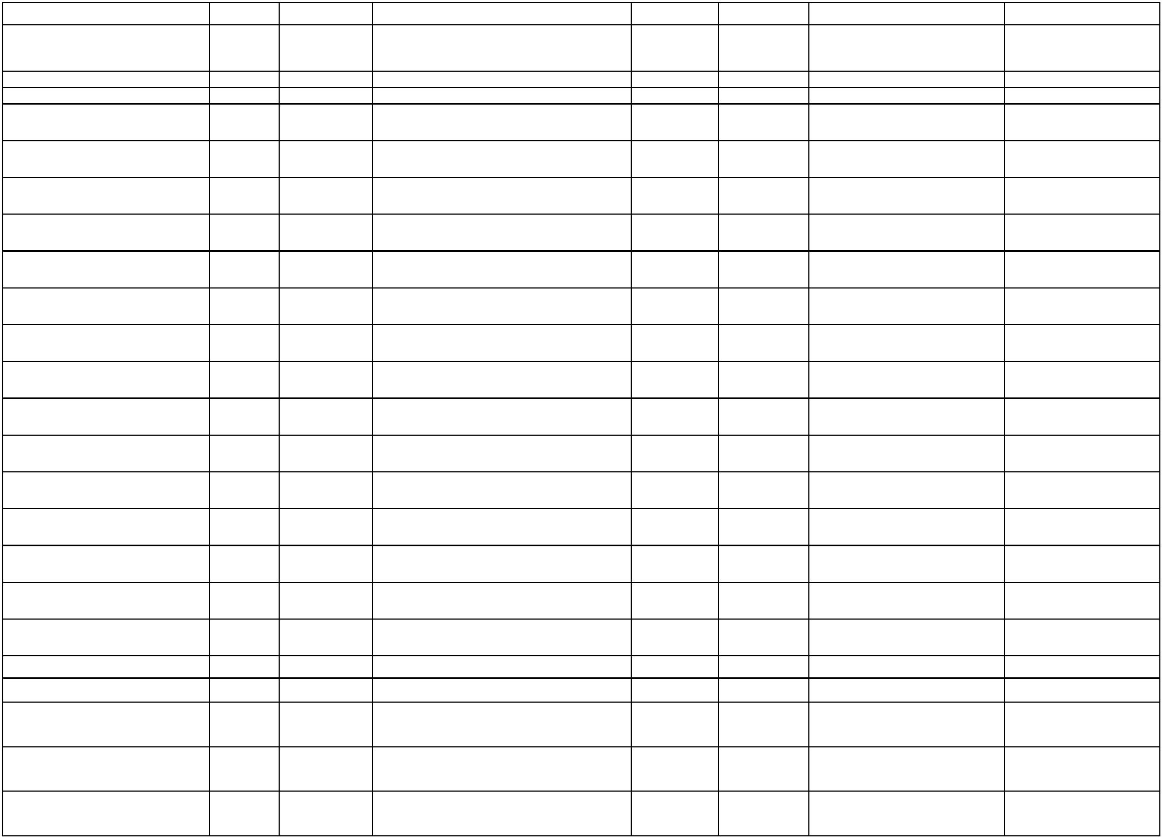

63625244 NDERTIMI I RRUGEVE
LOKALE
61/636/66405/31230/92236/0620
66405
10/12/2025 JOOS KRASNIQI BAZE SHPK
2025-189556 2025-518476
85,553.78
QKMF
8,691.55
7,000.00
vendimeve gjyqësore sipas
kërkesës së OB-re për shpenzimet
1
0/636/74200/34000/56202/0721
2/636/74200/32140/55014/0721
74200
74200
17/10/2025
PARQET DHE HAPSIRAT
PUBLIKE
2
10/6/2025
ELK GROUP SHPK
2025-97216
2025-201212
1,691.55
Arsim Fillore
15,265.00
8,181.60
Korrigjimi/bartja e shpenzimit për
vendime gjyqësore, sipas kërkesës
së OB-re për KSH.2025-265752
10/636/93571/34000/56191/0912
10/636/93571/34000/56191/0912
10/636/93571/31510/56280/0912
93571
93571
93571
6/10/2025
17/10/2025
9/7/2025
vendimeve gjyqësore sipas
kërkesës së OB-re për shpenzimet
1,818.40
PAJISJE E GJEN. TE ENERGJIS
ELEK.
EOR GROUP SHPK
2025-105212 2025-234726
5,265.00
Gjithsejtë Kapitalet
522,473.17
Zyra e Kryetarit
PAGESA PER PERFITUES
INDIVIDUAL
10/636/16020/22202/00000/0111
10/636/16020/22110/00000/0111
10/636/16020/22202/00000/0111
10/636/16020/22202/00000/0111
10/636/16020/22202/00000/0111
10/636/16020/22202/00000/0111
10/636/16020/22202/00000/0111
10/636/16020/22202/00000/0111
10/636/16020/22202/00000/0111
10/636/16020/22202/00000/0111
10/636/16020/22202/00000/0111
16020
16020
16020
16020
16020
16020
16020
16020
16020
16020
16020
30/1/2025
3/4/2025
RAMADAN JASIQI
2025-6132
2025-5645
300.00
500.00
250.00
250.00
250.00
250.00
250.00
250.00
250.00
250.00
250.00
TRANSFERET PER ENTITETET
PUBLIKE
QENDRA PER MIREQENIE E GRUAS QMG
IHSAN MALOKU
2025-57148
2025-85009
2025-84655
2025-84663
2025-84675
2025-84648
2025-84637
2025-84689
2025-84998
2025-84702
2025-94563
2025-147071
2025-147118
2025-147136
2025-147155
2025-147169
2025-147178
2025-147187
2025-147193
2025-147197
PAGESA PER PERFITUES
INDIVIDUAL
30/4/2025
30/4/2025
30/4/2025
30/4/2025
30/4/2025
30/4/2025
30/4/2025
30/4/2025
30/4/2025
PAGESA PER PERFITUES
INDIVIDUAL
RASIM GAXHERRI
NEVRUZ KRASNIQI
FIKNETE JASIQI
PAGESA PER PERFITUES
INDIVIDUAL
PAGESA PER PERFITUES
INDIVIDUAL
PAGESA PER PERFITUES
INDIVIDUAL
MERGIM MIFTARI
PAGESA PER PERFITUES
INDIVIDUAL
ALI MIFTARI
PAGESA PER PERFITUES
INDIVIDUAL
VALENTINA HOXHA
HIDAJETE TOFAJ
PAGESA PER PERFITUES
INDIVIDUAL
PAGESA PER PERFITUES
INDIVIDUAL
BURRNETE KRASNIQI
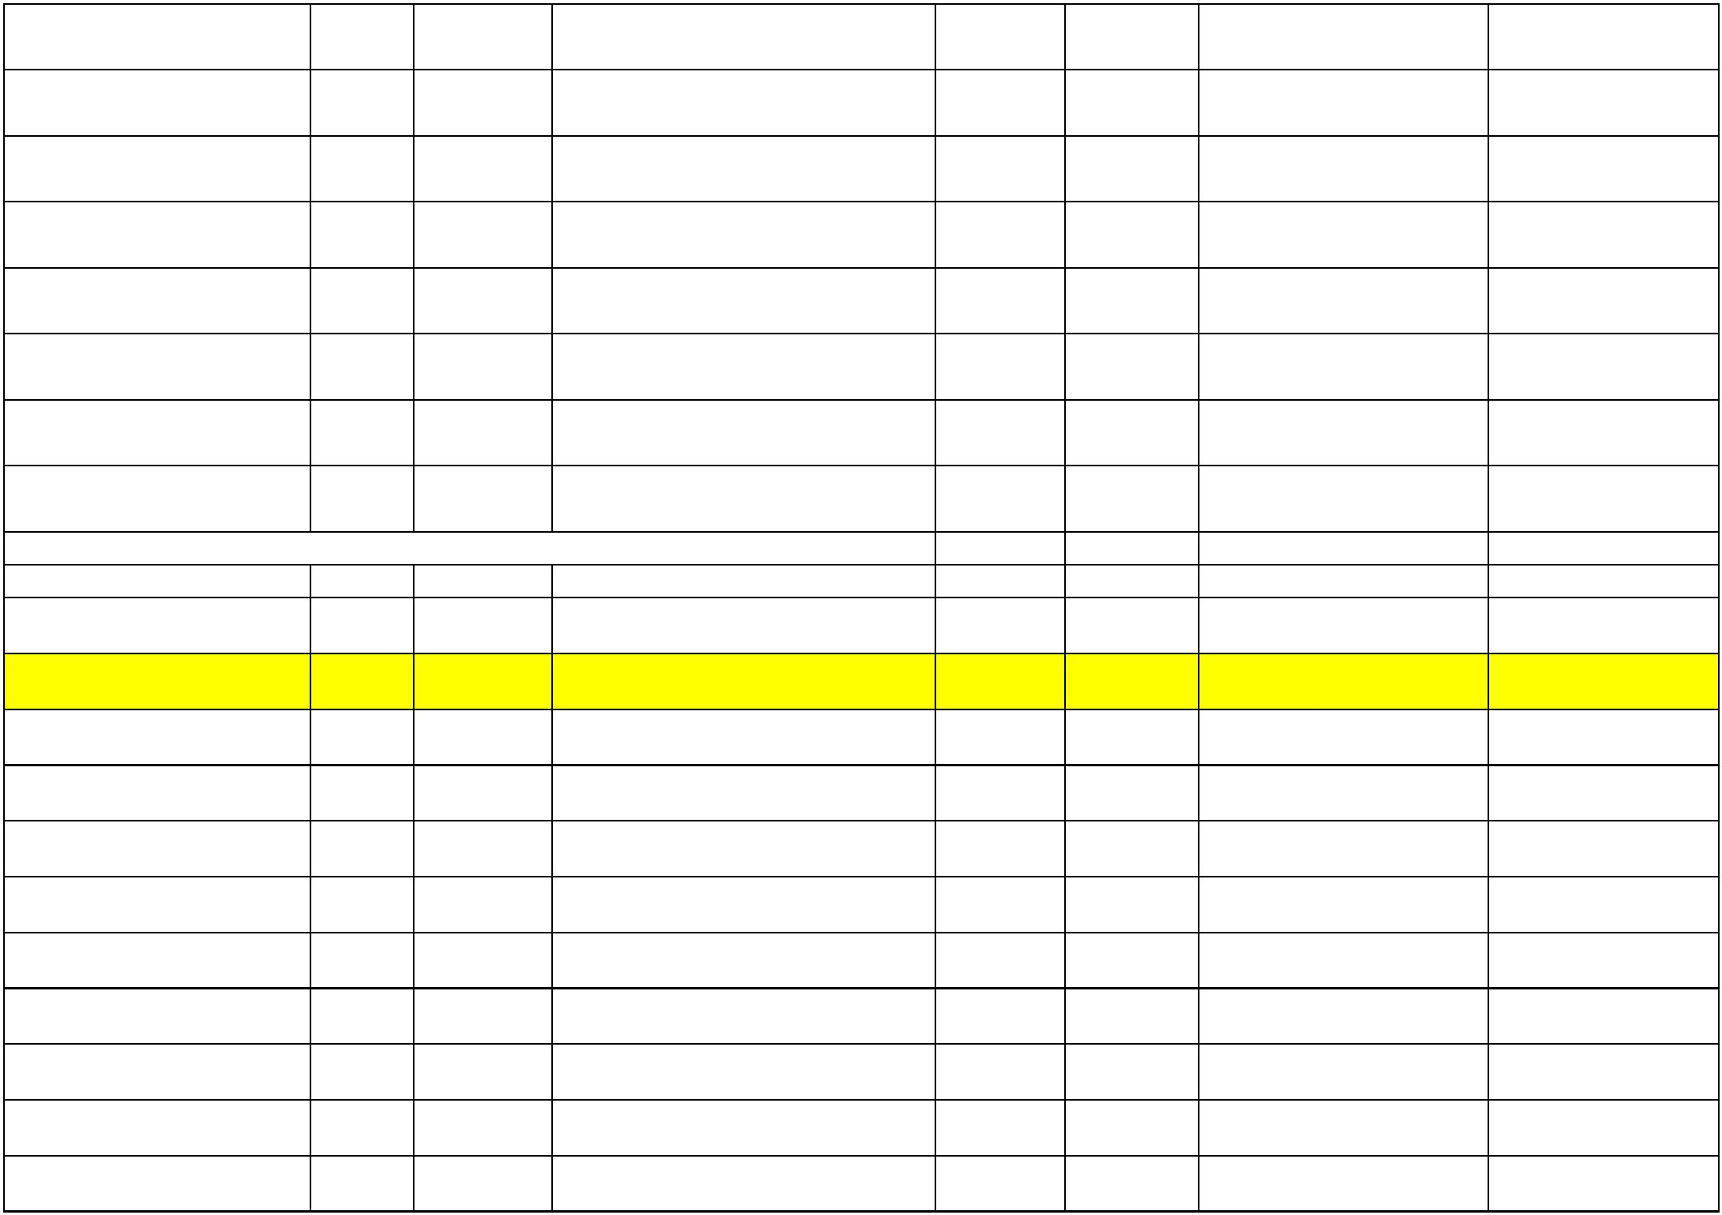

PAGESA PER PERFITUES
INDIVIDUAL
10/636/16020/22202/00000/0111
10/636/16020/22202/00000/0111
10/636/16020/22202/00000/0111
10/636/16020/21110/00000/0111
10/636/16020/22202/00000/0111
10/636/16020/22202/00000/0111
10/636/16020/22202/00000/0111
10/636/16020/22202/00000/0111
10/636/16020/22202/00000/0111
10/636/16020/22202/00000/0111
10/636/16020/22202/00000/0111
10/636/16020/22202/00000/0111
10/636/16020/22202/00000/0111
10/636/16020/22202/00000/0111
10/636/16020/22202/00000/0111
10/636/16020/22202/00000/0111
10/636/16020/22202/00000/0111
10/636/16020/22202/00000/0111
10/636/16020/22202/00000/0111
10/636/16020/22202/00000/0111
10/636/16020/22202/00000/0111
10/636/16020/22202/00000/0111
16020
16020
16020
16020
16020
16020
16020
16020
16020
16020
16020
16020
16020
16020
16020
16020
16020
16020
16020
16020
16020
16020
5/5/2025
12/5/2025
12/5/2025
23/5/2025
ISE GACAFERI
2025-84711
2025-88587
2025-88591
2025-149836
2025-160110
2025-160118
250.00
250.00
250.00
1,000.00
250.00
250.00
250.00
250.00
250.00
250.00
250.00
250.00
250.00
250.00
250.00
250.00
250.00
250.00
250.00
250.00
250.00
250.00
PAGESA PER PERFITUES
INDIVIDUAL
LUMNIJE GACAFERI
TEUTE GAXHERRI
ISLAMIC RELIEF
PAGESA PER PERFITUES
INDIVIDUAL
SUBVENCIONET PER ENTITETET
PUBLIKE
2025-102598 2025-177773
2025-194679 2025-391245
2025-194665 2025-391253
2025-194648 2025-391259
2025-194591 2025-391269
2025-194549 2025-391276
2025-194538 2025-391285
2025-194530 2025-391298
2025-194514 2025-391306
2025-194633 2025-391312
2025-194622 2025-391317
2025-194564 2025-391319
2025-194491 2025-391324
2025-194610 2025-391329
2025-195204 2025-391338
2025-200509 2025-407844
2025-200557 2025-407867
2025-200544 2025-407900
2025-200535 2025-407960
63625690 PAGESAT PER
PERFITUES INDIVIDUAL
10/10/2025 ALI MIFTARI
63625689 PAGESAT PER
PERFITUES INDIVIDUAL
10/10/2025 MERGIM MIFTARI
10/10/2025 HASIM KUCI
63625688 PAGESAT PER
PERFITUES INDIVIDUAL
63625684 PAGESAT PER
PERFITUES INDIVIDUAL
10/10/2025 SAMIRE SHALA
10/10/2025 NAZMIJE KRASNIQI
10/10/2025 NEVRUZ KRASNIQI
10/10/2025 BURRNETE KRASNIQI
10/10/2025 DURIM KRASNIQI
10/10/2025 RASIM GAXHERRI
10/10/2025 GANI KUQI
63625682 PAGESAT PER
PERFITUES INDIVIDUAL
63625681 PAGESAT PER
PERFITUES INDIVIDUAL
63625680 PAGESAT PER
PERFITUES INDIVIDUAL
63625679 PAGESAT PER
PERFITUES INDIVIDUAL
63625687 PAGESAT PER
PERFITUES INDIVIDUAL
63625686 PAGESAT PER
PERFITUES INDIVIDUAL
63625683 PAGESAT PER
PERFITUES INDIVIDUAL
10/10/2025 SYLE ZEKAJ
63625678 PAGESAT PER
PERFITUES INDIVIDUAL
10/10/2025 VALDETE HASANI
10/10/2025 HIDAJETE TOFAJ
10/10/2025 ARTA KUCI
63625685 PAGESAT PER
PERFITUES INDIVIDUAL
63625691 PAGESA PER
PERFITUES INDIVIDUAL
63625703 PAGESA PER
PERFITUES INDIVIDUAL
24/10/2025 HAVE MIROCI
24/10/2025 EDISON GACAFERI
24/10/2025 QERIM LLOLLUNI
24/10/2025 AVNI GAXHERRI
63625708 PAGESA PER
PERFITUES INDIVIDUAL
63625707 PAGESA PER
PERFITUES INDIVIDUAL
63625706 PAGESA PER
PERFITUES INDIVIDUAL
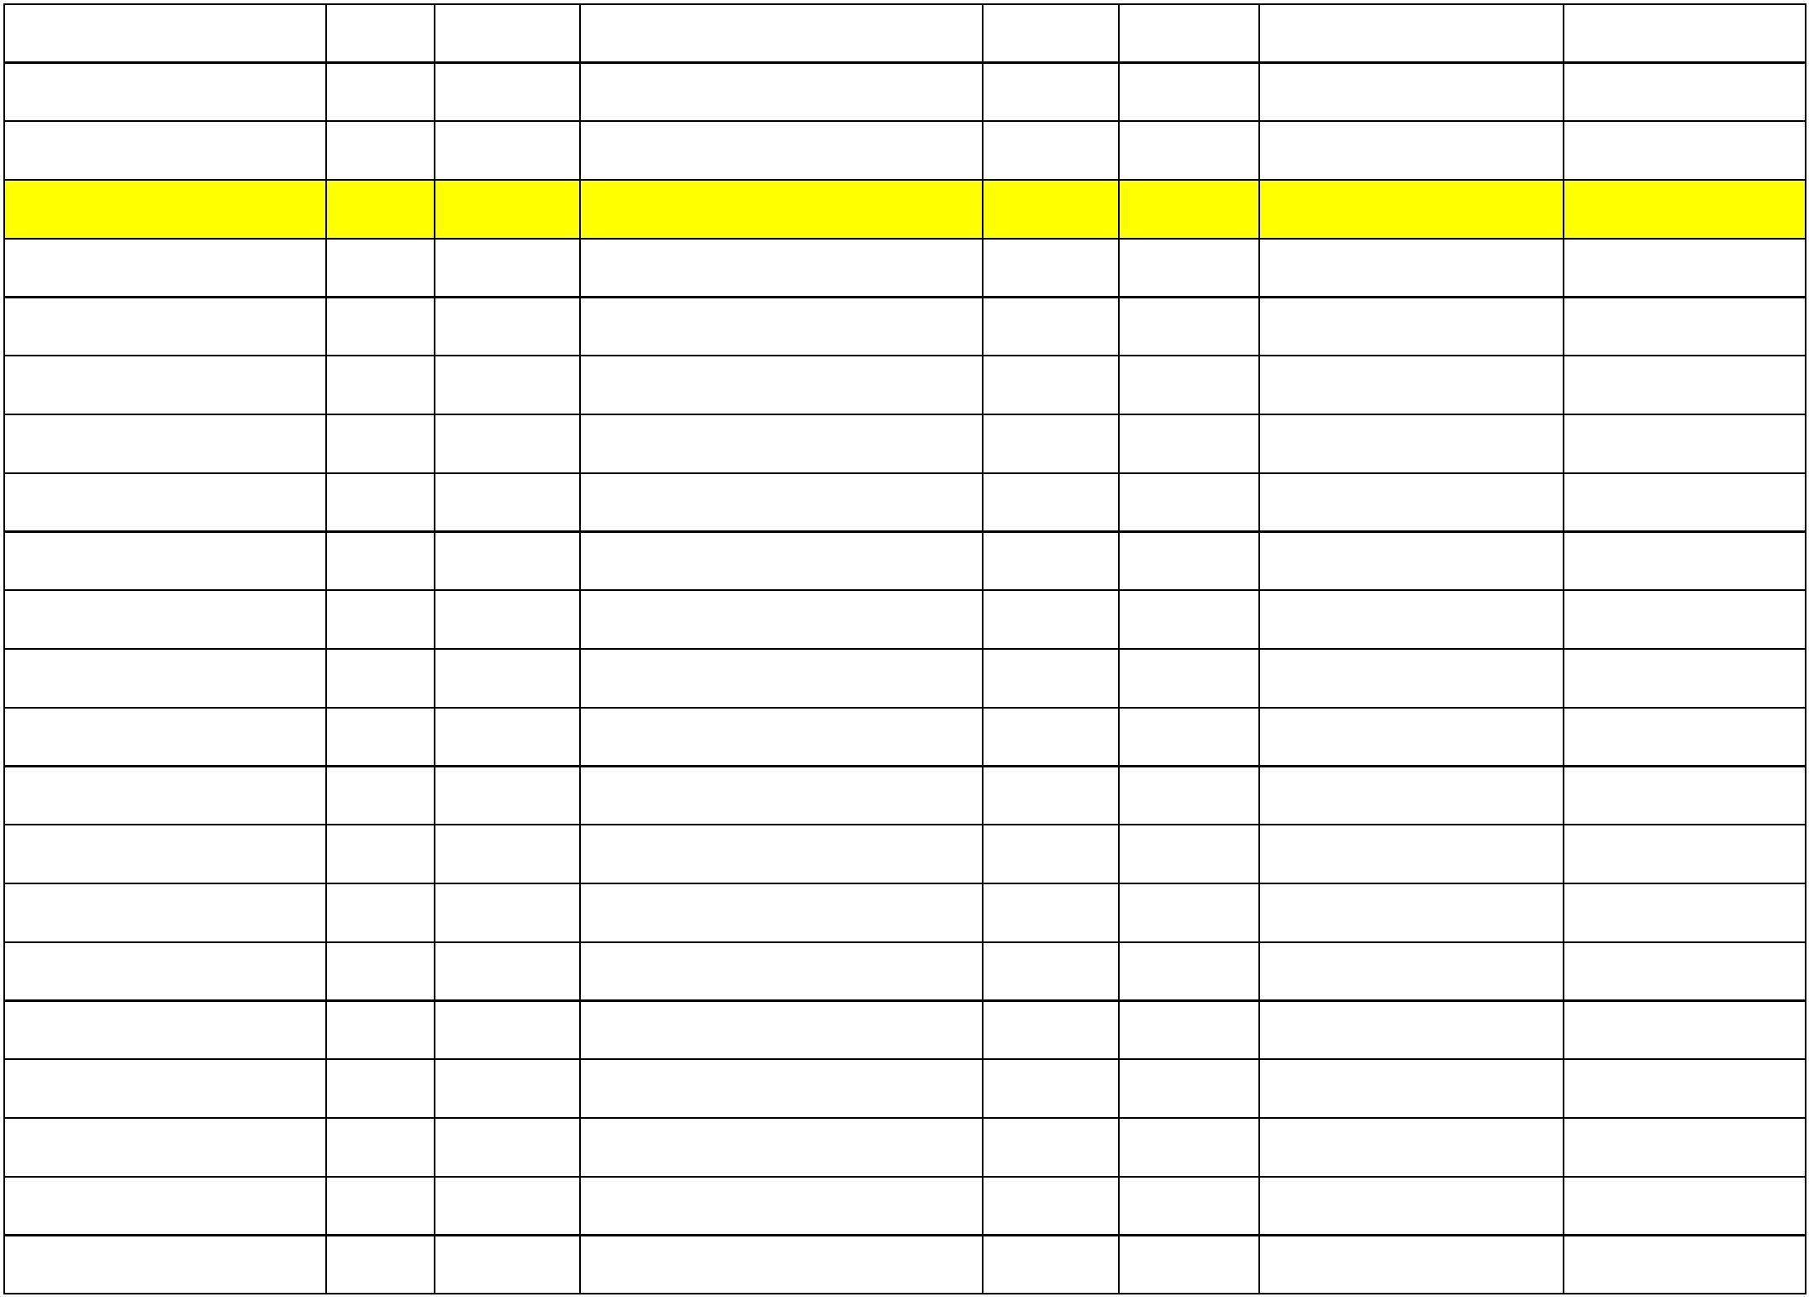

63625705 PAGESA PER
PERFITUES INDIVIDUAL
10/636/16020/22202/00000/0111
10/636/16020/22202/00000/0111
10/636/16020/22202/00000/0111
10/636/16020/22202/00000/0111
10/636/16020/22202/00000/0111
10/636/16020/22202/00000/0111
10/636/16020/22202/00000/0111
10/636/16020/22202/00000/0111
10/636/16020/22202/00000/0111
10/636/16020/22202/00000/0111
10/636/16020/22202/00000/0111
10/636/16020/22202/00000/0111
10/636/16020/22202/00000/0111
10/636/16020/22202/00000/0111
10/636/16020/22202/00000/0111
10/636/16020/22202/00000/0111
10/636/16020/22202/00000/0111
10/636/16020/22202/00000/0111
10/636/16020/22202/00000/0111
10/636/93571/22202/00000/0912
10/636/93571/22202/00000/0912
10/636/93571/22202/00000/0912
16020
16020
16020
16020
16020
16020
16020
16020
16020
16020
16020
16020
16020
16020
16020
16020
16020
16020
16020
16020
16020
16020
24/10/2025 HYRE KRASNIQI
24/10/2025 AHMET KRASNIQI
24/10/2025 BUTA SALIHAJ
2025-200523 2025-407964
2025-200520 2025-407972
2025-200437 2025-407978
2025-200427 2025-407987
2025-200406 2025-408000
2025-241790 2025-511525
2025-241794 2025-511534
2025-241798 2025-511546
2025-241828 2025-511555
2025-241816 2025-511564
2025-241810 2025-511575
2025-241806 2025-511582
2025-241818 2025-511593
2025-241825 2025-511603
2025-241833 2025-511615
2025-241831 2025-511626
2025-243687 2025-516017
2025-243675 2025-516028
2025-250394 2025-544308
250.00
250.00
250.00
250.00
250.00
300.00
300.00
300.00
300.00
300.00
300.00
300.00
300.00
300.00
300.00
300.00
300.00
300.00
550.00
300.00
300.00
300.00
63625704 PAGESA PER
PERFITUES INDIVIDUAL
63625702 PAGESA PER
PERFITUES INDIVIDUAL
63625701 PAGESA PER
PERFITUES INDIVIDUAL
24/10/2025 XHEVAHIRE GAXHERRI
24/10/2025 SHEMSIE HOXHA
63625700 PAGESA PER
PERFITUES INDIVIDUAL
#63625883 PAGESA PER
PERFITUESINDIVIDUAL
8/12/2025
8/12/2025
8/12/2025
8/12/2025
8/12/2025
8/12/2025
8/12/2025
8/12/2025
8/12/2025
8/12/2025
8/12/2025
9/12/2025
9/12/2025
ANISA PEPSHI
PAGESA PER PERFITUES
INDIVIDUAL
TAULANT GAGJERRI
YLL SHALA
#63625884 PAGESA PER
PERFITUES INDIVIDUAL
PAGESA PER PERFITUES
INDIVIDUAL
TEUTA JASIQI
PAGESA PER PERFITUES
INDIVIDUAL
LETUAN TOPALLI
MBRETRON QESTAJ
ENIS LLOLLUNI
BULEZA KUCI
PAGESA PER PERFITUES
INDIVIDUAL
PAGESA PER PERFITUES
INDIVIDUAL
PAGESA PER PERFITUES
INDIVIDUAL
PAGESA PER PERFITUES
INDIVIDUAL
LIRESA SALIHAJ
ARMEND META
MELVESA KRASNIQI
LIRAK SALIHAJ
ARIGON MALOKU
PAGESA PER PERFITUES
INDIVIDUAL
PAGESA PER PERFITUES
INDIVIDUAL
63625888 PAGESA PER
PERFITUES INDIVIDUAL
63625878 PAGESA PER
PERFITUES INDIVIDUAL
63625930 SUBVENCION PER
PERFITUES INDIVIDUAL
18/12/2025 ISE GACAFERI
24/11/2025 PAGESA ME LISTA FORME ELEKTRON
24/11/2025 PAGESA ME LISTA FORME ELEKTRON
24/11/2025 PAGESA ME LISTA FORME ELEKTRON
2025-194839 2025-474938 LAURETA MALOKU
2025-194839 2025-474940 ART GJULI
2025-194839 2025-474942 GRESA KRASNIQI


10/636/93571/22202/00000/0912
10/636/93571/22202/00000/0912
10/636/93571/22202/00000/0912
10/636/93571/22202/00000/0912
10/636/93571/22202/00000/0912
10/636/93571/22202/00000/0912
10/636/93571/22202/00000/0912
10/636/93571/22202/00000/0912
10/636/93571/22202/00000/0912
10/636/93571/22202/00000/0912
10/636/93571/22202/00000/0912
10/636/93571/22202/00000/0912
10/636/93571/22202/00000/0912
10/636/93571/22202/00000/0912
10/636/93571/22202/00000/0912
10/636/93571/22202/00000/0912
10/636/93571/22202/00000/0912
10/636/93571/22202/00000/0912
10/636/93571/22202/00000/0912
10/636/93571/22202/00000/0912
10/636/93571/22202/00000/0912
10/636/93571/22202/00000/0912
16020
16020
16020
16020
16020
16020
16020
16020
16020
16020
16020
16020
16020
16020
16020
16020
16020
16020
16020
16020
16020
16020
24/11/2025 PAGESA ME LISTA FORME ELEKTRON
24/11/2025 PAGESA ME LISTA FORME ELEKTRON
24/11/2025 PAGESA ME LISTA FORME ELEKTRON
24/11/2025 PAGESA ME LISTA FORME ELEKTRON
24/11/2025 PAGESA ME LISTA FORME ELEKTRON
24/11/2025 PAGESA ME LISTA FORME ELEKTRON
24/11/2025 PAGESA ME LISTA FORME ELEKTRON
24/11/2025 PAGESA ME LISTA FORME ELEKTRON
24/11/2025 PAGESA ME LISTA FORME ELEKTRON
24/11/2025 PAGESA ME LISTA FORME ELEKTRON
24/11/2025 PAGESA ME LISTA FORME ELEKTRON
24/11/2025 PAGESA ME LISTA FORME ELEKTRON
24/11/2025 PAGESA ME LISTA FORME ELEKTRON
24/11/2025 PAGESA ME LISTA FORME ELEKTRON
24/11/2025 PAGESA ME LISTA FORME ELEKTRON
24/11/2025 PAGESA ME LISTA FORME ELEKTRON
24/11/2025 PAGESA ME LISTA FORME ELEKTRON
24/11/2025 PAGESA ME LISTA FORME ELEKTRON
24/11/2025 PAGESA ME LISTA FORME ELEKTRON
24/11/2025 PAGESA ME LISTA FORME ELEKTRON
24/11/2025 PAGESA ME LISTA FORME ELEKTRON
24/11/2025 PAGESA ME LISTA FORME ELEKTRON
2025-194839 2025-474944 SARANDA KRASNIQI
2025-194839 2025-474947 FLORENTINA QESTAJ
2025-194839 2025-474949 KETJONA MALOKU
2025-194839 2025-474952 ARTANA KUQI
2025-194839 2025-474955 DIOR TOFAJ
300.00
300.00
300.00
300.00
300.00
300.00
300.00
300.00
300.00
300.00
300.00
300.00
300.00
300.00
300.00
300.00
300.00
300.00
300.00
300.00
300.00
300.00
2025-194839 2025-474957 ABDURRAHMAN QESTAJ
2025-194839 2025-474959 FESTINA MALOKU
2025-194839 2025-474961 UKË LLOLLUNI
2025-194839 2025-474964 ALKETA TOFAJ
2025-194839 2025-474967 BYLBYL TOFAJ
2025-194839 2025-474968 AULONA QALLAKU
2025-194839 2025-474971 VESA GACAFERI
2025-194839 2025-474972 AURORA KRASNIQI
2025-194839 2025-474975 DION GAXHERRI
2025-194839 2025-474978 RUKE SHEHU
2025-194839 2025-474980 SARA JASIQI
2025-194839 2025-474982 FLATRON KUQI
2025-194839 2025-474986 ALKETA ISUFAJ
2025-194839 2025-474988 SADIK GACAFERI
2025-194839 2025-474990 BUTRINT GAXHERRI
2025-194839 2025-474993 DREN HOXHA
2025-194839 2025-474995 VLERA SHEHU

10/636/93571/22202/00000/0912
10/636/93571/22202/00000/0912
10/636/93571/22202/00000/0912
10/636/93571/22202/00000/0912
10/636/93571/22202/00000/0912
10/636/93571/22202/00000/0912
10/636/93571/22202/00000/0912
10/636/93571/22202/00000/0912
10/636/93571/22202/00000/0912
10/636/93571/22202/00000/0912
10/636/93571/22202/00000/0912
10/636/93571/22202/00000/0912
10/636/93571/22202/00000/0912
10/636/93571/22202/00000/0912
10/636/93571/22202/00000/0912
10/636/93571/22202/00000/0912
10/636/93571/22202/00000/0912
10/636/93571/22202/00000/0912
10/636/93571/22202/00000/0912
10/636/93571/22202/00000/0912
10/636/93571/22202/00000/0912
10/636/93571/22202/00000/0912
16020
16020
16020
16020
16020
16020
16020
16020
16020
16020
16020
16020
16020
16020
16020
16020
16020
16020
16020
16020
16020
16020
24/11/2025 PAGESA ME LISTA FORME ELEKTRON
24/11/2025 PAGESA ME LISTA FORME ELEKTRON
24/11/2025 PAGESA ME LISTA FORME ELEKTRON
24/11/2025 PAGESA ME LISTA FORME ELEKTRON
24/11/2025 PAGESA ME LISTA FORME ELEKTRON
24/11/2025 PAGESA ME LISTA FORME ELEKTRON
24/11/2025 PAGESA ME LISTA FORME ELEKTRON
24/11/2025 PAGESA ME LISTA FORME ELEKTRON
24/11/2025 PAGESA ME LISTA FORME ELEKTRON
24/11/2025 PAGESA ME LISTA FORME ELEKTRON
24/11/2025 PAGESA ME LISTA FORME ELEKTRON
24/11/2025 PAGESA ME LISTA FORME ELEKTRON
24/11/2025 PAGESA ME LISTA FORME ELEKTRON
24/11/2025 PAGESA ME LISTA FORME ELEKTRON
24/11/2025 PAGESA ME LISTA FORME ELEKTRON
24/11/2025 PAGESA ME LISTA FORME ELEKTRON
24/11/2025 PAGESA ME LISTA FORME ELEKTRON
24/11/2025 PAGESA ME LISTA FORME ELEKTRON
24/11/2025 PAGESA ME LISTA FORME ELEKTRON
24/11/2025 PAGESA ME LISTA FORME ELEKTRON
24/11/2025 PAGESA ME LISTA FORME ELEKTRON
24/11/2025 PAGESA ME LISTA FORME ELEKTRON
2025-194839 2025-474999 DIELLORE VELIJAJ
2025-194839 2025-475001 ELIDA TOFAJ
2025-194839 2025-475004 LORETA ISUFAJ
2025-194839 2025-475005 BELIDA KUÇI
2025-194839 2025-475007 ENIS PEPSHI
2025-194839 2025-475010 FIDAN MIROCI
2025-194839 2025-475011 SABRIJE KUQI
2025-194839 2025-475014 AHMET SHEHU
2025-194839 2025-475016 ANDUESA SHEHU
2025-194839 2025-475019 ARGJENDA SHEHU
2025-194839 2025-475021 ERËSTINA KRASNIQI
2025-194839 2025-475023 ERINA GJOTA
2025-194839 2025-475024 GLAUK HOXHA
2025-194839 2025-475026 PRANVERA GACAFERI
2025-194839 2025-475029 RINESA GACAFERI
2025-194839 2025-475030 ERION PEPSHI
2025-194839 2025-475031 KUSHTRIM KRASNIQI
2025-194839 2025-475032 HAVE MALOKU
2025-194839 2025-475033 HAXHË META
2025-194839 2025-475035 ALISA KRASNIQI
2025-194839 2025-475038 KALTRINA SHEHU
2025-194839 2025-475039 ERLINA HIMA
300.00
300.00
300.00
300.00
300.00
300.00
300.00
300.00
300.00
300.00
300.00
300.00
300.00
300.00
300.00
300.00
300.00
300.00
300.00
300.00
300.00
300.00

10/636/93571/22202/00000/0912
10/636/93571/22202/00000/0912
10/636/93571/22202/00000/0912
10/636/93571/22202/00000/0912
10/636/93571/22202/00000/0912
10/636/93571/22202/00000/0912
10/636/93571/22202/00000/0912
10/636/93571/22202/00000/0912
10/636/93571/22202/00000/0912
10/636/93571/22202/00000/0912
10/636/93571/22202/00000/0912
10/636/93571/22202/00000/0912
10/636/93571/22202/00000/0912
10/636/93571/22202/00000/0912
10/636/93571/22202/00000/0912
10/636/93571/22202/00000/0912
10/636/93571/22202/00000/0912
10/636/93571/22202/00000/0912
10/636/93571/22202/00000/0912
10/636/93571/22202/00000/0912
21/636/16020/22202/00000/0111
21/636/16020/22202/00000/0111
16020
16020
16020
16020
16020
16020
16020
16020
16020
16020
16020
16020
16020
16020
16020
16020
16020
16020
16020
16020
16020
16020
24/11/2025 PAGESA ME LISTA FORME ELEKTRON
24/11/2025 PAGESA ME LISTA FORME ELEKTRON
24/11/2025 PAGESA ME LISTA FORME ELEKTRON
24/11/2025 PAGESA ME LISTA FORME ELEKTRON
24/11/2025 PAGESA ME LISTA FORME ELEKTRON
24/11/2025 PAGESA ME LISTA FORME ELEKTRON
24/11/2025 PAGESA ME LISTA FORME ELEKTRON
24/11/2025 PAGESA ME LISTA FORME ELEKTRON
24/11/2025 PAGESA ME LISTA FORME ELEKTRON
24/11/2025 PAGESA ME LISTA FORME ELEKTRON
24/11/2025 PAGESA ME LISTA FORME ELEKTRON
24/11/2025 PAGESA ME LISTA FORME ELEKTRON
24/11/2025 PAGESA ME LISTA FORME ELEKTRON
24/11/2025 PAGESA ME LISTA FORME ELEKTRON
24/11/2025 PAGESA ME LISTA FORME ELEKTRON
24/11/2025 PAGESA ME LISTA FORME ELEKTRON
24/11/2025 PAGESA ME LISTA FORME ELEKTRON
24/11/2025 PAGESA ME LISTA FORME ELEKTRON
24/11/2025 PAGESA ME LISTA FORME ELEKTRON
24/11/2025 PAGESA ME LISTA FORME ELEKTRON
19/12/2025 EDONIS GAXHERRI
2025-194839 2025-475041 GENTA LLOLLUNI
2025-194839 2025-475042 IDEAL SHEHU
2025-194839 2025-475043 DONIKA TOFAJ
2025-194839 2025-475044 ELIONA TOFAJ
2025-194839 2025-475045 LEONELA GACAFERI
2025-194839 2025-475047 ADELINA BERISHA
2025-194839 2025-475048 BESJANA KUÇI
2025-194839 2025-475049 MELISA QESTAJ
2025-194839 2025-475050 ERSA KRASNIQI
2025-194839 2025-475052 ESMA QESTAJ
2025-194839 2025-475053 ADNAN KRASNIQI
2025-194839 2025-475054 ALBIOT KRASNIQI
2025-194839 2025-475055 ENDRIT QESTAJ
2025-194839 2025-475056 LENDRITA SHEHU
2025-194839 2025-475057 LIRIGEZON GOÇAJ
2025-194839 2025-475058 VALJETA KRASNIQI
2025-194839 2025-475059 DAFINA KRASNIQI
2025-194839 2025-475060 JON SHALA
300.00
300.00
300.00
300.00
300.00
300.00
300.00
300.00
300.00
300.00
300.00
300.00
300.00
300.00
300.00
300.00
300.00
300.00
300.00
200.00
400.00
400.00
2025-194839 2025-475061 SHQIPDONA QESTAJ
2025-194839 2025-475062 ERMELINDA GJOTA
63625932 PAGESA PER
PERFITUES INDIVIDUAL
2025-256414 2025-547849
2025-256397 2025-548846
63625933 PAGESA PER
PERFITUES INDIVIDUAL
22/12/2025 ARSIM MIROCI

63625931 SUBVENCIONE PER
ENTITETE JOPUBLIKE
21/636/16020/21200/00000/0111
21/636/16020/22202/00000/0111
21/636/16020/21200/00000/0111
21/636/16020/21200/00000/0111
21/636/16020/22202/00000/0111
21/636/93571/22202/00000/0912
21/636/93571/22202/00000/0912
21/636/93571/22202/00000/0912
21/636/93571/22202/00000/0912
21/636/93571/22202/00000/0912
21/636/93571/22202/00000/0912
21/636/93571/22202/00000/0912
21/636/93571/22202/00000/0912
21/636/93571/22202/00000/0912
21/636/93571/22202/00000/0912
21/636/93571/22202/00000/0912
21/636/93571/22202/00000/0912
21/636/93571/22202/00000/0912
21/636/93571/22202/00000/0912
21/636/93571/22202/00000/0912
21/636/93571/22202/00000/0912
21/636/93571/22202/00000/0912
16020
16020
16020
16020
16020
16020
16020
16020
16020
16020
16020
16020
16020
16020
16020
16020
16020
16020
16020
16020
16020
16020
22/12/2025 KLUBI ATLETIK JUNIKU
23/12/2025 BESNIK KUCI
2025-256422 2025-550884
2025-256377 2025-551560
2025-256385 2025-551590
500.00
300.00
400.00
600.00
300.00
100.00
300.00
300.00
300.00
300.00
300.00
300.00
300.00
300.00
300.00
300.00
300.00
300.00
300.00
300.00
300.00
300.00
63625935 PAGESA PER
PERFITUES INDIVIDUAL
636259340SUBVENCIONIM PER
ENTITETE JOPUBLIKE
23/12/2025 KLUBI I PINGPONGUT JUNIKUT
63625940 SUBVENCIONE PER
ENTITETE JOPUBLIKE
24/12/2025 SHOQATA BJESHKATARE RRASA E ZOGUT 2025-259101 2025-556251
63625939 PAGESA PER
PERFITUES INDIVIDUAL
24/12/2025 NEVRUZ GACAFERI
2025-259063 2025-556277
24/11/2025 PAGESA ME LISTA FORME ELEKTRON
24/11/2025 PAGESA ME LISTA FORME ELEKTRON
24/11/2025 PAGESA ME LISTA FORME ELEKTRON
24/11/2025 PAGESA ME LISTA FORME ELEKTRON
24/11/2025 PAGESA ME LISTA FORME ELEKTRON
24/11/2025 PAGESA ME LISTA FORME ELEKTRON
24/11/2025 PAGESA ME LISTA FORME ELEKTRON
24/11/2025 PAGESA ME LISTA FORME ELEKTRON
24/11/2025 PAGESA ME LISTA FORME ELEKTRON
24/11/2025 PAGESA ME LISTA FORME ELEKTRON
24/11/2025 PAGESA ME LISTA FORME ELEKTRON
24/11/2025 PAGESA ME LISTA FORME ELEKTRON
24/11/2025 PAGESA ME LISTA FORME ELEKTRON
24/11/2025 PAGESA ME LISTA FORME ELEKTRON
24/11/2025 PAGESA ME LISTA FORME ELEKTRON
24/11/2025 PAGESA ME LISTA FORME ELEKTRON
24/11/2025 PAGESA ME LISTA FORME ELEKTRON
2025-194839 2025-475064 ERMELINDA GJOTA
2025-194839 2025-475065 FITORE GJOCAJ
2025-194839 2025-475066 ARIANA GJULI
2025-194839 2025-475067 DURESA HOXHA
2025-194839 2025-475068 ELISJETA TOFAJ
2025-194839 2025-475069 ERION BAJRAKTARI
2025-194839 2025-475071 VALENTINA GACAFERI
2025-194839 2025-475072 LIRON KRASNIQI
2025-194839 2025-475073 ELSA HIMA
2025-194839 2025-475074 ERLIRA SHALA
2025-194839 2025-475075 LEONA KRASNIQI
2025-194839 2025-475076 DIELLZA KRASNIQI
2025-194839 2025-475077 ERMIRA GOQAJ
2025-194839 2025-475079 ALKETA KRASNIQI
2025-194839 2025-475080 ANISA GOÇI
2025-194839 2025-475082 ARDIT SHEHIQI
2025-194839 2025-475084 DRITLIND QESTAJ
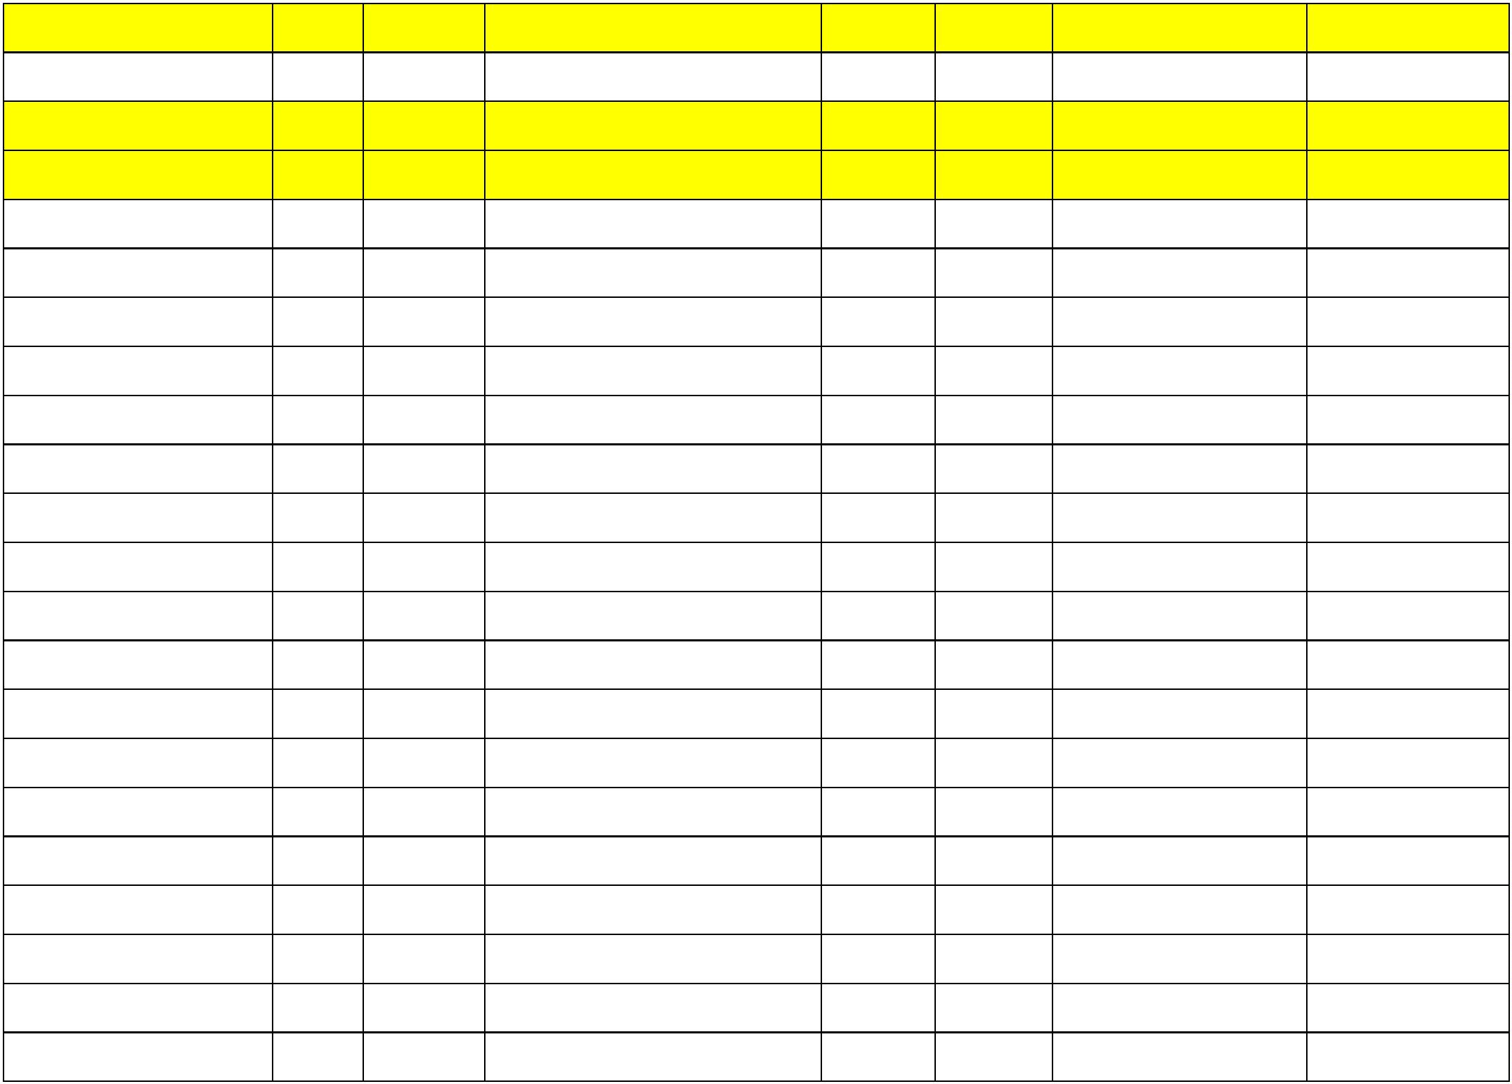

21/636/93571/22202/00000/0912
21/636/93571/22202/00000/0912
21/636/93571/22202/00000/0912
21/636/93571/22202/00000/0912
21/636/93571/22202/00000/0912
21/636/93571/22202/00000/0912
21/636/93571/22202/00000/0912
21/636/93571/22202/00000/0912
21/636/93571/22202/00000/0912
21/636/93571/22202/00000/0912
21/636/93571/22202/00000/0912
21/636/93571/22202/00000/0912
21/636/93571/22202/00000/0912
21/636/93571/22202/00000/0912
21/636/93571/22202/00000/0912
21/636/93571/22202/00000/0912
21/636/93571/22202/00000/0912
21/636/93571/22202/00000/0912
21/636/93571/22202/00000/0912
21/636/93571/22202/00000/0912
21/636/93571/22202/00000/0912
21/636/93571/22202/00000/0912
16020
16020
16020
16020
16020
16020
16020
16020
16020
16020
16020
16020
16020
16020
16020
16020
16020
16020
16020
16020
16020
16020
24/11/2025 PAGESA ME LISTA FORME ELEKTRON
24/11/2025 PAGESA ME LISTA FORME ELEKTRON
24/11/2025 PAGESA ME LISTA FORME ELEKTRON
24/11/2025 PAGESA ME LISTA FORME ELEKTRON
24/11/2025 PAGESA ME LISTA FORME ELEKTRON
24/11/2025 PAGESA ME LISTA FORME ELEKTRON
24/11/2025 PAGESA ME LISTA FORME ELEKTRON
24/11/2025 PAGESA ME LISTA FORME ELEKTRON
24/11/2025 PAGESA ME LISTA FORME ELEKTRON
24/11/2025 PAGESA ME LISTA FORME ELEKTRON
24/11/2025 PAGESA ME LISTA FORME ELEKTRON
24/11/2025 PAGESA ME LISTA FORME ELEKTRON
24/11/2025 PAGESA ME LISTA FORME ELEKTRON
24/11/2025 PAGESA ME LISTA FORME ELEKTRON
24/11/2025 PAGESA ME LISTA FORME ELEKTRON
24/11/2025 PAGESA ME LISTA FORME ELEKTRON
24/11/2025 PAGESA ME LISTA FORME ELEKTRON
24/11/2025 PAGESA ME LISTA FORME ELEKTRON
24/11/2025 PAGESA ME LISTA FORME ELEKTRON
24/11/2025 PAGESA ME LISTA FORME ELEKTRON
24/11/2025 PAGESA ME LISTA FORME ELEKTRON
24/11/2025 PAGESA ME LISTA FORME ELEKTRON
2025-194839 2025-475085 ELISA GACAFERI
2025-194839 2025-475086 ERLIS PEPSHI
2025-194839 2025-475087 GRESA MIROCI
2025-194839 2025-475088 JETON MAZREKAJ
2025-194839 2025-475090 LORENT BAJRAKTARI
2025-194839 2025-475092 SHEGA KRASNIQI
2025-194839 2025-475093 SHPETIM JASIQI
2025-194839 2025-475094 ALBIAN KUÇI
300.00
300.00
300.00
300.00
300.00
300.00
300.00
300.00
300.00
300.00
300.00
300.00
300.00
300.00
300.00
300.00
300.00
300.00
300.00
300.00
300.00
300.00
2025-194839 2025-475096 DENISA TOFAJ
2025-194839 2025-475099 EGZONTINA SHALA
2025-194839 2025-475101 RUKMON GACAFERI
2025-194839 2025-475103 AGNESA MALOKU
2025-194839 2025-475105 GJIN KRASNIQI
2025-194839 2025-475106 ANXHELA TREZHNJEVA
2025-194839 2025-475107 ARBANA BERISHA
2025-194839 2025-475108 EDONIS GAXHERRI
2025-194839 2025-475109 FLORIAN QESTAJ
2025-194839 2025-475110 SARA ÇEKA
2025-194839 2025-475113 SHABAN KRASNIQI
2025-194839 2025-475114 ENDRIT GAXHERRI
2025-194839 2025-475115 ENDRIT GANIJA
2025-194839 2025-475116 JETMIR GAXHERRI

21/636/93571/22202/00000/0912
21/636/93571/22202/00000/0912
21/636/93571/22202/00000/0912
21/636/93571/22202/00000/0912
21/636/93571/22202/00000/0912
21/636/93571/22202/00000/0912
21/636/93571/22202/00000/0912
21/636/93571/22202/00000/0912
21/636/93571/22202/00000/0912
21/636/93571/22202/00000/0912
21/636/93571/22202/00000/0912
21/636/93571/22202/00000/0912
21/636/93571/22202/00000/0912
21/636/93571/22202/00000/0912
21/636/93571/22202/00000/0912
21/636/93571/22202/00000/0912
21/636/93571/22202/00000/0912
21/636/93571/22202/00000/0912
21/636/93571/22202/00000/0912
21/636/93571/22202/00000/0912
21/636/93571/22202/00000/0912
21/636/93571/22202/00000/0912
16020
16020
16020
16020
16020
16020
16020
16020
16020
16020
16020
16020
16020
16020
16020
16020
16020
16020
16020
16020
16020
16020
24/11/2025 PAGESA ME LISTA FORME ELEKTRON
24/11/2025 PAGESA ME LISTA FORME ELEKTRON
24/11/2025 PAGESA ME LISTA FORME ELEKTRON
24/11/2025 PAGESA ME LISTA FORME ELEKTRON
24/11/2025 PAGESA ME LISTA FORME ELEKTRON
24/11/2025 PAGESA ME LISTA FORME ELEKTRON
24/11/2025 PAGESA ME LISTA FORME ELEKTRON
24/11/2025 PAGESA ME LISTA FORME ELEKTRON
24/11/2025 PAGESA ME LISTA FORME ELEKTRON
24/11/2025 PAGESA ME LISTA FORME ELEKTRON
24/11/2025 PAGESA ME LISTA FORME ELEKTRON
24/11/2025 PAGESA ME LISTA FORME ELEKTRON
24/11/2025 PAGESA ME LISTA FORME ELEKTRON
24/11/2025 PAGESA ME LISTA FORME ELEKTRON
24/11/2025 PAGESA ME LISTA FORME ELEKTRON
24/11/2025 PAGESA ME LISTA FORME ELEKTRON
24/11/2025 PAGESA ME LISTA FORME ELEKTRON
24/11/2025 PAGESA ME LISTA FORME ELEKTRON
24/11/2025 PAGESA ME LISTA FORME ELEKTRON
24/11/2025 PAGESA ME LISTA FORME ELEKTRON
24/11/2025 PAGESA ME LISTA FORME ELEKTRON
24/11/2025 PAGESA ME LISTA FORME ELEKTRON
2025-194839 2025-475117 ELDA KRASNIQI
2025-194839 2025-475118 ELIONA GJOTA
2025-194839 2025-475119 GERTA KUÇI
2025-194839 2025-475120 PETRIT MALOKU
2025-194839 2025-475121 BASHKIM JASIQI
2025-194839 2025-475122 EDONA GJOTA
2025-194839 2025-475123 ERION GAGJERRI
2025-194839 2025-475124 LORIK SALIHAJ
2025-194839 2025-475126 REXHEP XHULI
2025-194839 2025-475127 ZENEL KRASNIQI
2025-194839 2025-475128 AJMONE KRASNIQI
2025-194839 2025-475129 ARTIOL MALOKU
2025-194839 2025-475130 EDONA PEPSHI
2025-194839 2025-475131 FABIJOLA KRASNIQI
2025-194839 2025-475133 SYARTA KRASNIQI
2025-194839 2025-475134 SYL PEPSHI
300.00
300.00
300.00
300.00
300.00
300.00
300.00
300.00
300.00
300.00
300.00
300.00
300.00
300.00
300.00
300.00
300.00
300.00
300.00
300.00
300.00
300.00
2025-194839 2025-475135 ARGONETA GOÇI
2025-194839 2025-475136 ARIF QESTAJ
2025-194839 2025-475138 ASLLAN PEPSHI
2025-194839 2025-475139 DION KASTRATI
2025-194839 2025-475140 EDUARD BAJRAKTARI
2025-194839 2025-475141 ERLISA KRASNIQI

21/636/93571/22202/00000/0912
21/636/93571/22202/00000/0912
21/636/93571/22202/00000/0912
21/636/93571/22202/00000/0912
21/636/93571/22202/00000/0912
21/636/93571/22202/00000/0912
16020
16020
16020
16020
16020
16020
24/11/2025 PAGESA ME LISTA FORME ELEKTRON
24/11/2025 PAGESA ME LISTA FORME ELEKTRON
24/11/2025 PAGESA ME LISTA FORME ELEKTRON
24/11/2025 PAGESA ME LISTA FORME ELEKTRON
24/11/2025 PAGESA ME LISTA FORME ELEKTRON
24/11/2025 PAGESA ME LISTA FORME ELEKTRON
2025-194839 2025-475142 FATJON MIROCI
2025-194839 2025-475143 DENIS XHULI
300.00
300.00
300.00
300.00
300.00
2025-194839 2025-475144 ALBERINA GACAFERI
2025-194839 2025-475145 FIONA KRASNIQI
2025-194839 2025-475146 ELDION KRASNIQI
2025-194839 2025-475147 LEONITA KRASNIQI
300.00
Gjithsejtë Subvencione
57,800.00
Total Shpenzimet 1-12 2025
2,567,138.64
